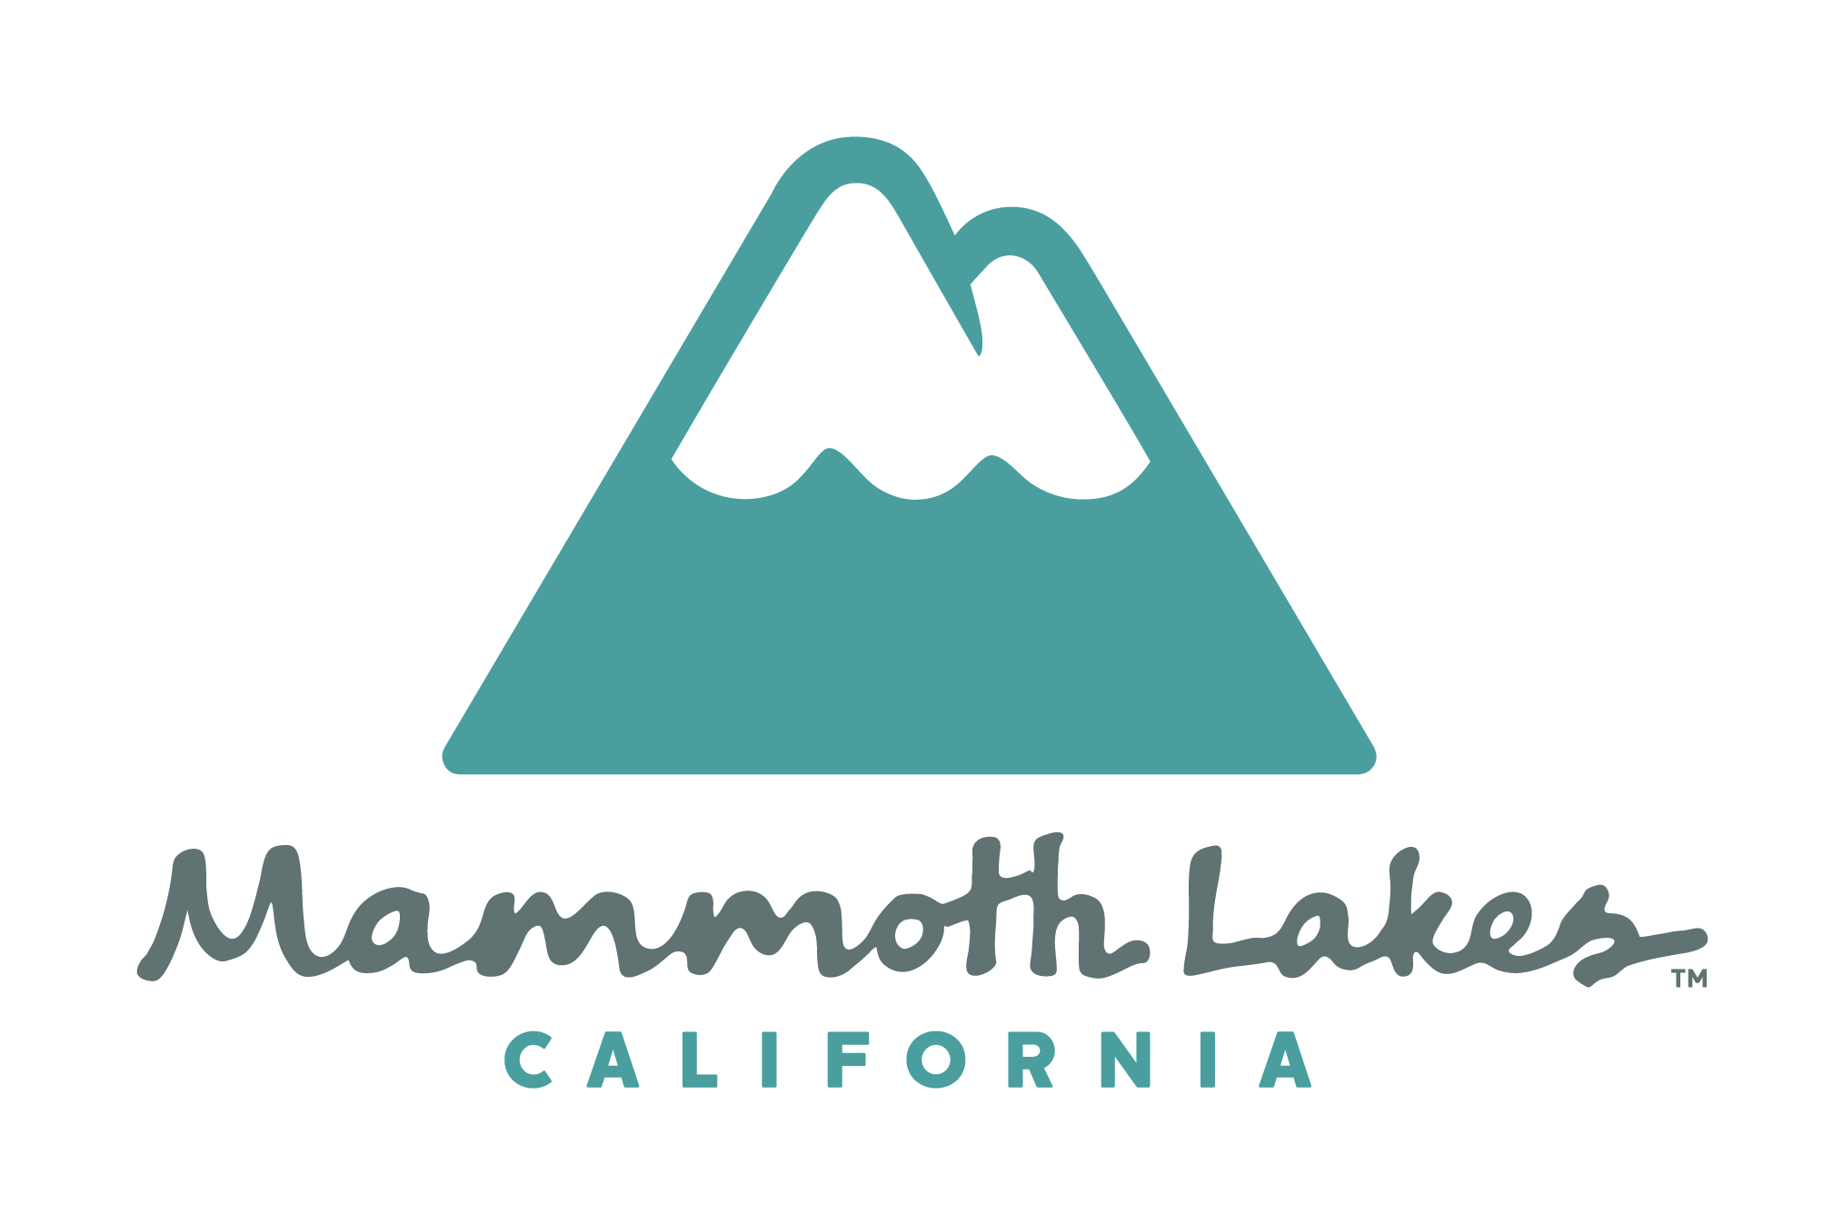
COMMUNITY AND ECONOMIC DEVELOPMENT

P.O. Box 1609, Mammoth Lakes, CA 93546
(760) 934-8989 fax (760) 934-8608
www.ci.mammoth-lakes.ca.us
_____________________________________________________________________________
Downtown Working Group
Meeting Agenda
February 12, 2013, 1PM, Town/County Conference Room

- Meeting Agenda and Purpose
- Agenda Review
- Meeting Purpose: Introduce Winter and Company and Main Street Work Program, including input and direction on items to be addressed related to physical and financial implementation, phasing and funding project components.
- Review 1-28-13 Meeting Notes

- Consultant Team Introductions
  - Martha Miller, Dyett and Bhatia
  - Nore Winter and Abe Barge: Winter and Company

- Recap Input from 1-28-13 DWG Meeting and Next Steps to Develop Draft Commercial Zones Chaper (Martha Miller)

- Main Street Implementation, Phasing and Funding (Winter & Company)
- Consultant Work Scope Overview

- Main Street Design Charrette April 2nd – 4th
    - Charette format, purpose and process
    - What do we need to do to prepare for the Charrette?
    - How would the DWG like to participate?

- Initial Input and Direction for Design Charette
- What We’ve Heard from the DWG
- Additional DWG Discussion, Comments and Key Items to be Addressed
  - Transportation and parking
  - Snow removal
  - Phasing and Financing

- Update on initial financial/market study & interview results (Andy Plescia)

- Next Steps/Meetings (proposed) BRING YOUR CALENDARS!!
  - Public Workshop: Tuesday, February 12, 5PM
  - Next DWG Meetings: Review of Commercial Zones Chapter
    - DWG initial review - TBD – Wed, March 6th?
    - DWG continued review – Use tables and building envelope recommendations TBD – Week of March 25th?
  - Main Street Design Charrette April 2nd - 4th (Winter & Company)
  - Joint Planning Commission/Town Council Workshop – TBD – Wed, April 17th

