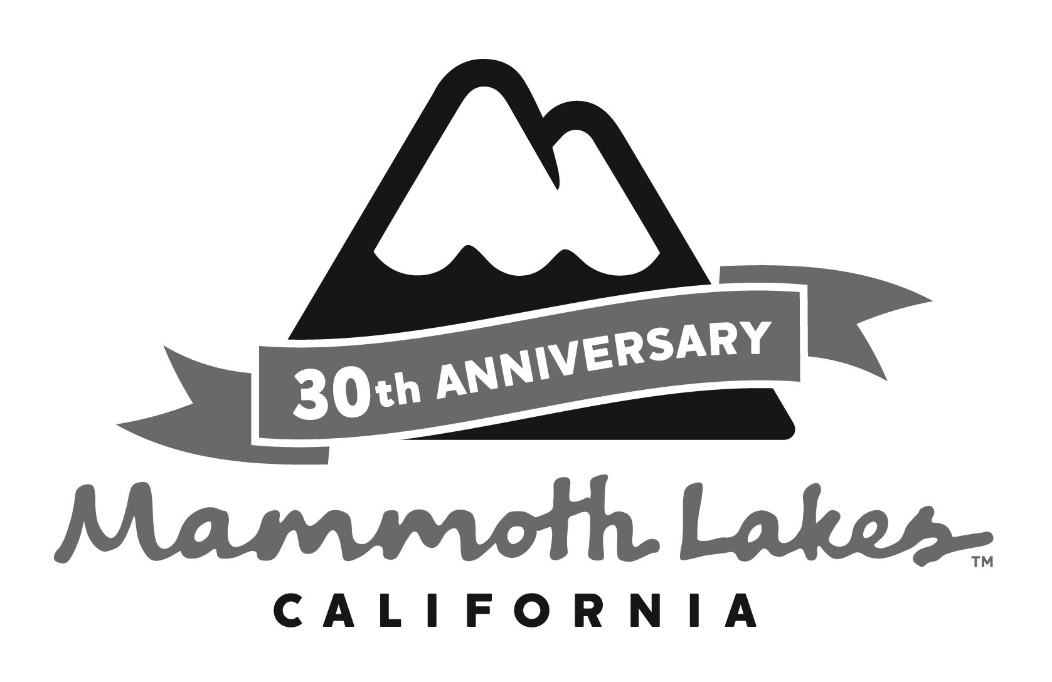
NOTICE OF AVAILABILITY OF A

DRAFT SUBSEQUENT ENVIRONMENTAL IMPACT REPORT (SEIR) FOR THE

INN AT THE VILLAGE

Date: July 8, 2014

To: Reviewing Agencies and Other Interested Parties

Subject: Notice of Availability of the Draft Subsequent Environmental Impact Report for the Inn at the Village

Project Applicant: Severy Realty Group

Draft SEIR Review Period: July 8, 2014 to August 22, 2014

Pursuant to the State of California Public Resources Code § 21166 and the “Guidelines for Implementation of the California Environmental Quality Act” as amended to date, as Lead Agency, the Town of Mammoth Lakes is circulating for public review a Draft Subsequent Environmental Impact Report (SEIR) for the proposed Inn at the Village (the project).

Project Title: Inn at the Village

Project Location: The project site is specifically located at 50 Canyon Boulevard, Mammoth Lakes, to the west of Minaret Road, north of Main Street/Lake Mary Road, and east of Canyon Boulevard.

Project Description: The project proposes a seven-story hotel that includes hotel rooms, food and beverage sales, spa, outdoor pool/jacuzzis, and landscaping elements. The hotel, totaling 64,750 gross square feet of buildable floor area, would consist of a maximum lodging room count of up to 67 rooms. The project would be built on top of the existing parking structure.

The project proposes to amend the approved 8050 project to address the current performance deficiencies in the existing 8050 project and the North Village area. The project would necessitate three amendments to the North Village Specific Plan (NVSP): (1) an increase in the allowable development density for the project site; (2) an increase in the allowable building height; and (3) a reduction in the required front yard setbacks along Minaret Road. The current application would supersede the approved 8050 project and seek entitlement/permitting for a proposed hotel (with the requisite market requirement to retain flexibility with respect to ownership structures [e.g., traditional hotel, condominium-hotel, etc.]).

The project-level environmental analysis tiers off of the Final Environmental Impact Report North Village Specific Plan (dated February 1991) (1991 PEIR), North Village Specific Plan Environmental Impact Report Addendum (dated May 1994) (1994 PEIR Addendum), and Subsequent Program Environmental Impact Report for the North Village 1999 Specific Plan Amendment (dated October 13, 2000) (1999 SPEIR), with subsequent addenda. A Modified Initial Study was prepared and circulated for a 30-day review period, from March 26, 2014 to April 24, 2014, with a scoping meeting on April 9, 2014. Based on the analysis in the Modified Initial Study and comment letters received in response to the Notice of Preparation (NOP), the Town has determined that the project could result in new or more significant impacts related to: Land Use and Relevant Planning, Aesthetics/Light and Glare, Traffic/Circulation, Noise, Air Quality, Greenhouse Gas Emissions, and Utilities and Service Systems. These issues have been analyzed in the Draft SEIR, which concludes that with implementation of regulations and recommended mitigation measures (as applicable), there would be no new significant and unavoidable impacts resulting from the project.

CEQA requires that this notice disclose whether any listed toxic sites are present at the project location. The project location does not contain a listed toxic site.

Notice of Availability: The Draft SEIR is available for a 45-day public review period beginning on Tuesday, July 8, 2014. All interested parties are invited to submit written comments on the Draft SEIR. Due to the time limits mandated by state law, comments on the Draft SEIR must be received from July 8, 2014 through August 22, 2014. Agencies should provide the name of a contact person with their response.

Copies of the Draft SEIR are available during the 45-day public review period at the following locations:

- Town of Mammoth Lakes, Community and Economic Development Department, 437 Old Mammoth Road, Suite R, Mammoth Lakes, CA 93546;
- Town of Mammoth Lakes website: http://www.townofmammothlakes.ca.gov/index.aspx?nid=542; and
- Mono County Library, 400 Sierra Park Road, Mammoth Lakes, CA 93546.

All comments and responses to this notice should be submitted in writing to: Jen Daugherty, Senior Planner, Town of Mammoth Lakes, Community and Economic Development Department, P.O. Box 1609, 437 Old Mammoth Road, Suite R, Mammoth Lakes, CA, 93546, 760.934.8989, ext. 260, or via email at jdaugherty@townofmammothlakes.ca.gov.

The Planning and Economic Development Commission of the Town of Mammoth Lakes will hold a public hearing to make a recommendation to the Town Council on the project. The Town Council will hold a public hearing to consider the project after the Planning and Economic Development Commission’s recommendation is made. The Planning and Economic Development Commission public hearing is preliminarily scheduled to take place on October 8, 2014. The Town Council public hearing will be scheduled after Planning and Economic Development Commission makes a recommendation; however, the Town Council hearing is preliminarily anticipated to be held on November 5, 2014. These public hearings will be held in the Town Council Chambers, Minaret Village Shopping Center, 437 Old Mammoth Road, Suite Z, Mammoth Lakes, CA 93546.

