nORTH vILLAGE sPECIFIC pLAN
2000

Adopted by the Town Council
December 2000
Amended January 19, 2005, May 21, 2008, OCTOBER 7, 2009, SEPTEMBER 17, 2014, AND month dAY, 2014
PUBLIC REVIEW DRAFT AMENDMENTS FOR
DZA 13-001 (INN AT THE VILLAGE)
sEPTEMBER 2014*
*Draft revisions are shown in redline/strikeout

TABLE OF CONTENTS:

Introduction Page 3
Existing Setting Page 7
Specific Plan Description Page 11
Specific Plan Elements Page 13
Land Use Element Page 14
Public Facilities Element Page 58
Transportation and Circulation Element Page 65
Housing Element Page 78
Conservation and Open Space Element Page 80
Safety Element Page 82
Noise Element Page 84
Parks and Recreation Element Page 85
Phasing Page 87
Project Implementation and Financing Page 89
Administrative Procedures Page 90

Appendix 1: Definitions Page 93
Appendix 2: Implementation Agreement Page 96
Appendix 3: Design Objectives and Guidelines for Mammoth Crossing Page 108

Exhibits
Exhibit A: North Village Specific Plan Zoning
Exhibit B: Existing Conditions
Exhibit C: Site Analysis
Exhibit D: North Village Conceptual Site Plan
Exhibit E: Pedestrian Core Conceptual Site Plan
Exhibit F: Pedestrian/Bike Circulation

INTRODUCTION

A Specific Plan is a planning document which establishes the type and pattern of land uses for a designated area which are more specific than those normally provided by either the General Plan or local zoning ordinances. A specific plan includes a text and a diagram or diagrams which specify all of the following in detail:
(1) The distribution, location, and extent of the uses of land, including open space, within the area covered by the plan.
(2) The proposed distribution, location, and extent and intensity of major components of public and private transportation, sewage, water, drainage, solid waste disposal, energy, and other essential facilities proposed to be located within the area covered by the plan and needed to support the land uses described in the plan.
(3) Standards and criteria by which development will proceed, and standards for the conservation, development, and utilization of natural resources, where applicable.
(4) A program of implementation measures including regulations, programs, public works projects, and financing measures necessary to carry out paragraphs (1), (2), and (3).

In addition, the Specific Plan includes a statement of the relationship of the Specific Plan to the General Plan because the Specific Plan must be in conformance with the General Plan. It replaces the existing zoning regulations and becomes the new “Zoning Ordinance” governing development of the properties within the Specific Plan area. The Specific Plan is a useful planning tool because it provides a detailed land development plan and zoning requirements which address site-specific conditions and constraints.
The primary purpose of the North Village Specific Plan is to provide new land use guidelines and development standards for the North Village area which will enable the development of a cohesive, pedestrian-oriented resort activity node, with supporting facilities, to create a year-round focus for visitor activity in the Town of Mammoth Lakes. The Specific Plan provides a mechanism for directing and focusing development in the project area and will contribute to the overall goal of positioning Mammoth Lakes as a year-round destination resort community.
NORTH VILLAGE SPECIFIC PLAN
RELATIONSHIP TO TOWN OF MAMMOTH LAKES GENERAL PLAN

The Town of Mammoth Lakes General Plan regulates development in Mammoth Lakes. Adopted in 1987, the General Plan contains the State-mandated elements which govern all development on private property, including residential, commercial, and industrial uses. The elements presented in the Mammoth Lakes General Plan are as follows:
Land Use (including Public Facilities)
Transportation and Circulation
Housing
Conservation and Open Space
Safety (including Seismic Safety) Noise
Parks and Recreation

Each element is described in terms of objectives and policies. “Objectives” are broad statements of a desired result, while “policies” define measures that can be followed to achieve the objectives. Actual implementation of the General Plan objectives and policies can be accomplished via several avenues; the most common of these being the regulations set forth in the Town zoning regulations. The Town of Mammoth Lakes General Plan identifies several broad goals that are reinforced by the objectives and policies of each of the General Plan elements. These general goals set the overall tone for development and land use in Mammoth Lakes. (Town of Mammoth Lakes General Plan, 1987, page 6.)
The purpose of the North Village Specific Plan is to provide a more refined description of land uses and development policies, which, while conforming to the overall development goals established in the General Plan, are oriented toward the ultimate goal of establishing North Village as a center for year-round resort activity. The North Village Specific Plan is comprised of the same elements identified in the Town General Plan. Objectives, policies, and implementation standards presented in the North Village Specific Plan, are oriented toward increased visitor uses and services and reflect the overall goals and policies established in the General Plan.
In order to demonstrate the North Village Specific Plan’s relationship to the General Plan, a brief description of the Specific Plan’s compliance with the nine overall goals of the General Plan is presented below.
1. “To provide for community development that is consistent with the community’s general health, safety, and welfare.” The North Village Specific Plan proposes land use and development policies which, when implemented, will enable the development of a concentrated resort-oriented center. Development policies and standards established in the plan address improvements to infrastructure, particularly roads, that will not only be helpful in accommodating the new development, but will also improve existing conditions. The development will create an active resort core which will add to the economic vitality and social richness of the community.
2. “To preserve and maintain the unique natural setting and mountain resort character of Mammoth Lakes while accommodating changing community needs and conditions.” The overall goal of the North Village project is to meet an identified community need by providing a concentrated center for visitor activity. This concentrated development is an improvement of a currently developed area. Development of the North Village area as a unified and centralized project will strengthen the mountain resort image and character of the community. Building heights are to be held generally below the existing tree canopy. Architectural and landscape detailing will conform to the regional mountain character of Mammoth Lakes.
3. “To preserve and maintain the natural environment and wildlife of the area.” The Specific Plan sets coverage and density restrictions similar to those established by the Town zoning regulations to ensure that some open space is preserved. The concentration of development in a primarily commercial area will relieve pressure for urban development in remaining open space areas in the Town. The coverage and massing of buildings will create open spaces and preserve view sheds throughout the development. Existing trees will be retained where possible and substantial new tree stands will be planted. By concentrating development on the existing private land base the project reduces the pressures for sprawl onto adjoining National Forest lands.
4. “To provide opportunities for economic growth and diversification.” An objective of the North Village Specific Plan is to define land use standards for the project area which will promote economic growth and urban development demanded by changing market conditions and the destination resort goal in the General Plan. The pedestrian orientation of North Village adds a shopping, recreational, and accommodations experience not now present in Mammoth Lakes. This diversity will benefit the entire community.
5. “To provide a wide range of housing, employment, and community facilities for the Town.” The North Village Specific Plan allows a wider range of accommodation units as well as new recreational and commercial facilities which will be available to both visitors and residents. Significant new employment opportunities will be created by the project. Although primarily oriented toward visitor and transient lodging, the North Village Specific Plan makes provisions for the development of permanent resident and employee housing.
6. “To provide a land use plan and policies that provide suitable types and intensities of land use.” The Specific Plan designates areas for commercial use, which are refined to reflect the visitor orientation of the project. Complimentary lodging facilities and housing opportunities are included to create a self-contained and integrated development with direct access to the mountain. This concentration of uses develops the critical mass essential for economic strength, social interaction, and support of mountain operations.
7. “To establish conservation and development policies for the wise management of the Town’s resources.” The North Village Specific Plan establishes standards for construction activities to protect the soil, water quality, and natural open space of the project area and surrounding lands. The option of using alternative energy sources such as solar and geothermal energy throughout North Village is provided. Scenic view corridors will be maintained and have been carefully laid out to achieve best solar orientation.
8. “To establish transportation policies that will promote the development of a comprehensive transportation system for the community.” Fundamental to the success of the North Village Development is the establishment of an integrated transportation system. The system will include improved street circulation, increased emphasis on public transportation, and development of a comprehensive pedestrian circulation system with connections to the town-wide trail system, bicycle paths, and bus stops, all in proximity to major destinations. North Village, by its concentration of uses and gondola, will be an attractive destination for transit system riders.
9. “To establish policies for the development of public services and facilities in accordance with the community’s need and the Town’s resources to provide for those needs.” The North Village Specific Plan addresses the construction of an improved system of infrastructure including a transit system, necessary to support the development area. The Plan responds to community needs by providing major public recreation facilities, public plazas capable of supporting social, cultural, and recreational events, and path, trail, and gondola connections to community-wide and mountain recreation corridors. The phasing of the project infrastructure improvements as well as potential financing to complete them is also addressed.

EXISTING SETTING

Regional Setting
The Town of Mammoth Lakes is located in the Eastern Sierra in the central portion of Mono County and is comprised of approximately 2,400 acres of private property surrounded by National Forest lands. Incorporated in 1984, Mammoth Lakes is the only incorporated town and the largest population center in Mono County. The Town balances the needs of approximately 5,000 permanent residents with providing services for weekend populations currently approaching 30,000 and ultimately expected to reach 52,000.
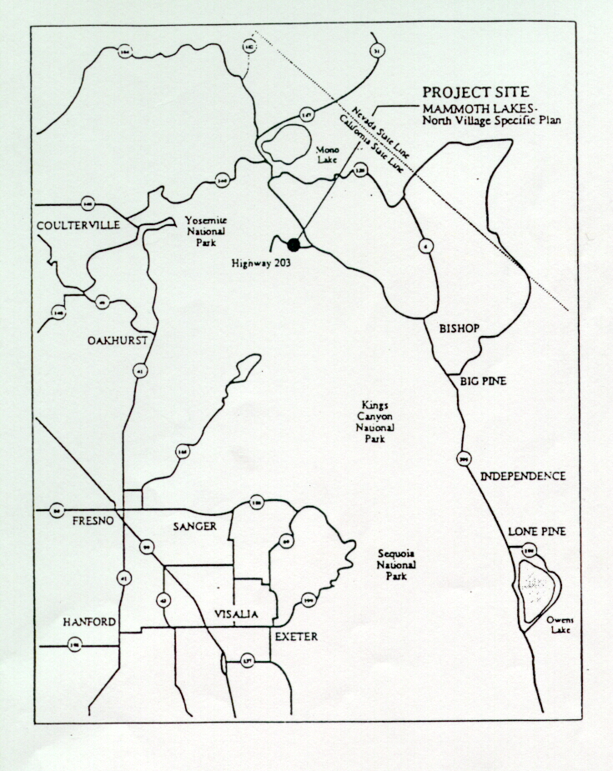

Access to the Town is provided by State Route 203, an east-west oriented highway, which meets U. S. Highway 395 approximately two miles east of Town. U. S. Highway 395 is the major north-south thoroughfare of the Eastern Sierra, providing access to both Reno and Los Angeles, 180 miles north and 300 miles south, respectively, of Mammoth Lakes.
Mammoth Lakes is known for its varied outdoor recreational opportunities, particularly the alpine skiing opportunities of Mammoth Mountain Ski Area (MMSA). Located immediately west of the Town on National Forest lands, MMSA offers over 3,500 acres of skiable terrain and draws over one million visitors to Mammoth Lakes each year, with a capacity of 24,000 skiers at one time (SAOT).
Mammoth Lakes and the Eastern Sierra are also well known for the many summer recreational opportunities offered by the vast acreage of the Inyo National Forest surrounding the Town. The Inyo National Forest, consisting of nearly two million acres in the Eastern Sierra, draws over two million visitors during the summer months.
In spite of its popularity and exceptional recreational opportunities, the Town of Mammoth Lakes exhibits a localized draw, with over 85 percent of its winter resort recreationists originating from within the State and the majority coming from Southern California. One of the shortcomings in Mammoth’s capacity for national or international visitor appeal is its lack of a destination resort amenities and resulting image. Currently, Mammoth is characterized by strip commercial development intermixed with budget to moderate level lodging facilities. There is no central focus or image to development in Mammoth, nor are there any full-service lodging facilities or recreational/activity centers; all of which are characteristic features of other major destination resorts.
Following the incorporation of Mammoth Lakes in 1984, Town officials and community leaders developed a Town General Plan to regulate land use and development. The General Plan was adopted in 1987, replacing the land use and development guidelines for Mammoth Lakes previously set forth in the General Plan for Mono County. A major goal established in the Town General Plan is to “provide opportunities for economic growth and diversification” and to direct future development toward unification of the Town and toward the ultimate establishment of Mammoth Lakes as a year-round destination resort. In 1992, a Town Vision Statement was adopted by the Town Council as part of the General Plan to communicate the desired image of Mammoth Lakes. The Vision Statement reaffirms the desire to become a unified destination resort community, with North Village as one of the primary resort centers in Mammoth Lakes.

North Village Specific Plan Area
The North Village Specific Plan Area is located in the northwest portion of the Town of Mammoth Lakes. As shown in Exhibit A - North Village Specific Plan Zoning, the Specific Plan Area consists of approximately 72 parcels, totaling approximately 64 acres. Exhibit A shows these as 41 separate sites, which are based on the parcelization of the Specific Plan Area at the time of its original adoption. Since the Specific Plan was adopted in 1991 some consolidation of ownership has occurred, but the majority of land remains under multiple ownerships. The Specific Plan Area is located adjacent to Main Street, Lake Mary Road and Minaret Road.
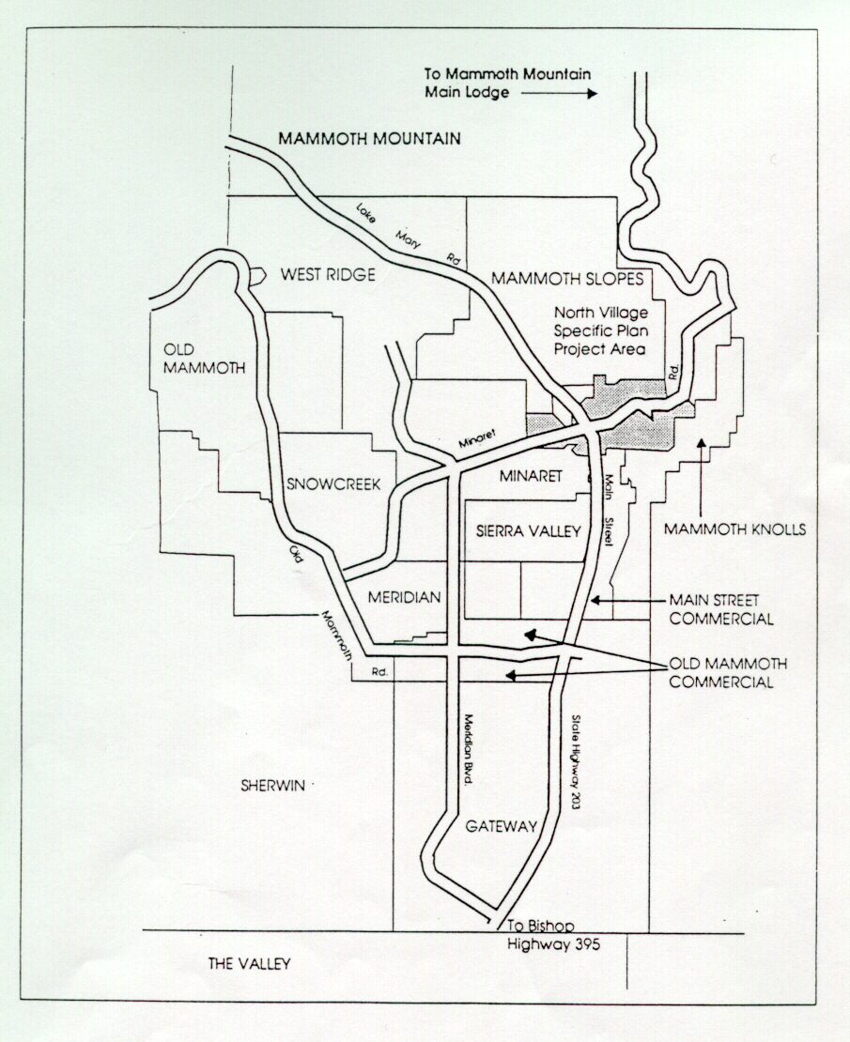
Under the previous Town of Mammoth Lakes zoning regulations, zoning of parcels within the North Village area was primarily Commercial Lodging (C-L) and Commercial General (C-G), with some of the fringe parcels zoned Residential Multiple Family-2 (RMF-2), and Residential Single Family (RSF).
Approximately 34 acres of the Specific Plan Area have already been substantially developed (as shown in Exhibit B - Existing Conditions). Existing land uses within the project area are varied and include hotels, restaurants, visitor-oriented and general commercial operations, professional and medical offices, condominiums, single family homes, and community facilities.
An analysis of existing land uses within the 64-acre North Village Specific Plan Area is included in Table 1. A solar analysis, existing vegetation analysis, and slope analysis of the properties within the Specific Plan area is shown in Exhibit C. Currently, the largest single component of land use, over 25 acres, in the Specific Plan Area is vacant land. Approximately 21 acres have already been developed for resort-oriented and supporting commercial uses compatible with those which are proposed for North Village, including the existing Village at Mammoth, which forms a pedestrian-oriented resort core. The remaining 13 acres currently support non-resort land uses which are considered less compatible with the ultimate development concept for North Village. It is planned that the vacant lands will ultimately be developed according to the Specific Plan standards and guidelines; existing compatible uses will be retained, renovated, or replaced and existing non-conforming uses will ultimately be replaced by conforming uses. The remaining approximately eight acres will remain in open space and public uses.

TABLE 1. EXISTING LAND USES IN NORTH VILLAGE
Land Use Acreage

Vacant 25.20
Commercial/Lodging 10.60
Restaurant 4.80
Resort Commercial .25
General Commercial 1.20
Non-Resort* 13.95
Open Space 3.00
Quasi-Public 5.10

Total 64.10 acres

*Non-resort uses include industrial uses, private home sites, and non-visitor oriented commercial operations such as office buildings.

SPECIFIC PLAN DESCRIPTION

Specific Plan Objectives
The objective of the North Village Specific Plan is to create a set of land use designations and development standards which will facilitate the development (or renovation) of “North Village” as a concentrated, pedestrian-oriented activity center with limited vehicular access. The North Village development will be oriented toward year-round uses and visitor activity, to strengthen the existing winter visitor market and to improve Mammoth’s attractiveness to spring, summer, and fall resort visitors. Unification of development throughout the Specific Plan Area through the establishment of architectural and landscaping guidelines will strengthen North Village’s image as a resort activity node in Mammoth Lakes.
The development plan for the Specific Plan area focuses on the creation of visitor services and attractions, while emphasizing pedestrian access and mobility. Parcels developed for non-lodging purposes will be oriented toward visitor commercial uses. Development densities and standards and the mix of permitted/conditional uses within each land use district will result in a variety of hotel, commercial, and residential uses
The North Village Specific Plan includes Conceptual Site Plans in Exhibits D, E and F. (Please reference Exhibit E and Figure 2 for detailed Conceptual Site Plan for the Mammoth Crossing Sites). These exhibits are intended to illustrate the contemplated development concept which meets the requirements and goals which are described in the Specific Plan’s text. They are not intended to preclude alternate creative development concepts and building designs which meet the goals and requirements described within the text.

Concept
The concept of the North Village development is to create a unique and attractive commercial center which will be of interest to local, regional, day, and destination visitors during all seasons of the year. The design emphasizes the creation of diverse shopping, recreational, residential and cultural opportunities which will appeal to all ages and family interests.
The Pedestrian Core area is intended to be a mixed-use village with commercial uses on the ground level and accommodation units on upper floors. The scale of the individual ground level shops will vary. The village commercial center should be perceived as a clustering of individual buildings which have grown over time. Building expressions are to be generally vertical rather than horizontal in form and should be carefully detailed to generate the scale and texture appropriate to pedestrian places. (See Exhibits D and E - North Village Conceptual Site Plan and Pedestrian Core Conceptual Site Plan). A guiding principle is that the Village should have the scale, complexity, and feeling of a small town that has grown over time. The arrangement of buildings will define the edges of the public plazas and serve as foreground buildings to larger scale lodges and hotels.
A major premise guiding the form of North Village is that the pedestrian system ultimately establishes the structure of the Village. As an example, the Conceptual Site Plans organizes buildings to create three major high-quality, auto-free pedestrian areas on either side of Minaret Road, and at Main Street/Lake Mary Road. Minaret Road in the center of the Village remains an important arterial for auto, transit, bicycle and pedestrian circulation. It also allows visibility of the commercial center, and as a dramatic view corridor for visitors as they pass through the Village and look south. (See Exhibit E - Pedestrian Core Conceptual Site Plan) Transitional mixed uses, including lodging and retail commercial and restaurant uses, at the intersection of Minaret and Main Street/Lake Mary Road provide a portal from Main Street to the North Village visitor core.
Surrounding the Pedestrian Core area are supporting accommodation and residential uses. Commercial uses within those outlying areas are limited to only those necessary to support the on-site lodging or residential units, or commercial uses within an existing developed commercial sites, existing as of October 1, 2014. In this way, the Village remains the focus of North Village shopping and cultural activities.
The style of the architecture and landscape will feature the materials and forms associated with the Sierra. The Development and Design Standards set forth in this Specific Plan and the Design Guidelines, as approved by the Planning Commission, describe the additional criteria for buildings and landscapes.

SPECIFIC PLAN ELEMENTS

The purpose of this section is to identify detailed objectives, policies, and implementation measures developed for the North Village area and to illustrate the project’s compliance with the seven elements of the Town of Mammoth Lakes General Plan. In order to facilitate easier evaluation of the project’s characteristics in relation to the Town General Plan, this chapter is formatted to parallel the seven elements of the 1987 Town General Plan. These are:
Land Use (including Public Facilities)
Transportation and Circulation
Housing
Conservation and Open Space
Safety (including Seismic Safety)
Noise
Parks and Recreation

Each element contains a list of objectives which generally describe the desired result for North Village planning and development. Following the objectives are policies and a program of implementation which may include regulations, development standards, required projects, phasing and financing.

LAND USE ELEMENT

The primary purpose of the Land Use Element is to define appropriate uses and development standards for lands within the North Village Specific Plan Area. The key objective of the North Village Specific Plan, and consequently the Land Use Element, is to enhance the Town’s image as a destination resort community, through the creation of a high profile, pedestrian oriented, resort activity center where lodging, restaurants, shopping, housing and recreational opportunities are located within proximity to one another and easily accessible by transit.
The critical factor, which dictates the level and scheduling of land development projects in North Village, is the availability of adequate infrastructure and/or public facilities needed to accommodate the proposed development. Significant improvements will be required for the area’s roads, sewer and water lines, electric, cable TV and telephone connections. With the exception of roads (discussed later in the Circulation Element), the Land Use Element addresses objectives, policies, and implementation standards for facilitating the desired development, infrastructure improvements and public facilities for the Specific Plan area.

Land Use Designations
There are six land use districts established for areas within North Village. Exhibit A - Zoning, indicates the site-specific land use designations for the individual parcels in North Village and in the Pedestrian Core overlay area. The overlay area covers all Plaza Resort parcels, Resort General parcels, and the Mammoth Crossing-designated parcels. The Pedestrian Core area establishes more detailed design objectives and standards to insure the viability of pedestrian orientation within North Village. Following are descriptions of each of the land use districts, their intent and expectations.

Plaza Resort (PR)

This designation has been applied to 12 existing sites totaling approximately 19.75 acres which comprise the central focus of the North Village Specific Plan Area. The Plaza Resort designation applies to areas within the Pedestrian Core Overlay area and establishes uses and development guidelines which are designed to support concentrated pedestrian oriented development. Allowable uses in the Plaza Resort district are oriented toward visitors and include full service and moderate level hotels, lodges, resort condominiums, specialty retail shops, restaurants, conference facilities, and public recreation facilities. Employee housing and residential uses are also permitted in this land use designation.

Mammoth Crossing (MC)

- This designation has been applied to nine properties, totaling approximately 9.3 acres, located at the northwest, southwest, and southeast corners of Minaret Road and Main Street, that are accessible to and easily connected to the Village at Mammoth by means of pedestrian connections. Each of these three corners is considered an individual site planning area, which together provide a range of short-stay accommodation choices, retail, entertainment, personal and community services, and some residential uses. The Mammoth Crossing district is intended to provide a complementary, pedestrian oriented node to the Village at Mammoth, that serves as a gateway and provides a sense of arrival for visitors to the North Village area. Allowable uses in the MC district include hotels, resort condominiums, specialty retail shops, restaurants, conference facilities, and public recreation facilities. Employee housing and residential uses are also permitted in this land use designation.

Resort General (RG)

This designation has been assigned to parcels adjacent to and easily accessible to the plaza, but still within the Pedestrian Core Overlay area. Resort General uses are also intended to provide visitor-oriented resort services, although with lesser intensity than PR parcels. The Resort General designation differs from the Plaza Resort designation in that retail uses are limited to multi-tenant complexes or within full-service hotels. Restaurants are generally the only freestanding uses permitted in the RG district. Allowable uses in the Resort General district include hotels, resort condominiums, restaurants, residential, and employee housing facilities. Four sites totaling 8.6 acres have been designated RG.

Specialty Lodging (SL)

This designation has been provided for parcels located on the periphery of the North Village Specific Plan Area which are physically separated by topography and integrated access from the Pedestrian Core Overlay area. Often these parcels are adjacent to existing residential developments zoned RMF-2 (Residential Multiple Family-2) or RSF (Residential Single Family). Although some flexibility through the use permit process is provided, this designation promotes land uses such as lodges, bed and breakfast establishments, resort condominiums, European-style inns, employee housing, various residential uses, and public facilities. Fifteen sites totaling 18.94 acres have been designated under this category.

Open Space (OS)

The Open Space designation is intended to provide permanent open spaces and to provide for the location and preservation of scenic areas and recreation areas. This classification is intended to apply to lands held under public ownership. One parcel administered by the United States Forest Service at the northeast corner of Forest Trail and Minaret Road is designated OS.

Public and Quasi-Public (PS)

The Public and Quasi-Public designation has been assigned to parcels which are reserved and developed for public uses other than street rights-of-way, to provide for the expansion of public facilities and to preserve areas of historic and community significance for the enjoyment of future generations. 5.1 acres has been designated PS which currently encompasses the Community Center, Mono County Library, outdoor play areas, tennis courts and parking.

Land Use Objectives

All new developments shall comply with the land use objectives, development objectives, policies, requirements and standards of this element.

Overall

1. To enhance the image of the Town of Mammoth Lakes as a destination resort by providing quality services, recreation elements and amenities comparable to other destination resort areas.
2. To establish the North Village area as a high-profile visitor activity core in the Town of Mammoth Lakes.
3. To create a pattern of land use designations and a system of standards for the North Village Specific Plan Area which will enable development of concentrated resort, support commercial and residential uses dependent upon a functional pedestrian circulation system. The central focus of the pedestrian system will be on the public plaza areas and the ski lift. The density granted to the Dempsey/Nevados site as a result of the Implementation Agreement, included as Appendix 2, is in addition to the Specific Plan maximum overall project density of 57 rooms per acre. The Implementation Agreement between the Town of Mammoth Lakes, Snowcreek Investments, LP and Minaret Investments, LP was agreed to and adopted by the Town on November 7, 2007.
4. To provide the necessary levels of services, facilities, and infrastructure as development occurs.
5. To provide for development which is planned as a unified and integrated resort area.
6. To provide for development which incorporates environmental sensitivity and sustainability into design features and amenities.
7. To allow land use densities and infrastructure which are consistent with the Town’s adopted air quality standards related to the reduction of vehicle miles traveled.
8. To avoid a “strip commercial” development which renders public transit and pedestrian facilities less effective.
9. To create a “critical mass” of commercial development which is supportable by the amount of hotel, resort condominium, and residential development and generates an appropriate level of pedestrian activity.
- To ensure an adequate supply of affordable housing is provided within the Town of Mammoth Lakes, at least half of the required affordable housing shall be located within the Specific Plan or Resort zones and the remainder may be located in any other zone, except RMF-1, Open Space, Airport, and Industrial.

Objectives specific to each land use designation are as follows.

Plaza Resort
1. To increase the commercial potential of the North Village Specific Plan Area through the creation of a pedestrian oriented core.
2. To provide resort oriented lodging and commercial facilities in a pedestrian setting.
3. To provide opportunities for visitors to take part in non-ski oriented activities.
4. To provide pedestrians a direct link to MMSA facilities through the construction of a lift and ski-return area.
- To provide appropriately sized public spaces to accommodate summertime activities, including festivals, concerts, art shows, etc.

Mammoth Crossing
1.To establish a sense of arrival to the visitor core through higher densities of development at the gateway intersection of Main Street/Lake Mary Road and Minaret Road.
- To provide a complementary pedestrian-oriented node that enhances the overall vitality and critical mass of lodging, retail, dining and entertainment uses.
- To provide a well-defined retail frontage with enticing shops and restaurants at ground level along Lake Mary Road, with high visibility from streets and pedestrian linkage corridors.
- To provide additional parking opportunities through on-street parking and convenient structured parking.
- To provide attractive public spaces that can serve as venues for visitor activities and events as well as pedestrian circulation .

Resort General
1. To provide resort accommodations and supporting commercial facilities for visitor-oriented activities and facilities.
2. To provide a transition zone between the Plaza Resort and Specialty Lodging uses within North Village and surrounding residential uses.
3. To provide integrated pedestrian access to and from the plazas.

Specialty Lodging
1. To provide a transition between North Village’s resort orientation and surrounding residential development.
2. To provide for special lodging opportunities which may not be available within the commercial orientation of the PR and RG districts in North Village.
3. To encourage development of employee housing and supporting residential facilities.
4. To lower development intensities for parcels located away from the Plaza Resort district and avoid future strip commercial development patterns.

Development Objectives
Development within all areas of North Village is intended to enhance the pedestrian experience. Designs and site plans shall achieve the following objectives.
1. small town appearance - buildings should be grouped to create a village-like atmosphere that provides a “small town” ambiance with building expressions that appear vertical, not horizontal.
2. sense of discovery - provide multiple walking routes that intrigue and invite
3. orientation to views - preserve views between and over buildings, across the valley, to Mammoth Mountain, to the Sherwin Mountains
4. emphasize sunlight - preserve sunlight in major pedestrian areas for much of the day; allow public plazas and shopping lanes to receive sunlight throughout the year for safety, snow removal and warmth
5. provide varied seating - create many ways to sit, rest, people-watch, relax
6. create special places, features - emphasize special buildings or places, such as the Gondola building, the pond, hotel entrances, the Gondola plaza, and others
7. encourage visual variety - allow colorful signs, banners, lights, interesting storefronts, individuality and attention focused at the pedestrian level
8. maintain landscape context - preserve as much of the existing landscape as practical; new landscaping should be appropriate to the local setting
- enhance the gateway experience - acknowledge Minaret Road as the spine of the North Village. From Minaret Road, the visitor can sense the life and vitality of North Village and experience the road as the gateway to Mammoth Mountain.

Within the Pedestrian Core areas, designs and site plans shall achieve the following objectives, in addition to the above:
1. develop varied public spaces - to accommodate a range of seasonal events, cultural and recreational programs
2. encourage street level activity - provide shops at road level on either side of Minaret and Lake Mary Road; bring pedestrian activity and human scale to the street. Allow views of storefronts and plaza areas.
- preserve views - allow gaps between shops permitting views of trees, landscape, and of inner pedestrian spaces. Maintain views from Minaret Road edges to the south.
4. facilitate easy pedestrian access - provide for safe and continuous pedestrian movements utilizing the skier bridge over Forest Trail, pedestrian crossing(s) mid-block on Minaret, and pedestrian crossings at the Main Street, Lake Mary Road, and Forest Trail intersections. Public places on each side of Minaret are connected by sidewalks, and paths for continuous pedestrian circulation within the pedestrian core and throughout North Village. These walks and pathways, along with the bicycle lanes on Minaret and Lake Mary Roads, connect to the community-wide trail and bikeway systems. Provide covered and uncovered bus drop off zones at the base of the gondola and along Minaret Road or to accommodate the transit system.
5. create an appropriate building scale - create mixed-use buildings with one to five levels to define the edges of the plazas and in scale with the public spaces. The Mammoth Crossing sites will include mixed-use buildings ranging in height from 25 to 80 feet plus appurtenances (see Table 4 and Figures 3, 4 and 5 in the development and Design Standards, Section 5) , designed to create a sense of arrival to the North Village. Each building should have an individual design personality and should create the scale and life appropriate to a small town.
6. locate higher density at edges of the pedestrian core - allow larger scale lodges, resort condominiums, and hotels at the outer edges of the Pedestrian Core, set in larger spaces, and in proximity to larger and more dense tree groupings to create a village atmosphere.
7. organize spaces around focal points - feature the gondola building and pond on the west side and the pedestrian plazas on the east in the Village Core. Each is to have distinctive architectural elements, such as towers, to convey their importance as major public destinations. At the Main/Lake Mary and Minaret intersection on the Mammoth Crossing sites, feature distinctive architecture and public plazas to create a sense of arrival and encourage pedestrian use.
8. develop distinctive character in public spaces - provide distinct differences in the plazas so that the visitor, while walking, will continually discover places varying in size, character and environment.

West side: The pedestrian plaza is higher than Minaret Road, yet connected to the road by landscaped stairs and large, sloped and stepped terraces and storefronts. The shops and/or landscaping within the Pedestrian Core screen the understructure parking facility. The gondola plaza is sized to accommodate the peak volumes of people using the gondola and has the capacity for large cultural events and shows. Perimeter terraces border the plaza providing places for sitting and outdoor dining, as well as planters featuring seasonal landscapes. The mountain pond adds a contrasting landscape environment and a relaxed recreation destination. The shopping lane connects to the pedestrian walk along Minaret Road and to the skier bridge over Forest Trail. The skier bridge provides direct access to the ski back trail linking North Village to existing ski area facilities.
East side: The plaza is virtually level with Minaret Road so shops and people activities have greater visibility from the road than those on the west. As many trees as practical are preserved at the perimeter of the development to frame the plaza. The east side plaza extends alongside Minaret Road to the south, past the Alpenhof, to a mixed-use complex on Lot 38, which, because of the magnificent views is an exciting southern terminus to the Pedestrian Core area.
Main/Lake Mary and Minaret at the Mammoth Crossing sites: The positioning of entry plazas, building massing, retail animation, and pedestrian linkage corridors will be placed to create a sense of arrival for the North Village while respecting the existing topography. The development must perform the dual roles of: 1) creating a true sense of arrival for the North Village, and 2) enhancing and invigorating the North Village as the vital and essential visitor experience.

Land Use Policies

Overall
- Development in the North Village Specific Plan Area shall reflect anticipated market needs and public demand by providing a variety of lodging, commercial, and recreational services. A large number of rooms will be available for transient occupancy.
- Site-specific development plans shall be sensitive to physical and environmental constraints as well as opportunities created by existing conditions.
3. High architectural standards shall be used throughout the North Village Specific Plan Area to create the desired image and promote cohesiveness among development.
4. Property owners shall be encouraged to consolidate properties for development to reduce land used for setbacks, minimize access points, reduce utility connections, create larger, more usable parcels of land which will allow for greater site flexibility, and provide for greater design continuity.
5. All development projects shall adhere to proper construction procedures concerning grading and revegetation.
6. Landscape plans shall be designed to promote continuity among landscaped areas throughout the project.
7. Building heights and setbacks for proposed development areas shall be coordinated to promote a varied skyline.
8. All development proposals within the Specific Plan area shall be subject to the mitigation measures and requirements included in the Final Subsequent Program Environmental Impact Report prepared for this project and in Environmental Impact Reports prepared for subsequent plan amendments.
9. North Village shall appear to be nestled within a forest, with native trees surrounding the pedestrian core and integrated into the development where practical. Building heights shall generally be held at or below the height of surrounding trees. The height standards will reflect this policy. The perimeter of North Village shall have a greater forested feel than the plaza areas due to the different land use objectives between the Specialty Lodging, Plaza Resort and Mammoth Crossing areas and the transitional nature between the programmed activity area and the surrounding residential community.
10. View corridors through North Village shall be protected by establishing building massing and setback requirements. Taller buildings shall be located where they will not block or impede important views of the surroundings from public spaces.
- Careful attention should be exercised in the design and detailing of the various storefronts along the pedestrian corridors. Building ornamentation, signs, materials, architectural detailing, outdoor use areas, etc. all must combine to create a rich tapestry of texture, color, and interest. Building frontages should be expressions of individual uses rather than bland homogeneity. Eating and dining activities should be allowed to take place in the public spaces. Plazas should be large enough to accommodate public events, yet feel friendly even when sparsely occupied. A public events program is expected to be developed to coordinate activities throughout the whole year among the Town, North Village homeowner or commercial association(s) and the other resort developments.
- Development of employee housing within North Village is encouraged.

Policies specific to each land use district are as follows.

Plaza Resort
1. Visitor-oriented commercial facilities shall be concentrated in the Plaza Resort district to facilitate easy access and encourage pedestrian activity.
2. A gondola shall be constructed to provide skiers and visitors direct access from North Village to MMSA’s facilities.
- A substantial number of the lodging facilities in the PR district shall be resort condominiums, hotels or multi-family lodging. Collectively, the lodging alternatives shall provide a full range of guest services.
- All parking associated with PR facilities, except for short-term parking and as otherwise provided in this Specific Plan shall be placed understructure or in freestanding structured garages.
5. Commercial development within the Plaza Resort district shall occur at a higher intensity than elsewhere throughout North Village to promote creation of a viable core for visitor activity. Ultimately, the amount of new retail commercial shall be based upon what is supportable by the ultimate build-out of the Resort zones and the North Village Specific Plan and not dependent upon an outside market.

Mammoth Crossing
- Visitor-oriented commercial facilities shall be developed in the Mammoth Crossing district to expand and complement those in the Plaza Resort district, and to contribute to the critical mass of such uses in the North Village as a whole.
- A range of lodging facilities shall be provided within the district, offering a range of short-stay accommodation choices. The various lodging facilities shall provide a complete range of guest services and amenities that enhance the overall visitor experience and draw visitors to the North Village.
- Pedestrian activity and alternative transportation shall be emphasized in project and site design, including incorporation of bike and pedestrian paths that link the Lake Mary Bike Path to the North Village visitor core, traffic calming strategies, bike lockers and racks, and transit stop(s) as needed. A variety of public pedestrian-oriented spaces shall be provided throughout the district.
- On-street and off-street public parking shall be provided to meet all the demands of proposed development within the district. Most parking shall be provided underground or understructure.
- Non hotel-related retail and entertainment retail uses within the MC district shall be sited so as to be located substantially at street level (elevation of retail frontages above the pedestrian way may be necessary due to topographic constraints), and facing the public right-of-way or internal pedestrian circulation routes and/or public plazas. Final design and siting of uses shall be determined in conjunction with future use permit(s).

- The operation of a hotel or condominium hotel (“hotel”) uses shall include the following services and amenities:
  - Reception area with 24-hour supervised front desk and key disbursement.
  - A central switchboard connecting to all units.
  - Space for rental management operations.
  - The hotel management entity shall have at least five years experience in the hotel management business and shall ensure that all portions of the condo-hotel are maintained and operated in accordance with a quality hotel standard.
  - If the units will be sold and not operated in total as a traditional hotel, those units which are sold shall befully furnished with standardized furniture, fixtures and equipment at the time of initial sale. Any condominium C,C&R’s should require maintenance of standardized interior design and furniture so that it is consistent with use as a short-term rental accommodation.
  - Daily housekeeping and linen service.
  - Ski and luggage storage.
  - Participation in any future Town central reservation and booking system.
  - An in-place reservation system.
  - Food and beverage operations on the site (restaurant or room service).
  - If provided, meeting/conference and/or performance facility, which shall include the following features:
    - Commercial food and beverage support and preparation area for public space. The size of this food support space shall be based upon the current industry standards for the size of the space to be serviced. These standards shall be provided by the applicant and agreed upon by the Town.
    - Divisible and flexible configuration, so that more than one function can be accommodated at the same time.
    - Pre-function space for registration area/reception area.
    - Current industry standards for audiovisual, internet and wireless infrastructure, and teleconferencing.
    - Cooperative booking and management with Town.
    - Available for rent for community use (when not otherwise booked) and designed to accommodate meetings and/or small performances.
    - On-site (or access anytime to) A/V equipment (LCD projectors, overheads, etc).
    - Complement or have the ability to be used in conjunction with outdoor plaza space, if available.
  - Concierge/Guest Services on-site (reservations for restaurants/activities).
  - Participation in joint marketing and promotional activities that include the Town’s current marketing, promotional and informational programs.
  - Participation in Destination Marketing Organization (membership and/or support).
  - Hotel-operated shuttle service.
  - Room configuration shall complement the proposed uses for the hotel.

- It is strongly preferred that meeting/conference space included in the Mammoth Crossing sites be consolidated to allow for at least one large conference facility of at least 9,000 square feet.

- The applicant for future project phases within the MC district shall use commercially reasonable efforts to efficiently use energy during project construction and operation, or as mandated by State or Town regulations. In addition, the project shall implement measures to reduce greenhouse gas emissions to the maximum extent feasible. Such strategies shall be reviewed and approved by the Town with each use permit and building permit.

- A story pole plan shall be submitted in conjunction with a use permit application for any of the three hotels or other significant new development on the Mammoth Crossing sites. The story pole plan shall be approved by the Town before it may be erected, and shall be used to inform the Town, Planning Commission, and public prior to and during the public hearing for the use permit.

- Each future development occurring on the Mammoth Crossing sites shall include such on-site and off-site improvements to facilitate pedestrian and bicycle connectivity and accessas may be demanded by the Town or specified in the Trails System Master Plan, Bikeway Master Plan, Pedestrian Master Plan, or Mobility Plan, as adopted at the time of Use Permit approval. Such improvements may include but are not limited to installation of sidewalks and/or Multi-Use Paths along public rights of way adjacent to the project sites; “mid-block” connectors that traverse a project site; connections to adjacent trail segments; and installation of street crosswalks or other facilities that permit safe pedestrian crossings. All facilities shall be designed to maximize safety and minimize conflicts between users. The detailed design of all pedestrian and bicycle facilities shall be determined and approved in conjunction with future use permit(s).

- Any future developer of properties within the MC district shall apply for annexation into the North Village Benefit Assessment District for maintenance of adjacent publicly owned facilities, at the time of Use Permit

- An offer of dedication or easement for a forty-foot road right-of-way that traverses Site 3 is a Condition of Approval associated with the Tanavista project (TTM 36-240, UPA 2006-08 & DZA 2006-02). The applicant or any future developer of properties shall collaborate to ensure that the dedication is provided to the Town.

Resort General
1. A variety of resort oriented lodging and limited commercial uses shall be developed in the RG district. Visitor lodging shall be primarily inns, resort condominiums, or specialty lodging, as opposed to motels.
2. Predominantly understructure parking shall be required.
- At least 50% of all commercial uses within a multi-tenant commercial development shall be devoted to restaurants.
- Convenient, safe pedestrian connections to the rest of the North Village area, transit facilities and ski lifts shall be provided.

Specialty Lodging
1. Development in this district shall be oriented toward visitor and resident lodging, resort condominiums, timeshare units or employee housing. Visitor lodging shall be inns or specialty hotels (i.e., European) as opposed to motels.
2. Development of parcels in this district strictly for commercial retail shall be prohibited to avoid strip commercial development and incompatibility with nearby residential uses.
3. Predominantly understructure parking shall be required.

Land Use Standards and Implementation Measures
All development within the Specific Plan boundaries shall be subject to the following requirements and standards and shall be in general conformance with Exhibits A, D, E and F. Except as specified herein, all requirements of the Mammoth Lakes Municipal Code shall apply.

Individual Site Requirements
Figure 1 on the following page indicates the specific locations (Planning Areas) for the following site-specific uses within the PR district and other sites within North Village. Figure 2 indicates the specific locations for site specific uses within the Mammoth Crossing (MC) district. The Individual Site Requirements are the desired expectations for development of each planning area. These expectations do not preclude uses permitted in the Land Use Table for each land use district. The exhibits are intended only to illustrate the contemplated development concept in the following areas.
Gondola Building/Skier Services area
Pedestrian Oriented Mixed Use area
Commercial/Retail Use area
Resort Lodging area
- Mammoth Crossing area
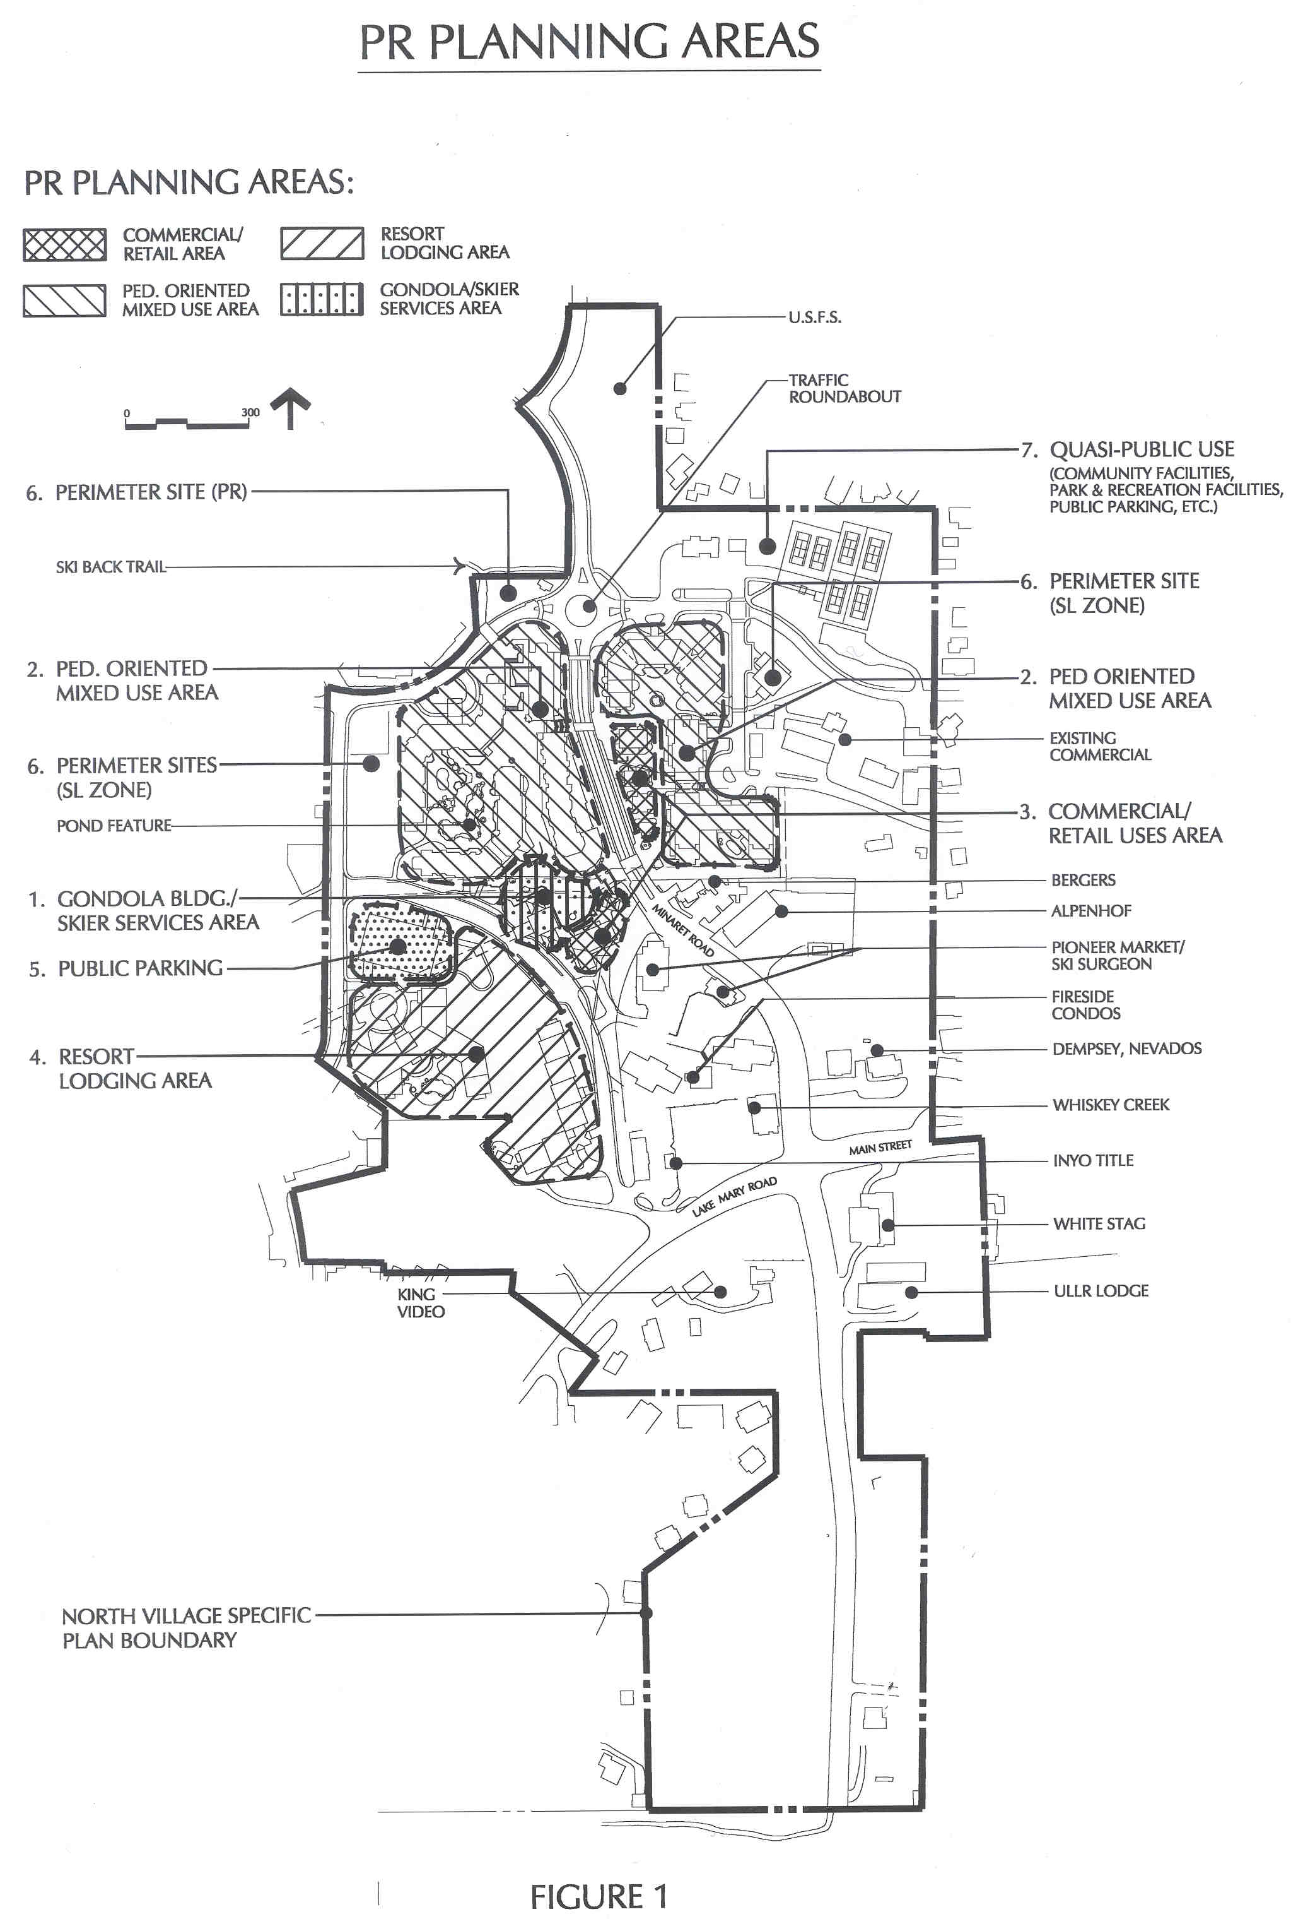

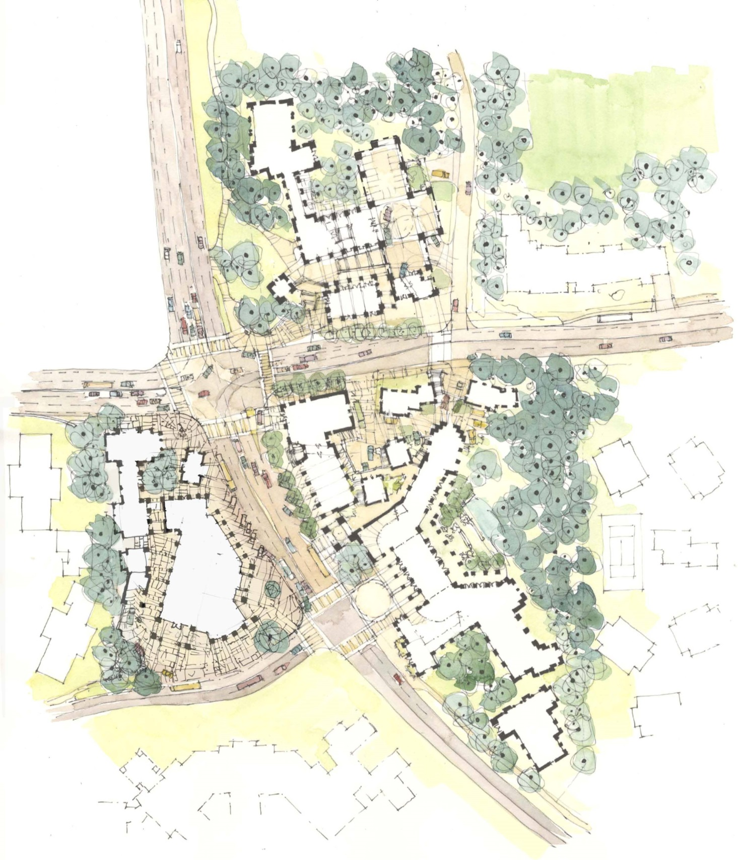
- The land use descriptions for the PR Planning Areas and for other site-specific uses within the Specific Plan Area are set forth below.
Site 2
Site 3
Site
1
FIGURE 2: MAMMOTH CROSSING CONCEPTUAL SITE PLAN
1. Gondola Building / Skier Services (PR) (see Figure 1, PR Planning Area 1) Included within the west-side plaza is the base of a planned ski lift which will transport skiers from the North Village area to the Canyon Lodge base facility. The lift is proposed to be a high-speed enclosed gondola with a capacity of approximately 2,500-3,000 skiers per hour. The gondola’s use will be oriented toward those skiers staying in accommodations in North Village or other facilities within walking distance of the lift or those accessing the facility by public and private transit. The gondola has been approved by Use Permit Application 90-3 which shall run with the life of the Specific Plan. The gondola building is a multi-level structure which houses the gondola, its mechanical systems, vertical circulation, skier services, ticketing, retail facilities, food & beverage facilities and other day lodge functions, including spaces for storage and servicing. The gondola building will be located immediately adjacent to the gondola plaza as well as the rerouted Canyon Boulevard next to a major public transit connection providing convenient lift access. The gondola building circulation and day-lodge function space is not counted as part of the overall project density calculations. Alternatively, to encourage a beneficial distribution of skier services within the Village and to provide flexibility to adjust to visitor preferences, the day lodge functions and services may be provided in multiple buildings, within the PR district If day lodge functions are provided in multiple buildings, they shall be considered commercial space and 20,000sf of commercial space shall be excluded from the calculation of density. Circulation space for the gondola, gondola service areas and public restrooms are excluded from density calculations.
2. Pedestrian Oriented Mixed-Use (PR) (See Figure 1, PR Planning Area 2) These buildings vary in height from one to six levels with retail/commercial uses at plaza and street levels, and residential accommodation units above. Accommodation units are permitted at street and plaza levels where suitably segregated from the main retail/commercial use areas. These buildings and retail uses play a very important role in defining and “activating” the adjacent pedestrian spaces and plazas. The pedestrian spaces and plazas are highly animated with activities, are designed with high quality finishes, and have landscaping which reintroduces the natural setting into the developed environment. Local interests and activities are found in this area which serves to bring residents and visitors together in a village environment. The design is integral to the success of the Village experience within the Pedestrian Core area.
- Commercial/Retail Use (PR) (See Figure 1, PR Planning Area 3) One to two story buildings with possible second level commercial uses or accommodation units. The buildings are kept low to avoid blockage of sunlight into plazas and adjacent pedestrian areas and to take advantage of the excellent views to the south. The retail buildings are also an important element in the activation of pedestrian areas within the village.
4. Resort Lodging (PR) (See Figure 1, PR Planning Area 4) These buildings vary in height from two to seven levels and are located on the hill area above the rerouted Canyon Boulevard. A major hotel, resort condominium, or lodge is encouraged. Because of their separation from the major pedestrian areas, these uses should not block sunlight or views. Staggered heights, changes in wall direction and elevations which step down the hillside are incorporated into building designs so that the building blends into the heavily treed site. Buildings located adjacent to Canyon Blvd. present varied setbacks to avoid a “tunnel” effect. Accessory commercial/restaurant facilities may be provided within the buildings.
5. Parking (PR) this site at the southeast corner of Canyon Boulevard and Hillside would include up to four levels of parking much of which would be buried below grade on the west and south sides. The parking facility would be available for commercial and events parking. Development of residential and/or community serving uses atop the structure are encouraged. Primary vehicular access would be from Canyon Blvd. A pedestrian bridge is desirable from the upper levels and connecting to the gondola plaza allowing users an aerial crossing of Canyon Blvd. At grade pedestrian crossings would also allow access to gondola plaza and other pedestrian oriented areas. Alternately and in lieu of its use for parking, this site may be incorporated into site 4 (above), except building heights shall be one to four levels.
6. Perimeter Sites (PR/SL, including Parcel 29) These sites are designated capable of accommodating buildings varying in height from one to three levels. The sites are in the SL district and in the PR district. These may be used for small lodges, condominiums, pensions, bed and breakfasts, resort condominiums, or housing and are transitional land uses to the adjacent neighborhood. Limited commercial/restaurant uses may also be provided within the buildings as prescribed by the appropriate land use district designations.
7. Quasi-Public Use This area includes the existing Town community center, library and park. It enjoys an excellent relationship to the proposed pedestrian oriented mixed-use areas directly across Forest Trail. Potential land use options here include community facilities, parks and recreational facilities, public parking facilities, employee /affordable housing, events, etc.
8. Alpenhof (Parcel 36 - (RG)) These parcels could retain their current use or could expand into a single larger size lodge or a series of smaller, separately operated lodges. Building heights would vary from one to four levels. Some accessory commercial/restaurant uses may be provided within the buildings. Stand-alone commercial/restaurant uses may be allowed only along the Minaret Road frontage.
9. Dempsey/Nevados (Parcel 38 (RG)) This parcel is an important part of the Pedestrian Core area. The development could consist of a mixture of accommodation units with some ground floor retail/commercial uses and a freestanding restaurant. Building heights would vary from one to five levels. This site is subject to an Implementation Agreement between the Town of Mammoth Lakes, Snowcreek Investments, LP, and Minaret Investments, LP which was adopted by the Town Council on November 7, 2007. The Implementation Agreement is incorporated into the North Village Specific Plan and is included as Appendix 2.
10.Berger’s Restaurant (Parcel 35 (PR)) Current use consists of a restaurant of approximately 2500 SF. This parcel can be integrated into the plaza design in its current form or it can be developed with other retail/commercial uses if parking is provided within a parking structure and the building is limited in height to two to three stories. I
11. Fireside Condos (Parcel 18 (RG)) - The Fireside Condominiums currently occupies this site. It contains 32 units and surface parking. The existing development can remain or it can be redeveloped to contain a mix of first floor commercial and restaurant with accommodation units above. Maximum building height would be 3 to 4 levels. Careful placement of any new or additional building mass is essential so as not to block views from plaza areas and Minaret Road.
12. 8050 Site (formerly Pioneer Market/Ski Surgeon) (Parcel 19 (RG)) - This parcel contains Phases A and B of the 8050 Private Residence Club, together with a parking garage, containing 136 stalls to serve Phases A, B, and C. Phases A and B consist of two resort lodging buildings containing a total of 28 units with 57 bedrooms, 3,335 square feet of commercial/restaurant space, a roof-top fitness/recreation room and jacuzzi terrace, and associated site and landscape improvements. Easy access to the Village plaza and gondola is provided through a skybridge.
a. The Inn at the Village (Area 19A (RG)) – This area is a portion of Parcel 19 (RG), which contains a portion of the undergrounding parking garage for Phases A, B, and C of the 8050 project. Formerly Phase C of the 8050 project, Area 19A is appropriate for visitor-oriented resort lodging and associated commercial uses in up to seven stories atop the existing parking garage podium. Allowed uses include hotel, inn, resort condominiums, spa, restaurant, and associated commercial uses. Careful placement of building mass is essential to take advantage of natural sun patterns, not increase public view blockage of the Sherwin Range than previously allowed, and avoid shading of pedestrian plaza areas.
13. Other Specialty Lodging Sites (Parcels 1, 2, 10-14 (SL)) - These parcels differ from the above listed sites in that they are not easily connected to the pedestrian core. Due to their distance from the plaza area they are less accessible by foot or vehicle to the plaza. As such, each parcel is developed as a stand-alone use. Allowed uses include hotels, resort condominiums, inns, bed and breakfasts, housing and other residential uses. Commercial and restaurant uses are only permitted within these uses solely to provide service for their guests. Residential uses are encouraged which contribute to the employee-housing base or are available for short-term rentals. Potential private access easements may be effectuated between parcels 14 and 15 to allow access to the plaza. Similar in all respects to Planning Area 4, Figure 1, Parcel 14 is located on a hill above the rerouted Canyon Blvd. This site is the most visible as North Village is approached on Main Street and thus will make a signature statement for the Village. Allowed uses include hotels, resort condominiums, inns, lodging, housing and other residential uses. Accessory commercial/restaurant facilities may be provided within the buildings.
14. Mammoth Crossing Site 1 (Parcel 16 & 17 (MC) See Figure 2, MC Planning Area 1) - Site 1 (1.7939 acres) may include an entry plaza linked to a major pedestrian thoroughfare traversing diagonally through the site lined with shops and restaurants, public art and accommodation entries. Allowable land uses include hotel, commercial retail, entertainment, child care, personal services, and public plaza. Notable site features may include a major public plaza with public art at the southeast corner, pedestrian walkway/corridor with public art, landmark towers, major pedestrian corridor connectivity, on-street parking on Lake Mary Road, retail animation of Lake Mary Road, transit stops and alternative transportation facilities, as well as significant underground parking. A pedestrian thoroughfare links to the existing Village at Mammoth and Gondola building.
15. Mammoth Crossing Site 2 (Parcel 3, 4, 5 plus (MC) See Figure 2, MC Planning Area 2) - Site 2 (4.5205 acres) may feature a large luxury brand hotel, select residential, and Lake Mary Road fronting commercial shops. Commercial shops may include a specialty market offering gourmet groceries and spirits. With the exception of small scale on-street parking for the Lake Mary shops and restaurants, the site will include all underground parking. Site 2 Planning Area’s notable site features may includemajor pedestrian corridor connectivity with public art, retail animation for Lake Mary Road.

16. Mammoth Crossing Site 3- (Parcel 6, 7, 8, 9 (MC) See Figure 2, MC Planning Area 3) - Site 3 (2.9629 acres) may include a hotel capable of accommodating tours and larger groups. Meeting space and an ancillary restaurant could be accommodated on this site. This site provides pedestrian and bicycle linkage from the eastern golf course Lodestar area and Main Street town core to the Mammoth Crossing sites and North Village. The site may include underground parking with a portion of the parking dedicated to public parking if the site is constructed at the upper end of permitted density (this public parking may also be located within sites 14 or 15).

Development and Design Standards

The following are general development and Design Standards, which shall be incorporated into new building projects. These standards shall apply to all property within North Village. Specific Design Guidelines shall be prepared by North Village property owners and approved by the Planning Commission, to address design issues such as, storefronts, lighting, signage, street furnishings, landscaping, etc., or to refine the general Design Standards contained herein. Specific Design Guidelines may apply to the entire North Village area or may be applicable to only a particular area, such as the PR district, the Pedestrian Core areas, RG district, etc. In the event of a conflict between the specific Design Guidelines approved by the Planning Commission and the general Design Standards, the specific Design Guidelines shall govern, except that specific Design Guidelines shall not supersede the requirements of Section 1(Land Use) through Section 8 (Minimum Parcel Size).

1. Land Uses

Land uses within the Plaza Resort, Resort General and Specialty Lodging districts are permitted as outlined in Table 2. All uses are subject to the Administrative Procedures of the Specific Plan.

TABLE 2: LAND USE MATRIX
X = Permitted Use A = Administrative Permit
O = Subject to Use Permit

 | PR | MC | RG | SL | OS | PS
A. Office and Related Uses
- Administrative,Clerical, And  Professional Offices | X | X | O
2. Financial Institutions | X | X | O
3. Medical, dental and related human  services | O | O
4. Telegraph/postal service offices | X | X | X
B. General Commercial Uses
1. Amusement, arcades, billiards, other indoor recreation uses | X | A | O
2. Automobile rental agency | X | A | O
3. Bakeries, retail | X | X | X
4. Barber and beauty shops | X | X | X
5. Bicycle and moped rental, sales  and service | X | A | O
6. Catering establishments | X | O | O
7. Cocktail lounges and bars | X | X | X
8. Delicatessen | X | X | X
9. Drug stores and pharmacies | X | X | O
10. Hotels, resort condominiums  and inns | X | O | X | X
11. Liquor stores | X | A
12. Night clubs | X | O | O
13. Recreational facilities,  commercial or public,outdoor | X | X | O | O | O | O
14. Restaurants, bars, night clubs  within hotels | X | X | X | X
15. Restaurants | X | X | X | ²
16. Retail | X | O¹ | O | ²
17. Accessory commercial uses  within a hotel | X | X | X | X
18. Bed and Breakfast inns | X | O | X | X
19. Services (e.g. laundromat,  copying) | X | X | X | ²
20. Freestanding Parking Structures | A | A | A | A |  | O
C. Public and Quasi-Public
1. Day nurseries and nursery schools | X | O | O | O |  | O
2. Libraries and museums, public or  private | X | X | O | O | O | O
3. Parks, public or private | X | X | X | X | O | O
4. Post office branch | O | O | O
5. Governmental offices and facilities | X | O | O | O |  | O
6. Convention and meeting facilities  within or adjacent to lodging facilities | X | X | X | O |  | O
7. Ski area development | X | O |  | O | O | O
8. Events Arena | O | O | O | O |  | O
9. Freestanding Parking Structures | A | A | A | A |  | O
D. Housing
1. Employee housing,  affordable housing, apartments,  condominiums, other housing | X | O | X | X |  | O
1. Use permit shall be required for any stand alone retail development within the Mammoth Crossing zone; i.e. that is not developed as part of or integrated into a larger mixed use development. Establishment of new retail uses within existing commercial spaces shall not be subject to a use permit.
2. Stand alone retail, restaurants, or service-type uses within the Specialty Lodging zone (i.e., that are not developed as part of or integrated into a larger mixed use development) shall be not permitted, except for retail, restaurant, or service-type uses within existing developed commercial spaces, exsiting as of October 1, 2014. New restaurants, retail, or service-type uses within an existing developed commercial space, exsiting as of October 1, 2014, shall be subject to all other development standards of the North Village Specific Plan.

2. Density
a. Density calculations for each development area shall be based on total land ownership prior to road realignment and encroachments by adjacent roads and rights-of-way. For development parcels adjacent to roads, which are proposed for realignment, closure, or abandonment, the developer must apply to the Town of Mammoth Lakes for vacation of right-of-way.
b. Maximum density for parcels within each land use district shall be as follows:
PR - 80 rooms per acre
MC – Maximum density for each site shall be as specified below, not to exceed an aggregate density of 80 rooms per acre for the entire MC district
- 110 rooms per acre for Site 1
    - 81 rooms per acre for Site 2
    - 61 rooms per acre for Site 3
Within the MC District, any award of density above the base of 48 rooms per acre shall be subject to the Community Benefits/Incentive Zoning Policy adopted in August 2009 or as subsequently amended. Implementation of the community benefits/incentive zoning policy shall include consideration of connectivity and infrastructure needs and issues associated with increased density and height.
RG - 55 rooms per acre, not to exceed an aggregate density of 48 rooms per acre for the entire RG district, with the exception of: (i) the Dempsey/Nevados (Parcel 38) site, which has a total density of 198.25 rooms as a result of the assignment of 73.25 rooms of additional density per the Implementation Agreement (Appendix 2); and (ii) the 8050 Site (Parcel 19), which shall have a maximum density of 72 rooms per acre if Site 1 or Site 3 within the Mammoth Crossing projects tranfers 30 rooms of its available density to Area 19A within Parcel 19 through a density transfer covenant recorded on title of the properties involved in the density transfer.
SL - 48 rooms per acre
Density bonuses for inclusion of affordable housing shall be in accordance with the provisions of the Municipal Code.
c. For purposes of development area calculations, the following density conversions shall apply throughout North Village.

1 “room” equals any of the following types of development:
- 1 hotel room
- 1 bedroom, loft or other sleeping area in residential uses
- 450 square feet of commercial or restaurant space

- Commercial or restaurant space within a hotel serving only the guests of that hotel, commercial space ancillary to property management of North Village, space within an events arena, space required for gondola building circulation and base lodge services and functions (up to 20,000 square feet), and uses within the Open Space and Public and Quasi-public districts are excluded from density calculations.

- * Commercial and restaurant space within the Mammoth Crossing projects and within Area 19A of the 8050 Site (Parcel 19) is exempt from this limitation. Commercial and restaurant space shall not be counted towards density within the Mammoth Crossing projects and Area 19A only.

d. Density exchanges among parcels may be permitted if all of the following occur:
i. Density exchanges may only occur between parcels within the same district except as follows:
- Where parcels with different land use designations are merged to accommodate a building that crosses the original designation boundary, density may be combined such that the total density of the new parcel is equal to the sum of the densities for each parcel prior to the merger.
- Densities for the SL parcels 39, 22, 41 and the SL portions of parcels 21 and 28 may be transferred to the PR district.
- Density from the ski-back trail Parcel “A” may be transferred to other PR parcels
- Density from the Mammoth Crossings projects, up to a total of 30 rooms, may be transferred to Parcel 19 for use in connection with the development of the Inn at the Village project (Area 19A of Parcel 19). This density transfer shall be implemented through a density transfer covenant recorded on title of the properties involved in the density transfer.

ii. Density and uses may be transferred among the three MC sites, provided that aggregate density is maintained at or below the maximum of 80 rpa, that requirements of the Community Benefits/Incentive Zoning policies are met, and that all development and design standards are maintained, including adherence to maximum height standards and massing as shown in Figures 3-5. No density may be transferred from Sites 2 or 3 to Site 1. Any density transfer shall be subject to review for conformance with the CEQA analysis for the Mammoth Crossing sites and, if applicable, the CEQA analysis for the Inn at the Village site (Area 19A of Parcel 19).

iii. Density exchanges may permit greater density per acre on one parcel subject to a commensurate reduction in density on the other parcel when all other development requirements can be met.
iv. The density exchange accomplishes at least one of the following: 1) concentrates retail and accommodation uses adjacent to a major public plaza, 2) accommodates the location of public facilities including public parking structures, and 3) protects sensitive environmental areas, such as view corridors, vegetation, or steep slopes.
v. A request for a density exchange shall be subject to the approval of the Community and Economic Development Director.

e. An approved density exchange shall be executed by one of the following instruments:
i. Lot line adjustment to match permitted density
ii. Deed restrictions recorded against the properties with the Town as a party to the release of the restriction

TABLE 3. DENSITY SUMMARY*
Land Use Designation | Size | Maximum  Density | Total Rooms | S.F. | S.F. Com/Ret  (Rm. Eq.) | Estimated  Accom Rms
Plaza Resort | 19.75 ac. | 80 rms/ac | 1,580 | 85,000 | (189) | 1,391
Mammoth Crossing | 9.27 ac. | 80 rms/ac*** | 742 | 40,500** | 0** | 742
Resort General | 8.60 ac. | 48 rms/ ac**** | 413 | 50,000** | (111)** | 302
Spec. Lodging | 18.37 ac. | 48 rms/ac | 882 | 0 | 0 | 882
Other (P, QP, OS) | 8.10 ac. | 0 | 0 | 0 | 0 | 0
Overall Total | 64.10 ac. | 57 rms/ac | 3,617 | 135,000 | (300) | 3,317

* Table 3 does not include the rooms that have been granted by the Town of Mammoth Lakes to the Dempsey/Nevados (Parcel 38) site as a result of the Implementation Agreement, which is included as Appendix 2, because the 73.25 rooms shall not be included in the calculation of aggregate density within the Resort General designation. The Dempsey/Nevados site has a total density of 198.25 rooms, which includes 73.25 rooms that are as a result of the Implementation Agreement, and which are in addition to the Specific Plan maximum overall project density of 57 rooms per acre as calculated in Table 3.
** Commercial and restaurant space shall not be counted towards density within the Mammoth Crossing project and within Area 19A of Parcel 19 (RG designation); this provision is applicable to the Mammoth Crossing district and Area 19A of Parcel 19 only.
- *** Density above the base of 48 rooms per acre for Mammoth Crossing, up to 80 rooms/acre may only be achieved subject to Community Benefits/Incentive Zoning policy (see 2b above).
**** Density above 55 rooms per acre for Parcel 19, up to 72 rooms per acre, may only be achieved if a density transfer of 30 rooms from Site 1 or Site 3 within the Mammoth Crossing projects to Area 19A of Parcel 19 is implemented through a density transfer covenant recorded on title of the properties involved in the density transfer. Table 3 does not include these 30 rooms because they shall not be included in the calculation of aggregate density within the Resort General designation.

3. Site Coverage

a. Maximum site coverage including all buildings and paved or otherwise developed impervious surfaces for each development area shall be as follows:

PR district - 75%*
MC district – Site 1: 70%
Site 2: 60%
- Site 3: 60%
RG district - 70%**
SL district - 60%
*Average coverage for the entire PR district shall not exceed 75%. However, where necessary, site coverage on an individual parcel may exceed 75% provided that a commensurate reduction is made on other PR properties (via cooperative agreements between owners recorded against properties affected with Town as a party to the agreement). Commensurate reductions in site coverage may also be made on SL lots 22, 39, and 41 and on the SL portions of lots 21 and 28 if required to offset increased site coverage on PR parcels. Site coverage transfers shall be subject to the approval of the Community Development Director.
**Dempsey/Nevados (Parcel 38) is permitted a maximum site coverage of 75% per the adjustments granted through the Implementation Agreement (Appendix 2). No additional adjustments to Parcel 38 are authorized.

b. Lots 20 and 32 may have 100% lot coverage due to their landlocked nature within the district, when integrated into the plaza.
c. Landscape planting areas of at least 50 square feet created on top of a parking structure shall not be included as part of the impervious surface area.

4. Building Area

a. Throughout North Village, the maximum building floor area for all developments shall be 87,000 square feet per acre (excluding structured parking) in the districts designated PR and RG and 75,000 square feet for the SL district. The MC district shall have a maximum building floor area (excluding structured parking) of 87,000 square feet per acre on Site 1, and 75,000 square feet per acre on Sites 2 and 3. All developments must also conform to the site coverage and building height requirements.

5. Building Heights

- Figure 1 shows four specific locations (PR Planning Areas) within the PR district, and three locations (Mammoth Crossing Planning Areas) within the MC district. Within these four Planning Areas, building heights shall comply with the heights as shown on Table 4 below and the designated land use locations as referenced in Figures 1 through 5.
- Developments outside the Pedestrian Core need only comply with the height table below.
- For buildings that cross a land use district boundary after merging parcels, the highest permitted and projected heights shall apply to the entire building, providing the majority of building area is within the most liberal district, subject to design review considerations as applied through the design review process.
d. Building heights shall be measured vertically from natural grade when the building does not sit above a parking garage. When all or a portion of a building sits above a parking garage, or when buildings front on the plaza in the PR district, building height shall be measured from the garage roof elevation or plaza elevation at the perimeter of the building.
e. The plaza and parking garages shall be no more than 20 feet above natural grade at any point and shall be stepped, faced with storefronts or similarly treated to diminish the exposed height. A freestanding parking garage shall have a maximum building face height of 35 feet, with projections permitted up to 15 feet, subject to the Design Review process.
- All buildings shall be measured to the building roof ridgeline of any section of roof. Roof appurtenances may project above the Projected Height up to 3 feet subject to Planning Commission approval.
- In Resort General and Specialty Lodging areas when a substantial number of affordable housing units is provided within a proposed development, a one floor increase (maximum 12 feet in height and equivalent in area to the number of affordable units provided) in building height may be permitted if all other development standards are met (particularly in relation to shading, solar access and view corridors), subject to the approval of the Planning Commission.
- A single tower feature on the plaza on both the west and east side of the north part of the Pedestrian Core may exceed the maximum projected height and shall not be required to be balanced by a roughly equivalent reduction in building height, subject to approval through the Design Review process.
- Building heights for the Inn at the Village site (Area 19A) shall not exceed 80 feet, plus four feet and six inches for roof appurtenances.

TABLE 4. BUILDING HEIGHTS
Maximum Maximum
Land Use Area Building Levels Permitted Ht.* Projected Ht.*

PR Planning Areas( Figure 1)
-Commercial /Retail Areas 1-2 25’ 35’
-Gondola Building/ Skier Service 1-3 50’ 85’
-Mixed Use Area 1-5 60’ 80’
-Resort Lodging Area 1-7 75’ 90’
-Plaza Resort area 1-4 50’ 80’
(excluding PR Planning Areas)

RG-Resort General area 1-4 40’ 50’
-Dempsey/Nevados (Parcel 38)** 1-5 56’ 67’
-Inn at the Village (Area 19A)*** 1-7 80’ 84’6”

SL-Specialty Lodging area 1-4 40’ 50’

Mammoth Crossing Sites
Maximum permitted building heights for Mammoth Crossing Sites 1, 2 and 3, and areas of each site that may be developed at each height shall shall be as specified in Figures 3, 4 and 5. Maximum heights are “up to” amounts above those allowed for the RG zone (Site 1) and SL zones (Sites 2 and 3) (i.e. 40 Feet Maximum permitted height and 50 Feet maximum projected height) which shall be considered as the “base”, granted subject to project specific review and approval. Number of building levels may vary within these maximum heights, depending on building design and configuration. Maximum building heights shown in Figures 3, 4 and 5 may be increased by a maximum of ten feet, subject to the approval of the Planning Commission and Town Council, where it would result in a building of higher architectural quality than may be achieved at the lower maximum height. Peer-reviewed computer and physical modeling of such proposals shall be provided to demonstrate proposed building design.

* Building projections above the permitted height may be allowed, provided that a roughly equivalent reduction in the building footprint area above the height is provided below the permitted height and no more than 50% of the building square footage exceeds the permitted height.
** Pursuant to the Implementation Agreement (Appendix 2), the maximum height for the Dempsey/Nevados parcel includes all permissible adjustments and no additional height adjustment is permitted.
*** The maximum permitted height for the Inn at the Village site (Area 19A) shall be 80 feet, when measured from the top of the existing parking garage podium. The maximum projected height for Area 19A shall be 84 feet, 6 inches including roof appurtenances, when measured from the top of the exising parking garage podium.

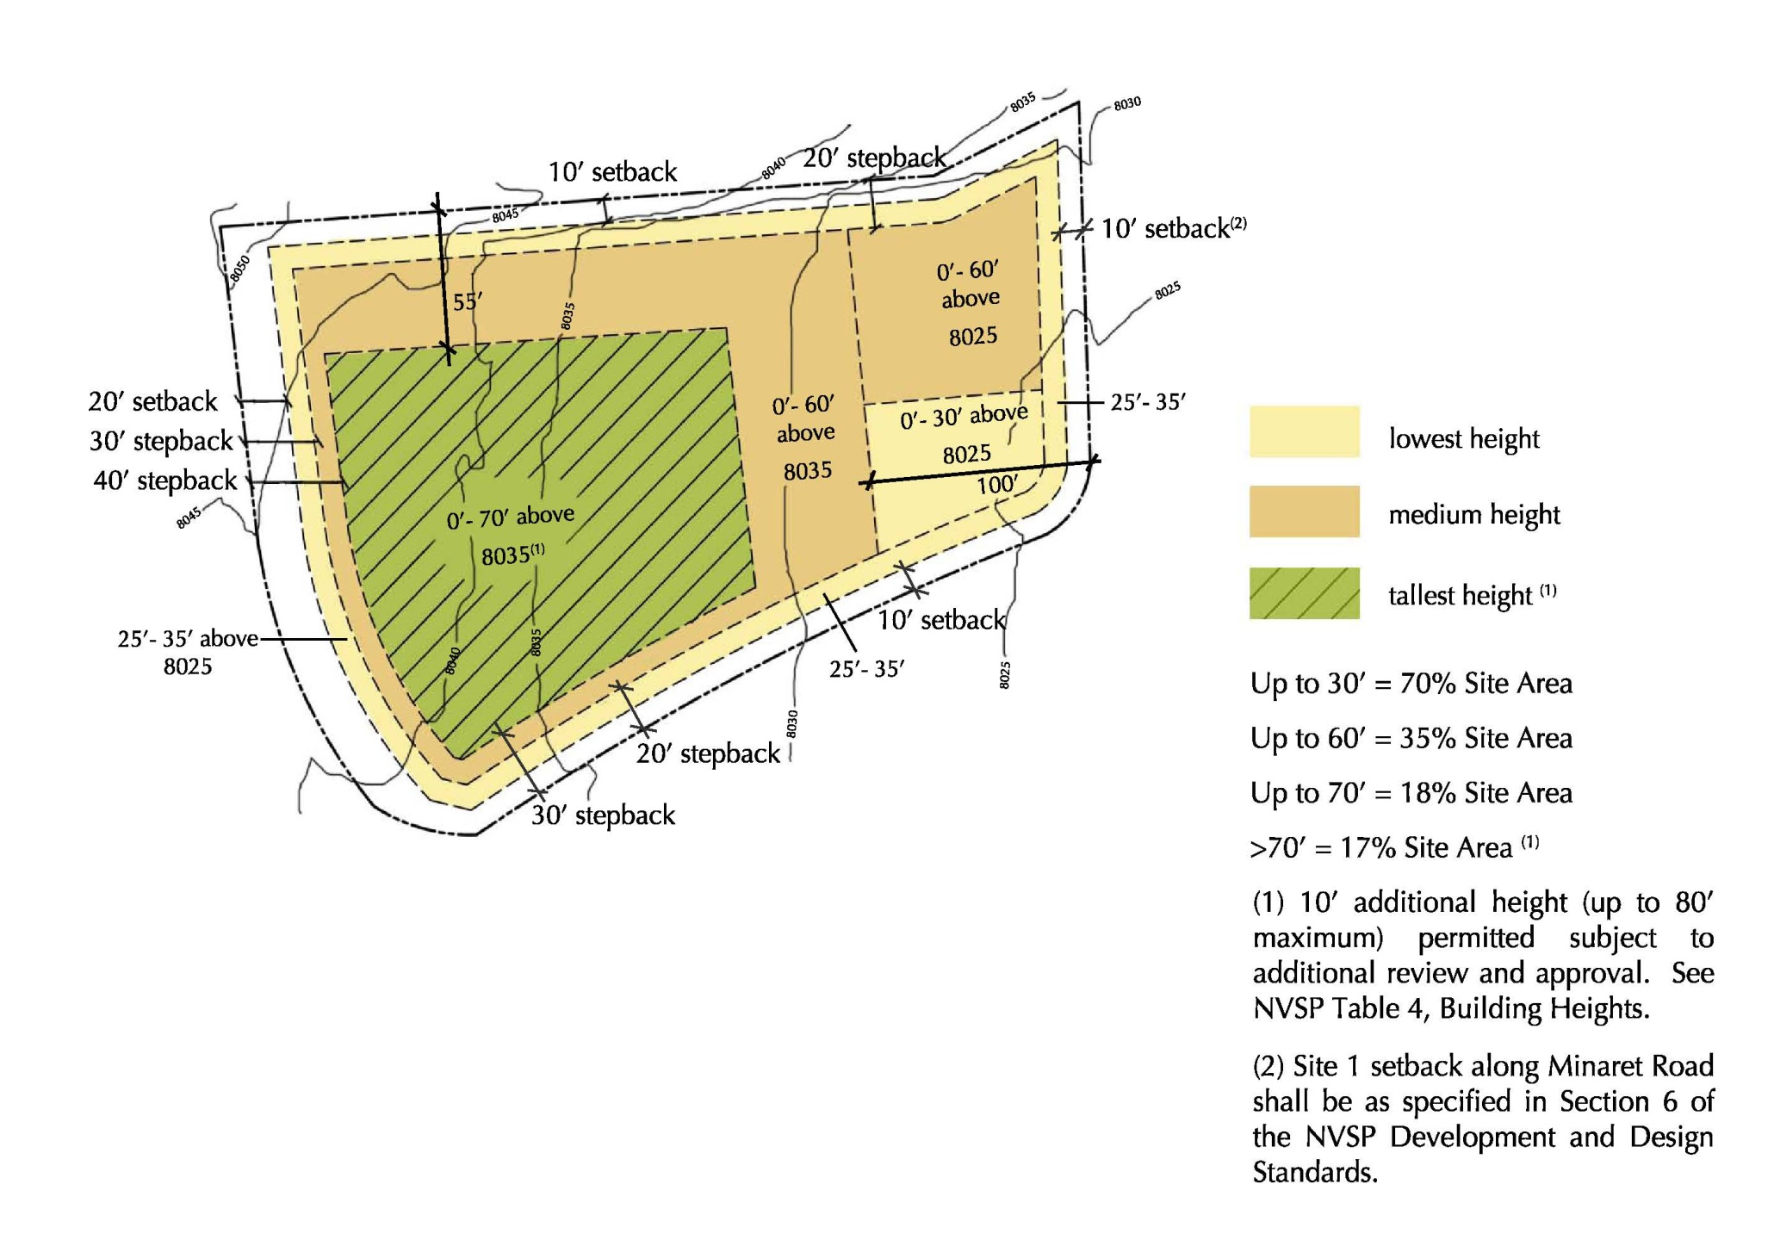
FIGURE 3: MAMMOTH CROSSING SITE 1
HEIGHT ZONES AND SETBACKS
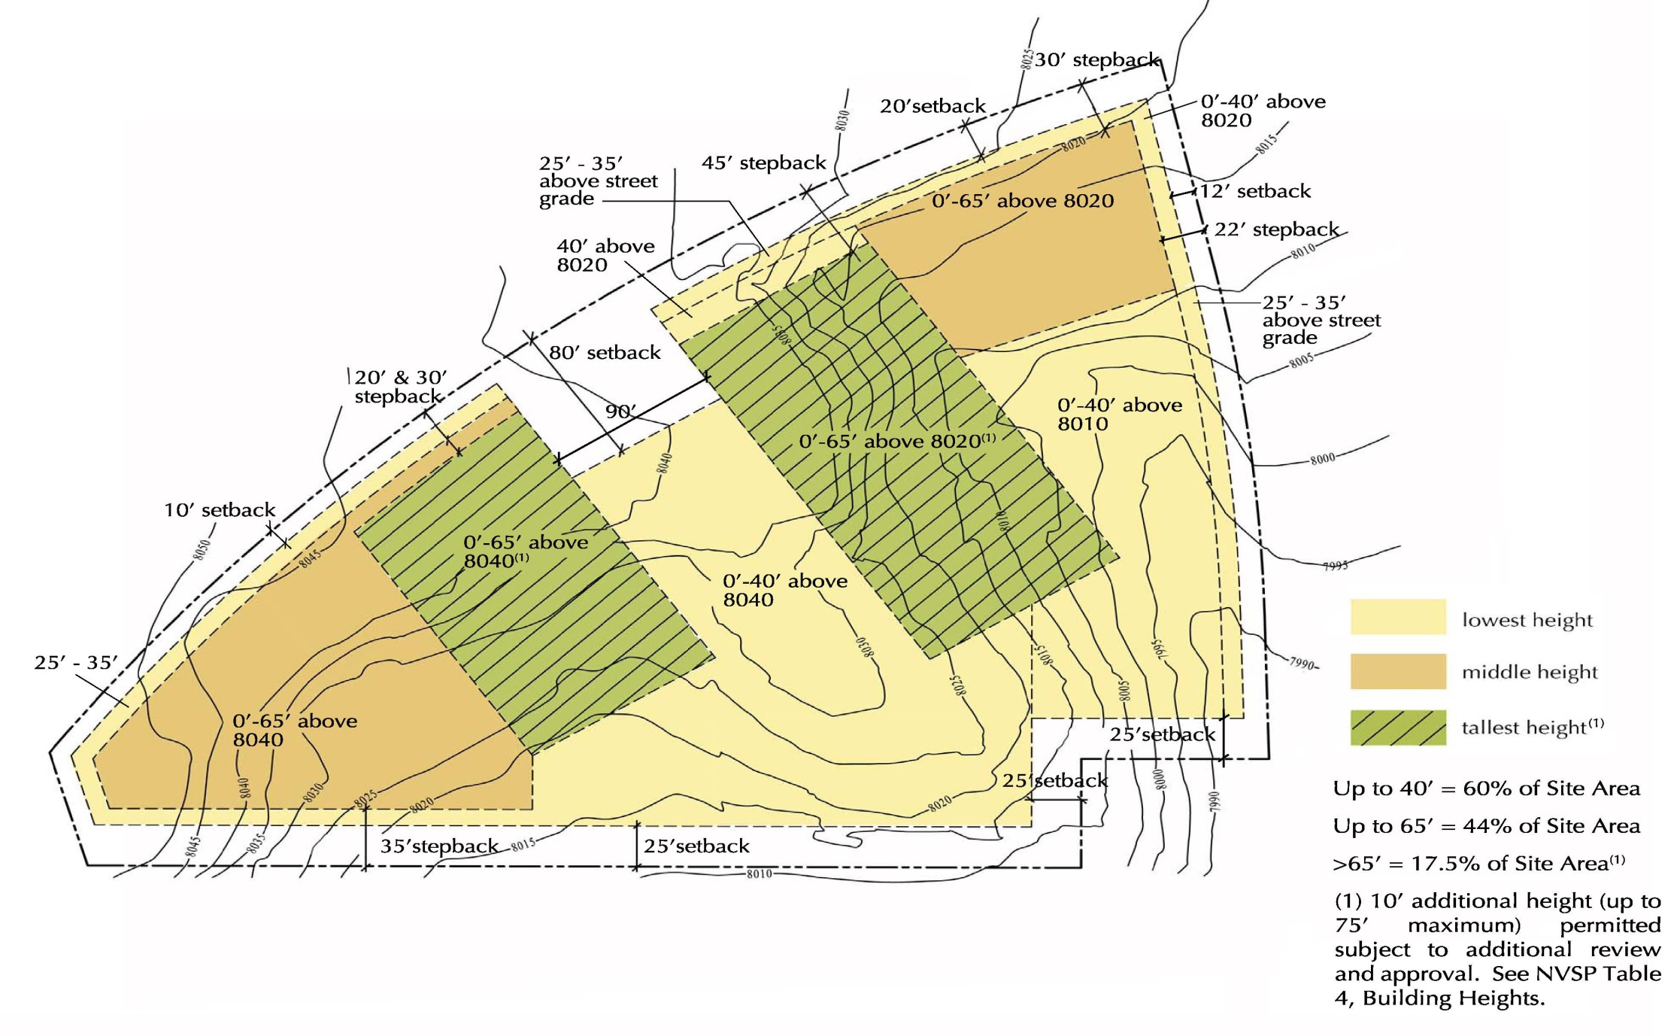
FIGURE 4: MAMMOTH CROSSING SITE 2
HEIGHT ZONES AND SETBACKS

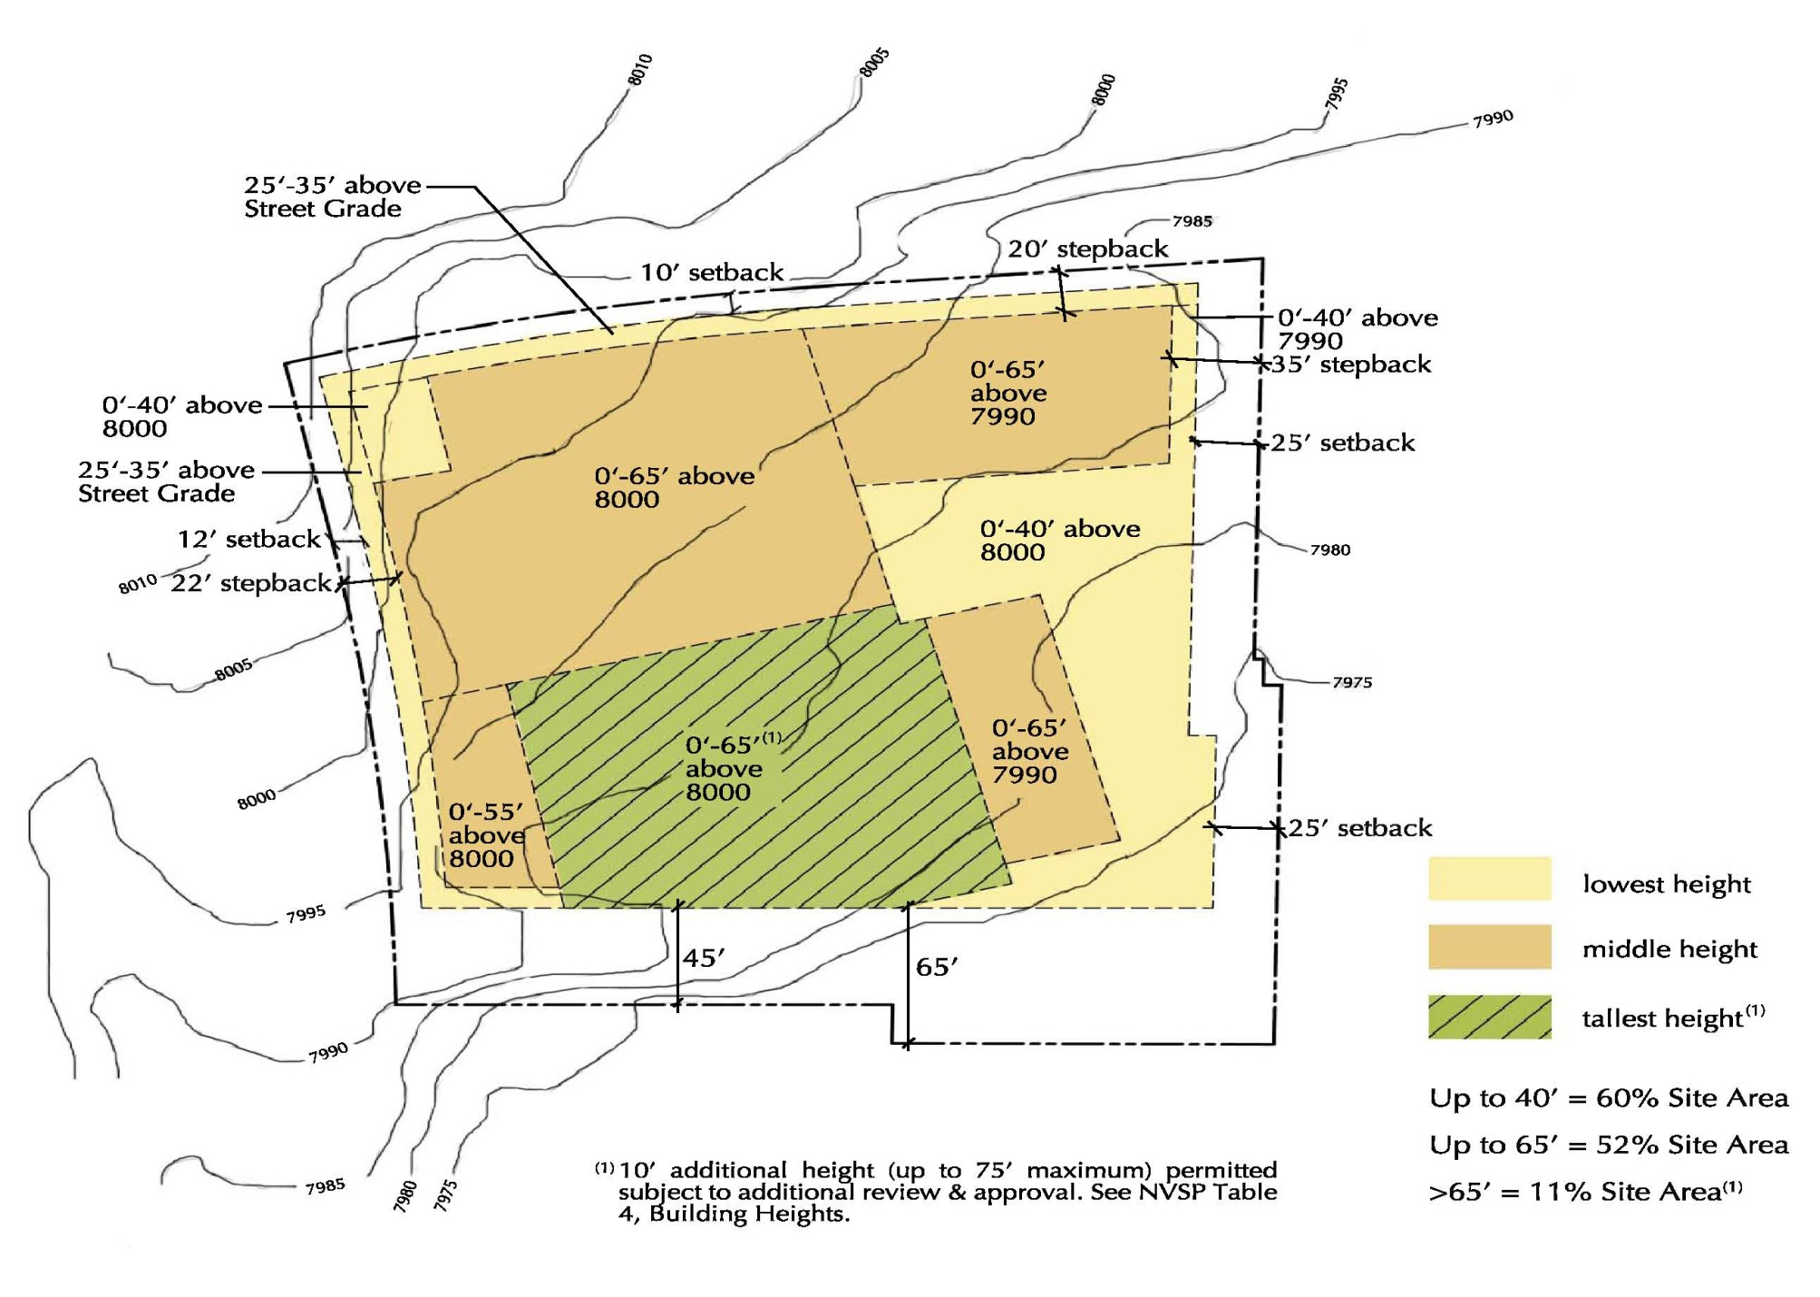

FIGURE 5: MAMMOTH CROSSING SITE 3
HEIGHT ZONES AND SETBACKS

6. Building Setbacks

a. Except as otherwise specified in this section, setbacks shall be measured from street rights-of-way and from Specific Plan boundaries as shown in Table 5. For the purpose of measuring setbacks, building heights shall be determined at the intersection of the building with a vertical plane established by the setback line. Measurement of building height shall be from natural grade as described in Section 5- Building Heights above.
- Within the PR district, no setbacks shall be required on internal side and rear lot lines. In RG and SL districts, side and rear setbacks shall be a minimum of 10 feet except as provided in Table 5.

- Within the MC district, minimum setbacks and stepbacks shall be as shown in Figures 3, 4 and 5.

- The Town’s Sidewalk Master Plan and this Specific Plan identify a future sidewalk to be located on the west side of Minaret Road, adjacent to Mammoth Crossing Site 1. As specified in North Village Specific Plan “Pedestrian, Bicycle, Skier Circulation” Policy 1, the Mammoth Crossing project is required to provide sidewalks in accordance with an approved design, connecting all developments to a pedestrian “spine” route along Minaret Road. The existing right-of way is limited in this area, and in order to accommodate the planned sidewalk, acquisition of additional right-of-way or easements from adjacent properties is necessary.

Therefore, the applicant or a future developer for a project on Mammoth Crossing Site 1 shall provide a right-of-way dedication or easement that can accommodate a sidewalk of a minimum eight feet in width clear of obstructions, along the west side of Minaret Road. The sidewalk easement and improvements shall be dedicated to the Town and will be incorporated into the North Village Benefit Assessment District. The permitted density for either Site 1, or the three Mammoth Crossing sites in total shall not be reduced to accommodate any reduction in property due to public dedications.

Allowed setbacks from the property line shall correspond to the above requirement: i.e., the setback from the property line on the east side of Site 1 may be as little as ten feet (as shown in Figure 3), although such a setback may only be granted if the required sidewalk described above can also be accommodated. In all instances, Site 1 buildings shall be set back a minimum of ten feet from the back of the Minaret Road sidewalk.

- All structures shall comply with the setbacks from ultimate lot line after final right-of-way and dedications have been made. Where Specific Plan boundaries are adjacent to U.S.F.S. lands, adjustments in the stated setbacks will be allowed with U.S.F.S. approval to allow for the development of a ski-back trail and skier bridge. Within the Pedestrian Core area adjustments of up to 10 % in setback requirements may be allowed in order to facilitate the development of major plaza areas, pedestrian access, transit connections, and retail/commercial visibility along Minaret Road. Supports for bridges, the gondola mechanisms, and the gondola support towers do not have to meet setback standards. The Gondola building shall have a minimum 5-foot setback along the realigned Canyon Boulevard, as measured to the vertical elements of the building. The gondola’s front support mast may be placed within the Canyon Boulevard right-of-way and out of the traveled way if approved by the Community Development Director.
- Transit facilities, information kiosks, etc., may be allowed in setback areas if approved by the Community Development Director.
- Buildings along Minaret Road between Main Street and Forest Trail must be set back at least 43 feet from the centerline of the roadway.
- Exceptions to the setbacks requirements in Table 5 are described as follows. The final determination for permitting exceptions shall be made by the Community Development Director if a supportable design rationale, such as an enhanced relationship to the street frontage, enhanced retail environment, enhanced pedestrian spaces, enhanced tree and landscaping provisions, offsetting building heights and setbacks in the vicinity or other design factors are provided along with the request for the exception.
  - For the area north of the Realigned Canyon Boulevard extending from 160 feet east of the Hillside Drive centerline to 260 feet east of the Hillside Drive centerline, setbacks shall be reduced 50%.
  - For the area west of Minaret Road, extending from 100 feet south of the existing Forest Trail centerline to 450 feet south of the centerline, setbacks for building heights over 24 feet shall be 15 feet.
  - For the area west of the realigned Berner Street, setbacks may be reduced by 50% along no more than 90 feet of contiguous road frontage.
  - The Dempsey/Nevados (Parcel 38) site is permitted up to a maximum of 20% reduction of each required setback, provided that the northerly setback may only be adjusted to less than 10 feet through a use permit or similar discretionary development project approval. No additional adjustments to Parcel 38 are authorized.
  - Large building eaves are encouraged. Eaves shall be allowed to encroach a maximum of four feet into setback areas.

TABLE 5: BUILDING SETBACKS FROM ROADWAYS AND SPECIFIC PLAN BOUNDARIES*
Building Height 0-24’ 25-34’ 35-54’ 55’+
Setbacks from:
Minaret 10’ 20’ 30’ 40’
Lake Mary/Main 10’ 20’ 30’ 40’
Canyon Blvd Realignment 10’ 20’ 30’ 40’
Forest Trail 10’ 20’ 30’ 40’
Hillside/Lakeview 10’ 20’ 30’ 40’
Berner 10’ 10’ 20’ 40’
Spec. Plan Boundaries 10’ 10’ 20’ 40’

*Setbacks and stepbacks for the Mammoth Crossing sites shall be as indicated in Figures 3, 4 and 5
**Setbacks and stepbacks for the Inn at the Village site (Area 19A) shall be as indicated in Table 6.

TABLE 6: BUILDING SETBACKS FROM MINARET ROAD FOR AREA 19A*

Building Height | 0’ – 24’ | 25’ – 34’ | 35’ – 54’ | 55’ – 73’ | 73’ +
Building Setback | 10’** | 20’ | 30’ | 30’ | 40’
*Consistent with NVSP Section 6.h.v, roof eaves and associated roof eave support structures are allowed to encroach up to four feet into these setbacks.
**An integrated and inviting pedestrian entry feature, no wider than 30 feet, is allowed to encroach up to nine feet into this 10-foot setback, subject to the review and approval of the Planning and Economic Development Commission.

7. Driveway Access and Gradients

a. Maximum gradients for private driveways shall not exceed 10 percent and should ideally be in the range of 0-5 percent. Covered and/or heated ramps and driveways may exceed these grades.
b. Shared access along property lines shall be required wherever feasible to minimize roadway access points.

8. Minimum Parcel Size

a. When creating or merging parcels, other than within a planned unit development, the minimum parcel size shall be as follows:
PR - 20,000 square feet
- MC – 20,000 square feet
RG - 20,000 square feet
SL - 15,000 square feet

- For planned unit developments and condominiums, minimum parcel size shall be established in accordance with the proposed development, subject to the approval of a subdivision map and use permit.
- For Mammoth Crossing, minimum parcel size may be less than shown in 8a. if it is determined to be necessary to successfully implement the illustrative plan.

9. Building Design

a. Building length shall not exceed 100 feet in one direction without a substantial change in one or more of the following elements:
- direction
- roof alignment
- wall offset
- building height
- exterior wall materials/finish
- setback.

b. Buildings shall be planned to take advantage of natural sun patterns. Designs shall avoid:
- Long shadows cast by buildings, land features, and landscaping, particularly onto major plaza and pedestrian areas
- “Mirrored” or shiny colors and surfaces
- Snow storage and potential snow shedding onto north sides of buildings or structures
c. Full-service hotels shall generally have large common areas, restaurants, and recreation facilities and may have meeting/conference facilities.
- All lodging uses within the Specialty Lodging district shall be oriented inward on a common hall or lobby, have a common gathering area (e.g. lobby, sitting area, etc.) and shall have a food serving capacity.
- The street façade for the Mammoth Crossing sites shall be architecturally modulated by bays that are not more than 30 feet in width. Bays within the street wall shall be defined by changes in the rhythmic pattern of window openings, bay windows, awnings and canopies, entrances, balconies, arcades, columns, pilasters, plane of the façade, materials and color, and other architectural features. Building design shall consider the Design Guidelines and Objectives for Mammoth Crossing included in Appendix 3.

10. Roof Form and Ridge Alignment

a. Roofs shall be designed to prevent the roofscape from dominating the architecture of the project.
b. A dominant roof shape shall be used on related building masses to provide harmony.
c. Roof ridge alignments shall enhance the visual impact of the buildings on the site.
d. A variety of ridge heights are encouraged. Protection of pedestrian entrances and walkways adjacent to buildings is encouraged where appropriate.
e. The following roof shapes are allowed: gable and gable on gable, intersecting gable, partial and full hip, Dutch eave gable and flared hip. Flat roofs may also be used if the design or function warrants.
f. The following roof shapes are not permitted: mansard, false mansard, curvilinear, domes, and Quonset.

11. Roof Design

a. The slope range acceptable for roofs on buildings within North Village is between 3/12 and 12/12. Lesser and greater slopes will be discouraged, except for architectural projections. Flat roof will be allowed where required for snow management, upper level exterior uses or architectural character.
b. Roofs shall truncate above the ground and roofs on both sides of a ridge shall be the same slope, but not necessarily the same length.
c. Roof forms shall be encouraged to protect walls and decks, to protect and cover pedestrian areas, to protect stairs, driveways and service areas. Roof forms, which direct snow, water and ice away from pedestrian ways, shall protect building entries.
d. Roofs shall not be designed to shed ice and snow onto adjacent properties, easements, or public rights-of-way unless approved by the owner of such property easement.

12. Roof Materials

a. Acceptable materials are:
- Aluminum or steel, which must be coated in an approved anodized or enameled color
- Concrete or slate tiles of an approved color and shape
- Fire resistant shingles or shakes
- Asphalt shingles (heavy grade)
b. Roof flashings, trim, cants, crickets and counter flashings shall be in a color and material, which harmonizes with the roof surfacing.

13. Roof Appurtenances

a. Roof appurtenances shall be integral parts of the architecture of the structure. Clerestories, dormers and skylights shall integrate with the overall exterior design. Dormers generally shall be gable, hip or derivative types.
b. Non-functional roof ornamentation shall be avoided.
c. Snow rails, clips, diverters, gutters, downspouts and similar accessories, if used shall be designed within the total roofscape.
d. Mechanical, electrical and roof access equipment, vents and antenna shall be integrated into the roof or dormer design to avoid visual impact on other properties. Ridge ventilators are acceptable.
e. Skylights, solar collectors and clerestories shall be designed as masses at angles relating to the primary roof, not as applied forms.
f. Chimneys of masonry, stucco and wood are permitted. Chimney materials shall complement major exterior finish materials used on the building. Back draft and spark arrestors shall be considered in chimney designs. Exposed flues will not be permitted. Solid fuel appliances shall be permitted as determined by the Town of Mammoth Lakes regulations.

14. Wall Surfaces
a. Lower wall surfaces shall be built of or finished with a hard durable surface material for protection from climatic conditions and to provide an aesthetic base to the architecture. All materials shall reflect the appearance, quality and scale of the surrounding mountain environment.
b. Any of the following materials, or materials which resemble these materials, are permitted for lower walls:
- Stone masonry
- Significantly textured and colored concrete
- Wood and masonry combination
- Reinforced concrete panel and plank siding, except where it fronts a pedestrian system
- Alternate material approved through the Design Review process or in adopted Design Guidelines
c. Upper wall surfaces shall be of durable material. Permitted materials include the following or those which resemble the following:
- Textured and colored concrete
- Wood
- Stucco finishes
- Stone masonry
- Reinforced concrete panel and plank siding
- Alternate material approved through the Design Review process or in adopted Design Guidelines
15. Doors and Windows

The exterior finishes of windows and doors shall be of wood, colorfast vinyl, painted aluminum or metal, or anodized aluminum finish. Unfinished aluminum and metal are prohibited.

16. Wall Appurtenances

Wall decorations, shutters, bay windows, flower boxes, balconies and other wall appurtenances shall be simple, functional and well integrated with the total design.

17. Color Palette

a. The overall color scheme for North Village shall be determined in the North Village Design Review standards, subject to approval by the Town of Mammoth Lakes Planning Commission.
b. In general, warm colors are encouraged for large field application. Dark colors shall be reserved for trim, accents, etc.
c. The color of exterior materials, whether applied or innate, shall reflect the appearance of the natural surroundings and not seem synthetic or man-made.
d. Accent colors shall integrate with the overall color scheme and form of the building.

18. Signs

General
a. Regulations governing the establishment and display of signs within North Village shall be in accordance with the purposes, general provisions, prohibitions, exemptions, and special purposes delineated in the Town of Mammoth Lakes Zoning Regulations or in accordance with North Village standards and guidelines for signs adopted hereafter by the Town Planning Commission.

Regulatory and Informational
a. A coordinated and unified signing system shall be developed for North Village to provide both graphic and visual continuity.
b. Whenever possible, signs shall be organized into unified systems, combined with lighting fixtures and kiosks or located in highly visible, well-lighted areas.
c. Informational signs shall be located in areas where people gather, change direction or change mode of travel. They shall be placed where they can be incorporated with the design of other site elements and where they allow safe pedestrian clearance and are not in conflict with door openings or vehicular and equipment operation.
d. Signs giving direction to handicapped access points and facilities shall be utilized.
e. Signs throughout the Specific Plan Area are encouraged to include a graphic or logo to reinforce the North Village identity and image.
f. The following standards shall be implemented for signs throughout North Village:
- Sign materials shall be such that they can withstand weather conditions and be generally damage proof.
- Regulatory signing systems shall require minimum painting and be rust and pit proof.
- Colors shall be fade resistant.

g. Within road rights-of-way, signs shall conform to Caltrans standards for uniform signs. Commercial signs are not permitted within rights-of-way.

Commercial Signing
Commercial signing is primarily intended to identify individual commercial enterprises. The following criteria shall be applied to commercial signs:
a. Commercial signs shall be an integral part of a building’s architecture. Signs shall be combined and coordinated with other elements such as porches, awnings, canopies, lighting, hanging planters, banners, etc. to create a streetscape that is lively, interesting and attractive at the pedestrian level.
b. Signs shall conform in a manner and style, which create character, color, and interest within pedestrian areas. Sign form and quality shall relate directly to its purpose, context, and location. Signs, which are symbolic, are encouraged to create visual diversity.
c. Signs shall reflect the character and tradition of the region in materials, form and use. Materials shall be durable, easy to maintain and compatible with other building finishes.
d. Signs on the exterior of buildings shall not be permitted for commercial uses within hotels unless the commercial is counted as density.

19. Pedestrian Walkways and Plaza Areas

a. Pedestrian walkways and easements for such shall be provided, if necessary, within private property along Minaret Road and Main St./Lake Mary Road and within plaza areas to ensure continuous access among parcels.
b. Walkways shall be landscaped in accordance with North Village landscape design guidelines as adopted by the Town Planning Commission.
c. Walkways shall be connected to existing or proposed walkway and trail systems to provide access to areas outside the North Village Specific Plan boundaries.
d. Materials for pedestrian walks shall be selected with regard to durability, maintenance, stability, aesthetic appearance and slip resistance.
e. The selected paving materials shall be applied to enhance the overall design intent and continuity.
f. Acceptable paving materials for pedestrian walks and plaza areas include asphalt concrete, stone, concrete, brick, bomanite and interlocking modular pavers. Materials must be appropriate to the area.
g. Stairways throughout the outdoor spaces in North Village shall employ a uniform tread width and riser height wherever possible. Stair treads shall be non-slip surfaces, suitable for snow removal operations.
h. Acceptable materials for private driveways and other paved surfaces include asphalt, concrete and precast concrete pavers. In areas located apart from major vehicular traffic, decomposed granite and crushed stone with cement treatment may be acceptable subject to approval by the Community Development Director.
i. Walkways and terraces adjacent to the main plaza areas may be raised above the adjacent plaza elevation. Covering portions of walkways and terraces is encouraged.
j. All developments shall be physically integrated with other walkways, plaza areas and bicycle trails which form the Pedestrian Core area circulation system.

20. Snow Removal and Management

Development plans shall include a snow storage, snowmelt and removal plan, which identifies areas dedicated for snow storage and snow melt, and outlines snow removal and snowmelt methods. The plan shall state that snow and ice shall be removed daily prior to the opening of any business and that pedestrian areas will be maintained during business hours. The plan shall be subject to the approval of the Town, as provided in the Municipal Code.

- The Snow Removal or Snow Management Plan shall address methods to prevent hazardous snow and ice build-up on public streets, and on public pedestrian pathways and sidewalks that would receive less than two hours of mid-day sun for more than a week, including plowing, application of cindering, and potential installation of heat-traced pavement.

21. Lighting

a. Lighting shall comply with the design guidelines established for North Village. Lighting shall be provided for safety, security, and an attractive nighttime environment. Exterior lighting shall be provided along roadways, pedestrian walks, plaza areas, stairways, transitions, intersections, garage entry points, etc. where safety and security are best served by lighting.
b. All exterior lighting shall be shielded or constructed so that the source of illumination (e.g. the bulb or globe) is not readily visible from off the subject property. This requirement shall not apply to decorative incandescent fixtures of forty watts or less or equivalent lumen standard. Area lighting shall be down directed and designed so that light does not project above the horizontal plane of the light source or onto adjacent properties or right-of-way.
c. Energy efficient lighting systems shall be used.
d. Low intensity indirect accent lighting of buildings and landscaping may be permitted subject to the approval of the Planning Commission. High intensity lighting shall not be allowed for accent lighting.
e. A detailed lighting plan for each development shall be prepared for approval by the Planning Commission showing location, intensity, heights, fixture type and design, and any other pertinent information.
f. Where safety and security is not affected, light levels shall be diminished after midnight to minimize impacts on adjacent properties.
g. Lighting plans shall be coordinated with other developments and overall lighting plans shall be established to balance site lighting, coordinate fixture types and locations and minimize duplication.
h. Decorative fixtures along pedestrian walks and the plaza shall utilize shatterproof coverings.
i. Lighting fixtures shall be located so that they do not interfere with pedestrian or vehicular movement.
j. Along Highway 203, parking lot and streetlights shall meet Caltrans standards and shall be decorative. All streetlights shall be designed in a style complementary to the overall design theme and image established for North Village.

22. Gates and Entrances
a. Private driveways may include entrance gates and landscaping.
b. Gates shall not exceed 6 feet in height and 15 feet on each side for a maximum width of 30 feet.
c. Gates shall be set back a minimum of 25 feet along the property access road.
d. Required materials for gate construction shall include masonry for gate supports or posts, and iron or wood for gates. Reflective aluminum chain link or other reflective fencing material shall not be used.
e. Mechanical gates are permitted provided they are constructed of wood, wrought iron, or other approved material.
f. No sentry or barrier gates (i.e. gates with mechanical arms) will be allowed except in parking structures.
g. All gates shall be equipped with mechanisms or access for emergency vehicles as approved by the Fire Chief and Police Chief.

23. Walls and Fences

a. Unless otherwise noted, walls and fences shall be constructed according to the Town of Mammoth Lakes zoning regulations and North Village Design Guidelines.
b. Acceptable materials for walls and fences include heavily textured concrete, stone, stone-faced concrete, and wood. Walls and fences used to screen utility and maintenance structures, play areas, storage, parking or other features shall be compatible with the exterior finish of any structure with which they are in contact. Tennis court enclosures shall be green or black chain link.

24. Site Furnishings

a. Site furniture, such as benches, drinking fountains, waste receptacles, etc., shall be complementary throughout North Village, durable, easily maintained, functional in form, simple in fabrication, standardized in appearance. Furnishings shall reflect the surrounding mountain environment in material, quality and scale.
b. A site furniture plan shall be adopted by the Planning Commission. Location and placement of furnishings shall logically respond to patterns, types and intensities of usage.
c. Components shall be located to optimize public safety and not restrict emergency vehicle access. Furnishing design and placement shall not obstruct efficient surface maintenance snow removal and cleaning operations.
d. Site elements shall allow “barrier free” access by all people including the elderly and handicapped.

25. Pedestrian and Skier Bridges

- The bridge design shall reflect the design theme established for North Village. Architectural treatment shall include masonry/stone, heavily textured concrete or wood.
- The Skier Bridge shall be designed for year round use and access and shall be compatible with adjacent building architecture and North Village design themes. Pedestrian bridges may be designed to provide protection from inclement weather as determined by the Community Development Director.
c. Low-level accent lighting may be incorporated into the bridge designs

26. Art/Events

- Art, sculpture, fountains, flags, banners, or other similar outdoor decoration are encouraged and the placement (not the design) of the art shall be reviewed through the Design Review process.
- A public events program is expected to be developed as part of a comprehensive Town-wide program or may be developed by commercial associations, master associations or other individual groups within North Village. Groups or associations programming events shall use reasonable efforts to mutually coordinate with Town visitor services and other community event associations.

27. Additional Development Standards
Development of all properties shall conform to the Mammoth Lakes zoning regulations, except as otherwise specified in the Specific Plan.

Grading Standards
1. A grading plan shall be submitted concurrently with the development plans and shall be subject to the approval of the Town Public Works Department.
2. Individual development projects shall be designed to be compatible with site topography to the extent practical, so as to minimize the amount of grading required.
3. All grading and earthwork activities must be conducted in accordance with an approved construction grading plan and grading permit issued by the Mammoth Lakes Public Works Department. All grading plans must meet Lahontan Regional Water Quality Control Board standards for interim and permanent erosion control measures and shall be permitted by that agency.
4. Prior to commencing grading and clearing operations, the limits of disturbance shall be staked and shall be inspected by the Town. All construction disturbances shall be limited to the staked areas. Inspections to ensure compliance shall be made during grading and clearing as deemed necessary by the Town.
5. Prior to development within any area of the Specific Plan, a soils engineering investigation and/or construction plan may be required by the Town of Mammoth Lakes.
6. Interim control measures, such as the provision of temporary dikes, filter fences, hay bales, and retention basins shall be implemented during the construction period as necessary.
7. All graded sites must be repaired and revegetated in accordance with a landscaping/revegetation plan approved by the Town of Mammoth Lakes.
8. Unique natural features, such as rock outcroppings or large trees, shall be protected to the greatest extent possible in the design of development.
9. Graded slopes shall be oriented to minimize visual impacts to surrounding areas and shall be designed to blend into existing natural topography.
10. All grading plans/activities shall comply with all grading-related mitigation measures included in the North Village Final Subsequent Program EIR to ensure seismic safety, reduce erosion, and promote long term preservation of natural plant communities.
11. Construction activity within the drip line of retained trees shall be avoided. The design features of the proposed developments should not enter the root zone of retained trees.
12. All vegetative slash shall be properly disposed within 15 days of its creation. This may include the grinding of the slash.
- Slopes for private access drives shall not exceed 10% unless covered and/or heated and should ideally be within the range of 0-5%.
- All cut and fill slopes shall be landscaped, seeded and mulched as required by development approval conditions. Graded slopes shall be minimized by using retaining walls rather than extensive grading, subject to approval by the Town Community Development Director and/or Public Works Director.
15. The design of retaining walls shall be subject to the Design Guidelines and approval by the Community Development Director and the Public Works Director.

Landscaping and Revegetation Standards

1. All disturbed sites in the Specific Plan Area shall be revegetated, regardless of time of disturbance. All projects will be required to establish and maintain dense, permanent, and drought resistant ground cover.
2. Revegetation shall be conducted on disturbed slopes after slopes have been successfully stabilized through methods approved by the Town of Mammoth Lakes.
3. Revegetation shall be initiated upon completion of rough grading. Temporary soil stabilization measures shall be maintained until vegetation is established. A schedule of revegetation shall be included in the Revegetation Plan.
4. Bonds or other appropriate security may be required to guarantee site stabilization, restoration, and revegetation within the time periods specified in project approvals.
5. Site specific and regional characteristics such as soil conditions, nutrients, precipitation, shading, and temperature shall be considered in the formulation of project revegetation and landscaping plans.
6. The specific planting time for revegetation purposes shall be selected to maximize plant survival.
7. All revegetation and landscaping plans shall include an irrigation program to ensure plant survival.
8. The use of fertilizer or soil amendments shall be specified in the revegetation plan. All backfill placements for planting shall be approved by the Public Works Director prior to placement.
9. Revegetated and landscaped areas shall be regularly maintained in a neat, clean, and healthy condition. Regular maintenance activities shall include, but may not be limited to:
a. Cultivation of planting beds on a regular basis
b. Regular pruning and fertilization
c. Insect, disease, and pest control
d. Removal of leaves and pine needles
e. Maintenance of irrigation controllers and repair of system components as needed to maintain good working conditions
f. Periodic planting of new trees to maintain a healthy stock of trees at all times.
10. All landscaping designs and revegetation plans for new developments shall be submitted to the Town for review and approval prior to issuance of any building or grading permit.
11. Landscaped areas in the vicinity of roadways and intersections will be designed to preserve adequate fields of vision for motorists. Landscaped areas within a public right-of-way shall be designed not to obstruct motorists’ fields of vision and shall meet with the approval of and be permitted by the governing regulatory agency (Town or Caltrans) prior to installation.
12. Water consumption shall be minimized through the use of drought tolerant plants and properly designed irrigation systems utilizing drip technology where feasible to minimize over-watering.
13. Plants with aggressive root systems will not be permitted over or near underground utilities or within a public right-of-way.
14. Any plants designated for preservation shall be protected during construction by ensuring that grade changes are made outside the drip line and by minimizing soil compaction
15. Ornamental plantings shall occur at entrances, plazas, courtyards, and in planters adjacent to buildings. Other plantings throughout the Specific Plan area shall emphasize natural groupings and arrangement of vegetation.
16. All trees greater than 12 inches dbh (diameter breast height) that are required to be removed due to improvements, shall be replaced on a one-to-one basis either on-site or on an off-site location approved by the Community Development Director. Trees recommended for removal based on health, overstock, etc. by a qualified professional are not required to be replaced. Trees used for revegetation and landscaping purposes shall be a minimum size of 2-inch caliper. Selective use of smaller native trees may be permitted. Shrubs used for revegetation and landscaping purposes shall be a minimum size of 2-gallon container category.
17. The design for new plantings should consider solar aspect and the views of others so that existing patterns of sunlight and view are not obscured. New plantings that interfere with the views or solar access of neighboring properties will not be permitted.
18. The plaza areas shall be landscaped with groups of climate adaptive conifers and aspens, hardy shrubs, and flowering ground covers, along with low maintenance drought-tolerant plant materials that will add interest at the pedestrian level, yet endure snow storage and provide year-round character and habitability.

PUBLIC FACILITIES ELEMENT

Water Supply
The North Village Specific Plan Area is included within the service area of the Mammoth County Water District (MCWD), which currently maintains distribution and service lines in the project area. MCWD obtains water from Lake Mary and from groundwater wells. The existing water distribution system in the Specific Plan Area is served via a 12 inch main along Lake Mary Road to distribution lines along Millers Siding and Minaret Road. Although the MCWD possesses sufficient capacity to accommodate the North Village development, some existing lines within the Specific Plan Area are not sufficient to serve the proposed development. The issuance of building permits will be dependent upon MCWD approval based upon the existence of available water supply, as opposed to known resources. A number of the existing lines will ultimately be abandoned while others may continue to be used as small service connections to existing buildings. Determinations will be made during actual water system design as to which lines will be abandoned or will remain in use. For the most part, however, a new water distribution system will be constructed to service the Specific Plan Area.

Sewage Disposal
As with water supply, the North Village Specific Plan Area lies within the service boundaries of the MCWD. The MCWD operates a 5.0 mgd (million gallons a day) capacity secondary level sewage treatment plant east of the Mammoth Lakes community and provides adequate capacity for peak populations for complete Town build-out, as projected in the Town of Mammoth Lakes General Plan. The MCWD has indicated the ability to extend full service to the Specific Plan Area; however, existing sewer lines within the project area do not have adequate reserve capacity to accommodate future flows resulting from development of the Specific Plan Area. Most of the existing sewer lines will remain in service. The lines along Canyon Boulevard, which deliver flows from residential developments west of the project to the existing trunk line along Minaret, may be rerouted along the Canyon Blvd. realignment to connect with the existing Millers Siding line or may remain in the Canyon Boulevard utility corridor. The capacity of all lines within the project area must be verified when detailed project development information is available. Final design decisions including re-routing options and increased size line replacements will be made in conjunction with MCWD

Drainage
Current drainage facilities in the Specific Plan Area include a 42-inch diameter reinforced concrete pipe (RCP) which runs west to east along Canyon Boulevard to Minaret Road; heading north on Minaret Road to Berner Street, and east on Berner Street where it exits the Specific Plan Area. At a point on Berner Street approximately halfway between Minaret Road and Alpine Circle, the existing drainage pipe is increased to a 54-inch diameter to accommodate additional inflow. This storm drain is a portion of the system, which conveys drainage from the Mammoth Slopes subdivisions along Canyon Boulevard, 1-1/2 miles easterly to Murphy Gulch. Other drain lines in the Specific Plan Area convey storm water for short distances across roadways, including the Minaret/Main Street intersection and the Minaret/Forest Trail intersection.
The North Village Drainage Plan shall be designed based upon a drainage study in accordance with the Town of Mammoth Lakes Storm Drainage Master Plan. The Town plans calls for the installation of an additional 54-inch diameter pipe parallel to the existing drainage pipe in Canyon and Berner to provide sufficient capacity for anticipated flows resulting from full development of the Specific Plan Area. Alternate storm drain designs, which meet the intent and requirements of the storm drain master plan, may also be utilized. Much of the Canyon Boulevard right-of-way will be vacated in conjunction with the Canyon-Miller Siding realignment. A utility corridor may remain over a portion of the vacated Canyon Blvd. right-of-way, which will allow the construction of the additional drainage pipe, or the storm drain may be rerouted to an alternate utility easement.

The Berner Street vacation will cause the portion of the storm drain east of Minaret Road to be re-routed in a new utility corridor. The re-routed line may be single line of sufficient capacity to carry the flow of the existing line and the proposed line. This single line will connect to the existing 54-inch drain in Berner Street at the eastern end of the Specific Plan Area. The actual routing of the storm drain will be determined prior to construction when more specific detail is available on parking structures and other site development, as approved by the Public Works Director. One other major improvement in the Specific Plan Area called for by the Storm Drain Master Plan is a new 48-inch line from the intersection of Minaret and Forest Trail to the new Berner Street Strom Drain. Currently a 42” line crosses Minaret Road and empties to an open channel on the south side of Forest Trail.

This channel drains easterly across the Specific Plan Area towards Berner Street. The proposed re-routing of Berner Street will provide a new road easement in which the storm drainage facilities may be constructed. Again, the actual routing will be determined prior to construction when more specific detail is available.

Solid Waste
Solid waste disposal and collection throughout the Town of Mammoth Lakes is provided by a private company, which transports the waste to Mono County’s solid waste disposal facility at Benton Crossing, approximately eight miles southeast of Town.
Solid waste generated by North Village will be collected by the franchise operator or, if applicable, by the North Village maintenance district, and ultimately deposited at the Benton Crossing Landfill. In an effort toward conservation, all developments will be required to be equipped with waste compaction and recycling facilities and shall participate in programs of the Town of Mammoth Lakes Source Reduction and Recycling Element.

Utilities
All new power, telephone, gas, cable television, and other utility lines will be installed underground within the Specific Plan Area. Main lines for virtually all services are located in proximity to the project site. Existing overhead lines will ultimately be placed underground in duct bank facilities along or in roadways. Suppliers of major services, such as Southern California Edison (SCE), have indicated sufficient capacity to service full build-out of the Specific Plan Area.
Specific development and installation plans for major utilities are described below:
Propane - Propane is presently available in Mammoth Lakes from private companies. Developments within North Village that utilize gas will be required to provide space in areas not visible to the general public for storage tanks and must provide adequate screening and setbacks from property lines and structures. It is possible that arrangements could be made with one of the propane suppliers to supply service to a majority of or all of the North Village properties. If an area-wide distribution system is implemented, centralized storage tanks could be constructed to service the entire North Village Specific Plan Area. The details of gas service must be provided in association with the design approval for each development phase.
Power - Power will be provided by Southern California Edison Company (SCE). Major (33KV) underground facilities are located in Minaret Road, Lake Mary Road, and Forest Trail. Existing aerial service line facilities throughout the project area are also planned for placement underground. Service to the various developments will require construction of new duct bank facilities in the roadway and the installation of power, telephone, and television conduits. In areas in North Village where roadways are being reconstructed and when economically feasible, new duct bank facilities for all utilities will be installed while roads are being improved. This will eliminate the need for future disturbance of new roads for utility installation for individual projects, which may be constructed in the Specific Plan Area.
Telephone - Telephone service will be provided. A major underground telephone line currently is located in Canyon Boulevard. When the North Village plaza construction results in the realignment of Canyon Boulevard, the line may remain in the utility corridor southwest of the plaza or may be relocated. The exact location of the utility corridor will be determined in coordination with development plans for the plaza area. Where economically feasible telephone conduit shall be installed in the common utility duct shared with SCE and cable television.
Cable Television - Cable television service is currently provided to Mammoth Lakes. Underground cable television conduits are normally installed adjacent to telephone conduits.

Fire and Police Protection
Both fire and police protection will be provided by existing entities in the Town. Fire protection will be provided by the Mammoth Lakes Fire Protection District, which maintains a station approximately one mile east of the project on Main Street, and another station on Old Mammoth Road, approximately two miles south of the project. The Town of Mammoth Lakes Police Department will provide police protection.

Snow Removal

The increase in paved areas due to street improvements and the development of the pedestrian plaza will result in greater snow removal requirements. Snow removal on privately maintained areas, such as the plaza, project sidewalks, and private roads will be conducted by the property owners association. Snow removal on State or Town roads will still be the responsibility of the respective agency or a maintenance district. Snow removal equipment will have access throughout major plaza areas. Snow may be hauled off site and deposited in a suitable location to reduce on-site snow storage areas. Facilities adjacent or peripheral to the plaza area may opt for similar immediate removal or provide adequate on-site snow storage space. Each development project shall be required to submit a snow removal and storage plan as part of final project review and approval by the Town of Mammoth Lakes. Geothermal heat will be considered as a source for snowmelt in major plaza areas.

Schools
The Environmental Impact Report identifies an unavoidable significant impact for the Mammoth Unified School District as a result of the development proposed in North Village. The proposed project would add more students to the school district and would result in a net cost for the district. A mitigation measure to assess a development fee was adopted.

Public Facilities Objectives
1. To size new utilities in accordance with the intensity of proposed development.
2. To upgrade and repair utilities which will be strained by proposed development.
3. To maintain or improve the level and quality of service to proposed and surrounding developments.
4. To maintain police and fire protection standards and snow removal operations through appropriate building and site designs.

Public Facilities Policies
1. A new water distribution system shall be installed to accommodate the volumes expected by the cumulative developments within North Village.
2. Sewer facilities shall be improved to avoid overloading of current facilities.
3. Improvements shall be made, as determined by the Town Engineer, to downstream drainage in order to prevent damage and to accommodate any increased flows.
4. Solid waste disposal shall include on-site storage and recycling methods which will reduce the amount and bulk of waste deposited at the Benton Crossing Landfill.
5. Utility installations shall be coordinated to limit total area of disturbance.

Public Facilities Standards

1. Overall
a. Easements shall be located during development plan preparation to the satisfaction of the easement holders.
b. No utility construction shall result in disturbance of natural slopes that exceed 30%, unless environmental documentation has been prepared and mitigation proposed.

2. Drainage Plan
a. Storm drains and other drainage improvements installed in the Specific Plan Area shall be installed as required by the Storm Drain Master Plan and with the approval of the Public Works Department and Lahontan Regional Water Quality Control Board. This may include mitigating upstream impacts on-site as a method of controlling flows exiting the Specific Plan area.
b. On-site drainage collection retention, and infiltration facilities shall be constructed and maintained to accommodate runoff from a 20-year, one-hour storm. Storm Drainage Master Plan facilities shall be designed in accordance with the Master Plan Design Manual and shall be based upon a detailed drainage study.
c. A preliminary Drainage Plan and Waste Discharge Report for each development project within the North Village Specific Plan Area shall be submitted for approval to the Mammoth Lakes Public Works Department and the Lahontan Regional Water Quality Control Board, as required, prior to commencing the project.
d. All construction areas shall be protected by filter berms, fencing, or other interim controls to retain sediment and prevent downstream sedimentation and flooding.
e. All disturbed soils shall be stabilized to prevent downstream discharge of sediments.
f. Snow storage areas shall be located primarily on unpaved areas to promote groundwater recharge and reduce runoff from paved areas.
g. The individual project developers, or land owners within North Village, shall contribute Development Impact Fees (DIF) based on the DIF schedule established as mitigation by the Town and as appropriate for the development project for expanded public storm drainage facilities needed as a result of North Village development to serve the downstream areas.

3. Sewer Plan
a. Sewer improvements shall be installed per the requirements of the Town of Mammoth Lakes Public Works Department and MCWD. All sewer lines and sewage disposal facilities shall be designed in accordance with MCWD requirements.

4. Water Plan
a. All water lines and water facilities shall be designed and installed in accordance with MCWD requirements and Town of Mammoth Lakes Public Works Department specifications.
b.Water conservation measures shall be used in all developments, including low-use water fixtures and drought resistant landscaping.
- Applicants for future development phases shall coordinate with MCWD as early in the conceptual development stages as possible to ensure that off-site MCWD infrastructure necessary to provide water and wastewater service for future development is in place or planned for as early prior to development as feasible. The applicant shall apply and obtain approvals for water and wastewater service in accordance with MCWD policy.

- In accordance with 2007 General Plan Policy R.4.A., no Use Permit or Tentative Map that would allow for density above the base of 48 rooms per acre on the Mammoth Crossing sites shall be approved unless a finding can be made by MCWD that adequate water supply is, or will be, available to serve the project when it is constructed. At the discretion of MCWD, such a determination may be made based on the ability of the project to reduce its water demand such that they would not exceed the demand projected for a similar project at 48 rooms per acre.

5. Solid Waste
a. Recycling and waste reduction methods shall be incorporated into all developments.
b. Solid waste disposal shall be handled in accordance with policies and procedures adopted by the Mono County Board of Supervisors. Necessary solid waste permits shall be obtained from the Mono County Public Works Department.

6. Utilities
a. All utility service lines shall be placed underground. All existing, new or realigned utility lines within or adjacent to a development site shall be placed underground unless such placement results in a greater quantity of utility poles.
b. Installation of utilities shall be coordinated with one another to minimize conflicts. A common utility duct shall be used where feasible.

7. Snow Removal
a. Sufficient snow storage areas shall be incorporated into each development to accommodate snow removal. A snow removal and snow storage plan shall be incorporated into project designs and approved by the Design Review Committee and the Planning Commission.
b. As the above snow storage areas reach maximum capacity, excess snow shall be hauled away to an approved disposal site.
- Snow storage and snow removal from public streets and public facilities shall be considered in the design of projects fronting on public streets and adjoining public facilities.
- The Town, Caltrans and/or a maintenance district or association, shall accomplish Snow removal from public streets.
- Snow removal from private vehicular and pedestrian areas, public sidewalks and transit stops is the responsibility of the property owner and/or maintenance district.

8. Schools
a. New development shall fully mitigate school impacts through payment of the established school mitigation fee.

TRANSPORTATION AND CIRCULATION ELEMENT

Implementation of the North Village Specific Plan will result in development of an activity core and a concentration of visitor traffic in the vicinity of the Main Street and Minaret Road intersection.
Residential streets and main thoroughfares within and around the North Village Specific Plan Area currently experience relatively high traffic volumes and congestion compared to surrounding development, resulting from MMSA patrons traveling to and from the ski area’s Main Lodge and Canyon Lodge facilities and merging with local traffic under uncontrolled conditions.
In spite of its pedestrian orientation, the North Village Specific Plan Area will result in additional traffic generated by development of new hotel, lodging, or residential rooms, and significant commercial facilities, further increasing volumes on already congested roads through Town.
The intent of the circulation element is to establish objectives, policies, and implementation standards to improve existing circulation conditions and minimize future impacts from project development, particularly in the surrounding residential areas. The improvements are designed to allow continued access to and from the Main Lodge, Canyon Lodge and surrounding neighborhoods while accommodating increased traffic within the North Village area, without increasing congestion. The goal is to have a circulation system where virtually all traffic, which passes through the North Village area either, merges with local traffic or intersects local traffic under controlled conditions. In addition, traffic is reduced by the provision of the gondola for use by skiers staying in North Village facilities who will not need to drive to other MMSA base facilities. Also, development of a comprehensive Town-wide transit system, and reductions in parking supply within North Village will minimize increased vehicular traffic on Forest Trail, Lakeview, Upper Canyon, and other surrounding predominantly residential streets, particularly during peak traffic hours.
Expansion of the public transportation system to North Village and throughout Town will be provided through the provision of additional bus stops, increased trip frequency, and extended operating hours. A transit system will be developed to meet the needs of the North Village Specific Plan and other resorts to reduce potential vehicle trips.
Pedestrian access and circulation is provided through the development and year-round maintenance of a pedestrian sidewalk and walkway system connecting all developments within North Village. Development of a ski lift in the plaza core of North Village without associated parking facilities will enable North Village visitors to walk to the gondola and to enable other skiers to access the lift via the public transportation system.

Circulation Objectives
1. To provide less congested vehicular circulation through modifications to the existing circulation system.
2. To provide a positive setting for comprehensive pedestrian activity through the development of a pedestrian circulation system.
3. To accommodate project patrons through the provision of adequate off-street parking.
4. To encourage the use of public transportation by limiting the use of the private automobile and increasing accessibility to transit facilities.

Circulation Policies
1. On-street parking shall be eliminated, except for chain-up zones, short-term parking, transit stops and service pullouts. Adequate off-street, structured parking will be required for each proposed development within North Village.
2. The existing street circulation system shall be revised to decrease visitor traffic through residential neighborhoods and improve traffic safety conditions.
3. Physical reconstruction or improvements such as grade modifications, road widening, or signal installations shall be provided, only where necessary, on roads and intersections to accommodate increased traffic levels.
4. Proposed streets and driveways shall be evaluated by the Town and Caltrans prior to construction to minimize the potential for unsafe access or traffic congestion.
5. All roadway improvements shall be designed in conformance with applicable Town and Caltrans standards for traffic index, vehicular speed, and structural section. All roadway designs shall be approved by the Town of Mammoth Lakes Public Works Department and Caltrans (SR 203).
6. A system of pedestrian walkways shall be developed throughout the project area to facilitate pedestrian circulation between developments and with areas outside of North Village including Main Street and the balance of the Resort Corridor.
7. A gondola will be constructed in the central plaza area. Ski return trails will be developed within, and in the vicinity of, the Specific Plan Area. These facilities will be designed to provide access to MMSA facilities without the use of private automobiles.
8. Bus stops and drop-off stations shall be provided at strategic locations throughout North Village to enable increased use of public transportation facilities.
9. All lighting on project roads shall be controlled to prevent excessive nighttime glare.
10. A North Village signing program shall denote all streets, trails, and major North Village facilities.
11. At each development phase, mitigations for traffic related impacts shall be imposed in accordance with adopted policies and regulations.
12. The number of parking spaces required for any use within the Specific Plan Area shall be in proportion with and sufficient to accommodate the potential demand created by each use.

Proposed Circulation Improvements
Proposed circulation improvements based on the North Village Conceptual Site Plan attached as Exhibit D are outlined below. Actual improvements may vary based on a project’s design and its associated traffic study, but the improvements must meet the circulation objectives and policies of the Specific Plan.

- Minaret Road improvements.
- Abandonment of the lower sections of Canyon Boulevard and Millers Siding. Connections of the upper sections of the two to create a through public road from Lake Mary Road to the Hillside Drive intersection.
- Forest Trail Improvements, including improvements to the Hillside Drive intersection, if required by traffic studies.
- Abandonment of the upper section of Berner Street, addition of a connection from Berner Street to Forest Trail.
- Abandonment of Spring Lane.
- Construction of the Gondola.
- Participation in Transit System.
- Parking.
- Signing and Traffic Management.
- Construction of a ski-back trail.

1. Minaret Road
a. Roundabout installed at Forest Trail.
b. Between Forest Trail and existing Miller’s Siding: one travel lane each direction with 10’ median area. Bicycle lanes on each side. Parallel parking lanes for short term parking and loading on each side. Five foot sidewalk each side within 70’ Caltrans right-of-way. Additional sidewalk width as required for adjacent development. No turning movements into structures allowed.
c. Main Street to previous Miller’s Siding: Single or multiple travel lanes each direction as required for traffic and as approved by Caltrans. Turning lanes may be required to provide access into parcels having frontage on Minaret Road. Configuration dependent on development plans for adjoining sites. Eighty foot right-of-way unless otherwise approved by Caltrans and Town Engineer. Signal modifications at Main Street as required for traffic flow.
d. No change to the Fireside condominium entrance driveway.
e. Modify driveway access into Berger’s Restaurant if required.
f. Encourage the combination of the Alpenhof driveway with a new driveway servicing Parcel 38.
g. No change to Pioneer Market parking area.
  - No curbside parking, except as provided elsewhere within this Specific Plan.
  - North of Forest Trail: One travel lane each direction.
  - Future development on the Mammoth Crossing sites shall be required to implement improvements to Minaret Road/Main Street intersection to maintain adequate traffic flows, including maintaining two lanes in each direction on Lake Mary Road and addition of a center median to provide left-turn stacking in two directions.
  - Access to Mammoth Crossing Site 2 shall be provided via access points from Minaret Road as follows: a southerly access point which shall provide for all turn movements, and a northerly access which shall be restricted to right turns in/out only.

2. Canyon Boulevard/Millers Siding

a. Reroute Canyon Blvd. from the Hillside Drive intersection to connect via Millers Siding to Lake Mary Road. This will require some grading and possible use of retaining walls for a portion of the road. The grade is improved for access into the Pioneer Market and at the approach to Lake Mary Road from Millers Siding. One travel lane each direction with a continuous left turn lane and widened shoulder at Lake Mary Road, which will allow for left turns from two lanes eastbound on to Lake Mary Road. Signal at the Millers Siding/Lake Mary Road intersection to be coordinated with the Minaret Road/Main Street signal
b. New roadway to have pullout areas on each side to accommodate transit buses. A separate pullout area for miscellaneous passenger drop off will be provided. This portion is approximately on grade with the Gondola Plaza.
c. Access to Pioneer Market, public parking structure at Hillside, service areas and access to lodging sites west of roadway.
d. Access to Parcel 16 to be off of Millers Siding only; eliminate Lake Mary Road access, if the traffic signal goes in.
- Stop signs at Canyon Boulevard and Hillside Drive (4-way stop) if required by the Town Engineer, based on traffic studies.
- Pedestrian bridge providing access from parking garage over roadway to Gondola Plaza area subject to traffic study findings.
- Addition of a fourth lane at the Canyon Boulevard/Lake Mary Road intersection to provide access to Mammoth Crossing Site 2, and addition of an access point to that site.
- Construction of a new access road from Minaret along the south side of Mammoth Crossing site 3, that includes provisions to ultimately connect to a future through connection across the Sierra Star golf course (also known as the “7B” Road). (This improvement is a condition of the Tanavista project (TTM 36-240, UPA 2006-08).)

3. Forest Trail

a. Points of access to hotel site passenger drop off, service areas and parking structures.
b. Access to Parcels 25 and 27.
c. Regrading of Hillside Drive/Forest Trail intersection to include the elimination of south cross-gutter. Stop signs may be installed at upper Forest Trail and upper Hillside Drive if traffic conflicts become evident, subject to the determination of the Public Works Director. Other mitigation measures may be installed to deter cut-through traffic on Forest Trail if studies indicate measures are necessary.
d. Intersection with Berner Street to serve east side parking structure. Stop signs or other mitigation measures implemented if studies indicate a significant cut-through traffic problem from Minaret Road
e. No right turn from Berner Street to Forest Trail, if required as a mitigation measure (possible physical barrier).

4. Berner Street

a. Abandonment of upper (west-most) portion.
- Connection to Forest Trail. The intersection with Forest Trail may include stop signs, if determined necessary by the Town Engineer.
- Points of access to parking structures under the plaza and lodge/hotel sites.
- Access to existing uses.
- Access to Parcel 28b.
- No right turn from Berner Street to Forest Trail, if determined necessary by the Town Engineer.

5. Spring Lane

- To be abandoned.

6. Lake Mary Road

- Access to Mammoth Crossing Site 2.

7. Construction and Opening of Gondola

A high-speed gondola lift will be constructed in the plaza area of North Village. The lift will have a capacity of approximately 2,500 people per hour. As no day use skier parking will be provided near the lift, its use will be oriented to those accessing it on foot or via the public transportation system.
The gondola will be constructed as one of the first major facilities of North Village. The gondola must be completed and operating by December 1st following occupancy of the first new hotel or resort condominium in the Pedestrian Core.

8. Participation in Transit System

In conjunction with MMSA and new resort developments, a town-wide transit system is vital to reduce vehicle use, especially by visitors, and avoid large-scale street widenings. MMSA is developing plans and policies to distribute skier access more evenly between its various ski bases in conjunction with town-wide transit development. The Town has recently completed a transit study, which recommends the implementation of a community-wide transit system, which will emphasize shuttle buses and other forms of mechanical transportation in the near term. If the Town establishes a Town-wide transit system, developments within the North Village Specific Plan Area shall participate on a Town-wide fair share basis, along with all other existing and future developments to fund a Town-wide transit system. If timely, some of the aforementioned street improvements may be modified based upon trips reduced by the transit system as determined by the Planning Commission. In addition, the Mammoth Crossing project shall provide private shuttle service to its guests to local attractions and ski portals as a supplement to public transit service.

9. Parking

a. Off-street parking facilities will be provided for all development within North Village.
- All off-street parking will be structured except for residential visitor parking and designated passenger and freight loading areas, short-term parking, delivery parking, affordable housing parking and as otherwise provided in this Specific Plan, subject to conformance with the Design Review Guidelines adopted by the Planning Commission.
c. The parking spaces required for uses within the North Village Specific Plan area are set forth below and such requirements supersede the parking standards specified in the zoning regulations and Municipal Code. Due to the intended pedestrian orientation and shared parking opportunities, the number of parking spaces required has been reduced from the number required for similar uses in the Municipal Code. Where uses have fewer shared parking opportunities, the standards have not been significantly reduced. The rationale for this reduction is that it is anticipated that many of the patrons of the on-site accommodations will also be patronizing commercial operations in North Village and will be arriving by other transportation modes than by private car. An additional reduction in parking requirements has been allocated for projected transit use to result in the following standards:

TABLE 7: PARKING SCHEDULE FOR NORTH VILLAGE

Use Parking Spaces Required
Single family, multi-family and transient uses which provide private garages | 3 spaces per unit; a minimum of 1 space shall be enclosed and a minimum of one space shall be unenclosed. Driveways may be used for parking if the minimum dimensions are 10 feet wide by 20 feet deep. Additional guest parking may be required if on-street parking is not available.
Resort Condominiums, multi-family and transient uses which do not have a lobby or on-site management and which have common parking facilities | Studio/1 bedroom unit 1 space  2 bedroom unit 1.75 spaces  3 bedroom unit 2 spaces  4+ bedroom unit 2.5 spaces  All projects shall have guest access to a minimum of 10% of the total number of parking spaces
Resort Condominiums, multi-family and transient uses of less than 50 units which have a lobby or on-site management, common parking and may have an accessory recreation amenity, meeting room (s), retail, or restaurant which is oriented to the guests of the project | Studio/1 bedroom unit 1 space  1 bedroom unit with lock off 1.75 spaces  2 bedroom unit 1.5 spaces  2 bedroom unit with lock off 2 spaces  3+ bedroom unit 2 spaces  All projects shall have a minimum of 3 check-in spaces and guest access to a minimum of 10% of the total number of parking spaces
Resort condominium, multi-family and transient uses of more than 50 units which have a lobby or on-site management, common parking, and may have an accessory recreation amenity, meeting room(s), retail use or restaurant which is oriented to the guests of the project | Studio/1 bedroom unit 1 space  1 bedroom unit with lock off 1.5 spaces  2 bedroom unit 1 spaces  2 bedroom unit with lock off 1.75 spaces  3+ bedroom unit, when 3 bedroom units make up more than 15% of the total number of units in a project 1.75 spaces  3+ bedroom unit, when 3 bedroom units make up less than 15% of the total number of units in a project  1.5 spaces  All projects shall have a minimum of 3 check-in spaces and guest access to a minimum of 10% of the total number of parking spaces. Parking management, such as valet parking, shall be provided when parking demand exceeds parking supply.
Retail/restaurant/office/conference/theaters (includes employee parking) in the PR and MC districts | 3.5 spaces per 1000 square feet of gross floor area, excluding toilet rooms and mechanical rooms
Retail/restaurant/office/conference/theates (includes employee parking) in the RG and SL districts | Retail/commercial - 2.4 spaces per 1000 square feet of gross floor area, excluding toilet rooms and mechanical rooms  Restaurant – 11.2 spaces per 1000 square feet of gross floor area, excluding toilet rooms and mechanical rooms  Theaters/Conference - 1 space per 8 seats
Affordable housing | Dorm units .25 spaces/bed*  Studio/1 bedroom unit 1 space*  2 bedroom unit 1.5 spaces*  3 bedroom unit 2 spaces*  *The exact number of spaces required shall be dependent on the size and management characteristics of each project.

- Bus Parking shall be provided for all transient uses pursuant to Municipal Code Section 3.12.030 D.
- Compact stalls: If structural constraints within a structured parking garage created areas where full–sized parking stalls result in a highly inefficient layout, compact stalls may be permitted, provided that no more than 5% of the total stalls are compact and provided that turning movements can be accommodated. Compact stall width shall be no less than 7 feet 6 inches wide by 15 feet long.
- Administrative and property management offices of the Village shall be included the parking calculations at a rate of 2 spaces per 1,000 square feet.
- The gondola use shall require 1 parking space (exclusive of office operations which shall be included in g above).
- No transient or multifamily project (excluding affordable housing) shall have less than 1.05 parking spaces per key.
- For affordable housing projects, tandem parking may be provided if tandem spaces are managed.

10. Traffic Management and Signing

Prior to construction of each phase of development, a traffic management and signing program shall be designed with the intent of minimizing congestion on public streets within North Village by directing traffic to appropriate streets and parking facilities. This may include implementation of one-way travel, directing traffic to appropriate entry and exit points of parking garages, requiring controlled intersections and other measures as necessary. The Public Works Director shall make these determinations based on projected traffic flows of the proposed development, after consultation with a traffic engineer. The developer of each phase shall be responsible for implementing the traffic management and signing requirements.

11. Mammoth Crossing Traffic Monitoring
Any future development on the Mammoth Crossing sites shall be required to prepare and submit, for the Town’s review, an annual trip-generation monitoring report to document actual project trip generation during a typical winter Saturday peak hour. If the report(s) demonstrate that the project(s) would produce more trips than identified in the Mammoth Crossing FEIR (April 2009), then the Town may impose additional Travel Demand Management (TDM) requirements of those projects to further reduce vehicle trips. Such measures may include provision of additional transit, payment of in-lieu fees supportive of TDM programs, addition of pedestrian or bicycle facilities, or other combination of appropriate TDM measures or programs.

Circulation Standards

General
- Phasing of public improvements shall be approved by the Town Engineer based upon projected traffic and circulation demands, unless otherwise specified in this Specific Plan.
- Design of future or improved streets shall meet Town right-of-way standards, except for a minimum 70-foot right-of-way for Minaret Road through the Plaza Resort district. All additional right-of-way shall be acquired by the developer and irrevocably offered for dedication to the Town or Caltrans prior to development.
3. Design of future street and parking lot improvements shall include snow storage areas.
4. Improvements to streets and loading and drop-off areas shall include all elements described above and any other element determined by the Public Works Director to be necessary for sound traffic management within the framework of environmental regulations.

Specific Street Standards

1. Minaret Road

a. Joint access driveways shall be provided between developments, where feasible, to reduce the number of access points onto Minaret Road.
b. Turnouts for transit buses and loading zones for street side commercial uses and maintenance vehicles may be provided on both sides of Minaret Road adjacent to major plaza areas.
- Right-of-way shall be dedicated and/or vacated to achieve necessary street improvements required by the North Village Specific Plan Amendment EIR or Mammoth Crossing EIR mitigation measures, as determined by the Town Engineer.
- An adequate chain-up area shall be provided north of Forest Trail, subject to the approval of Caltrans.

2. Canyon Boulevard

a. The Canyon Boulevard realignment shall be completed prior to the completion of the first project in the plaza area that requires closure or realignment of Canyon Boulevard.
b. An emergency route shall be provided into the west plaza area from realigned Canyon Blvd. in order to accommodate emergency vehicles.
- The grades shall be lowered by approximately 5 feet and shall not exceed 9% slope when realigning Canyon Blvd. to allow connection to Lake Mary Road, provide better access into parking garage entrances and Pioneer Market and to accommodate snow removal operations. Realign water main in conjunction with Canyon Blvd.
- Legal access shall be provided to all parcels along
Spring Lane until such time as alternate access provided or other agreements are in place between the Town and affected landowners.

3. Berner Street

a. Re-routing of Berner Street shall occur in conjunction with development plans for the east plaza area.

4. Forest Trail

  - An intersection shall be created at Berner Street with stop signs or other mitigation measures at Berner Street and Forest Trail if traffic studies indicate a significant traffic problem is occurring along Forest Trail.
b. A monitoring program shall be developed and implemented to assess the volume of cut-through traffic using Forest Trail, eastbound and westbound from Minaret Road.

Parking
1. Parking shall be provided for each use, as prescribed in the parking standard table.
2. Parking for all future uses shall be placed under structure or in freestanding structures, except as otherwise permitted by this Specific Plan.
- Day skier parking in public parking facilities shall be permitted only to the extent that excess commercial parking capacity is available.
4. Parking servicing hotels, resort condominiums, and commercial developments shall provide adequate space to accommodate vehicles generated by patrons, delivery trucks, garbage trucks, as well as a sufficient number of buses and taxis to serve the facilities.
5. Electronic or other signing shall be provided in appropriate locations to direct people to parking garages in North Village, Main Lodge, the Canyon Lodge parking lots, downtown and other significant Town destinations. Signs shall also be provided at Canyon Lodge direct people to various Town destinations. This will help prevent unnecessary congestion and traffic conflicts.
6. Proposed parking garages shall be developed following consultation with a traffic engineer and with approval of the Public Works Director to determine appropriate traffic control measures which should be implemented to reduce traffic congestion and/or hazards.
7. The understructure-parking garage shall accommodate trash collection facilities, heating and ventilation equipment (if not within a building), recycling areas and mechanical equipment. Small delivery/drop-off bays adjacent to the plaza areas along Minaret Road shall be permitted. Some small service vehicles may be allowed onto plaza areas during non-business hours. All service areas shall be designed and located to minimize visibility from public vantage points and shall be subject to conformance with the Design Review Guidelines adopted by the Planning Commission.
8. The exposed exterior surfaces and entry points of the parking garages shall have an architectural treatment that is integrated with the surrounding building(s).
- Residential visitor parking and passenger loading and unloading areas may be at surface level, provided they are adequately landscaped.
- Temporary surface parking lots are permitted if approved by the Planning Commission. If a temporary lot straddles existing lot lines, internal setback requirements shall not apply provided an easement or other agreement is recorded allowing such improvements within the setback area.
- The Mammoth Crossing project may include public parking spaces (additional to those required to serve on-site uses) within any one of the three sites subject to a use permit. The inclusion of public parking spaces within Sites 1 or 2 shall not change the approved building envelopes and shall comply with CEQA.

Transit
1. Individual projects may provide informal shuttle service for their guests to have convenient access to the gondola drop-off area, the plazas and other destinations.
2. Safe and convenient bus stop facilities shall be provided near the stairway/elevator access to the pedestrian plaza and lift, and conveniently throughout North Village to encourage use of public transportation.
3. The bus pullout and drop-off points near parking garage entrances shall be located to avoid pedestrian/vehicular conflicts.
4. The Town intends to establish, maintain and operate a Town-wide transit system to serve North Village and other destinations throughout Town. Property owners shall participate on a fair-share basis in a Town-wide transit system, including capital, operational and maintenance expenses.

Pedestrian, Bicycle, Skier Circulation
1. Provisions shall be made by all property owners for development of a safe and efficient sidewalk network, built in accordance with an approved design, connecting all developments to a pedestrian “spine” route along Minaret Road and to the plaza and lift. This network will provide for pedestrian and bicycle circulation in conjunction with the roadway system. This system will allow access anywhere in the Specific Plan Area and connect to trails along the proposed ski return.
2. The pedestrian system shall be maintained and kept open by a project maintenance district, property owners association, and other private entity or the Town (in the public right-of-way). The determination will be made at the project level based upon the type of pedestrian system being proposed.
3. The pedestrian circulation system shall be low maintenance, allow easy removal of snow and ice, and provide a safe walking surface for the pedestrian population year round.
4. All intersections shall be designed for safe pedestrian crossing. .
5. Skiers, hikers and cyclists shall be accommodated within the proposed skier return to North Village.
6. Off-street bicycle trails through North Village shall be incorporated into project designs where topography dictates that they are practical. Otherwise, on-street bike lanes shall be provided along Minaret Road.

- For development within the MC district, bicycle parking and storage shall be provided on-site at a minimum rate of 2 spaces per commercial unit, 2 spaces per 2,500 square feet of plaza space, and 1 space for every 5 condominium /hotel units. If the Town adopts Town-wide bicycle parking requirements prior to submittal of a use permit for these sites, whichever requirements are stricter will apply to development within the MC district. All bicycles racks shall be large enough to accommodate a minimum of 6 bicycles at any one time. Condominium/hotel bicycle parking shall be secure and shall be indoors or within a garage.

- For workforce housing development within the MC district, bicycle storage shall be provided for residents on-site. Storage spaces shall be provided at a minimum rate of at least one space per each 1.5 units. The majority of bicycle storage shall be secure and shall be shall be indoors or in a garage, with 10-15 spaces of outdoor bicycle parking provided. If the Town adopts Town-wide bicycle parking requirements prior to submittal of a use permit for this site, whichever requirements are stricter will apply to development within the MC District.

- Enhanced pedestrian crossings, including bridge or tunnel connections may be considered in future design for the Mammoth Crossing sites as part of Use Permit, and funded by a future developer if necessary.

- A range of design options that could improve pedestrian safety and convenience for the Mammoth Crossing sites shall be considered at the use permit stage and funded by a future developer if necessary.

- Circulation infrastructure improvements to create pedestrian connectivity that complements existing development and integrates the north and south areas of the North Village shall be considered and implemented with future development at time of use permit application.

HOUSING ELEMENT

The primary goals of the North Village Specific Plan involve the development of facilities directed toward transient or visitor occupancy. Housing for local residents is proposed as a necessary accessory use in the North Village Specific Plan Area. Implementation of the Specific Plan will result in an increase in service-related employment opportunities and consequently in the need for low to moderate priced living accommodations.

The State of California and the Mammoth Lakes General Plan require the development of a balanced residential environment with provision of suitable housing for all people regardless of age, race, status or income. The General Plan describes in detail the issues and constraints relating to housing in Mammoth Lakes. Those most adversely affected by this housing shortage are the seasonal employees and low income households. North Village will provide housing for the demand generated by the proposed development.

While it is possible to estimate the number of employees that will be needed for these planned lodging and commercial facilities, it is impossible to determine the total number of employees needed for all possible commercial operations which may be constructed throughout North Village. The total number of employees needed in North Village will obviously be dictated by the total amount of commercial, residential and hotel space ultimately constructed. However, the amount of commercial, residential and hotel space which may be constructed is dependent upon a number of factors, including parking facilities, site topography, setbacks, building heights, parcel configuration, and market demand. Additionally, the number of employees needed for each commercial use will be somewhat dependent upon the type of use proposed.

Of the total number of employees generated by complete buildout of North Village, a portion will be in the low to moderate-income category. These employees will place an increased demand on a type of housing, which is already in inordinately low supply in Mammoth Lakes. As businesses throughout the Town depend on low to moderate income employees, supply of sufficient amounts of housing affordable to those employees is critical to the economic survival of businesses in Mammoth Lakes. In order to ensure that developers will have an adequate employee supply to support their operations, the North Village Specific Plan includes a housing plan. The plan pertains to all future development (or expansions of existing operations) in the Specific Plan Area.

Housing Objectives

1. To provide a sufficient number of quality housing alternatives.
2. To ensure an adequate supply of locally available, affordable housing for North Village employees.
3. To ensure that housing structures are sensitively designed to be compatible with the setting.

Housing Policies:

Developers in North Village shall be required to construct or make available a number of affordable housing units pursuant to Mammoth Lakes Municipal Code, Chapter 17.36 et seq. with exceptions as noted below.

- A minimum of 50% of the housing required shall be located on property within the Resort zone or within the Specific Plan Area, and the balance shall be located in any zone(s) other than the RMF-1 zone, and 100% within the Town boundaries. Wherever possible, mitigation housing should be located in proximity to employment centers, transportation, and infrastructure. Mitigation housing produced for any development within the resort corridor shall not be counted in the density calculation of the development. Existing apartments may not be purchased for the purpose of providing project mitigation housing, nor may the Shady Rest Tract be used for this purpose.

- Provision of Replacement Housing for Displaced Permanent Residents. The Developer of a project, which displaces any permanent residents from multi-family residential units, which were historically rented to individuals within the range of affordable housing rents, shall provide a sufficient number of bedrooms to house the same number of permanent residents displaced by the project, in a similar unit type, and at rents maintained within the affordable range.

- Limitation on the Provision of Housing for Construction Workers. If a developer enters into a construction contract for a project covered by this Specific Plan with any contractor or subcontractor: 1) whose principal place of business is outside Mono and Inyo Counties; 2) whose employees will reside in the Town of Mammoth Lakes in connection with such construction in excess of ninety (90) consecutive days; and 3) who provides housing for its employees, then the developer shall include a provision in the developer's contracts with the contractor(s) and subcontractor(s) which prohibits the contractor(s) and subcontractor(s) from housing all such employees on property within the RMF-1 zone within the Town boundaries.

4. No on-site workforce housing units shall be permitted to be rented on a transient basis, nor shall any density assigned to accommodate workforce housing be permitted to be utilized or converted to non-workforce housing units.

CONSERVATION AND OPEN SPACE ELEMENT

The North Village Specific Plan imposes coverage restrictions similar to the Town zoning regulations to ensure that some open space is preserved on each parcel as part of the individual development plan. Although open space is critical to all development projects within North Village from planning, aesthetics, and environmental points of view, it should be noted that the North Village Specific Plan Area constitutes a primarily urban development. Open space areas will be included throughout the plaza to enhance aesthetics and provide opportunities for pedestrians to relax. The following open space plan provides measures for the consideration of open space and conservation of natural resources within the Specific Plan Area.

Conservation and Open Space Objectives
1. Retain native vegetation to preserve the alpine character of the vicinity.
2. Protect and preserve surface and groundwater resources.
3. Maintain air quality and conserve energy resources.

Conservation and Open Space Policies
1. Areas not slated for development shall be protected during project construction.
2. Project development shall be designed to minimize or eliminate impacts on natural water resources.
3. Project development shall be designed to minimize air quality impacts.
4. Project development shall be designed to conserve energy resources.
5. Significant environmental features shall be preserved where feasible and shall be incorporated into project designs.

Conservation/Open Space Standards

1. Land Use and Energy

a. CC&R’s shall preserve and restrict encroachment or development of designated open space areas.
b. Project development shall be required to retain as much natural open space as feasible in site-specific design. Project grading and construction plans shall minimize disturbance of the site.
c. Development within the planning area shall obtain a construction permit from the Great Basin Unified Air Pollution Control District (GBUAPCD) and comply with its requirements.
d. All residential structures shall be designed to comply with State energy conservation standards to reduce the need for fossil fuels and wood burning for heating.
e. All development proposing solid fuel burning facilities (wood stoves, pellet stoves, fireplaces) shall be subject to emissions standards and operating requirements established by the Town of Mammoth Lakes and/or the GBUAPCD.
f. Passive solar features are encouraged in the design of all developments within North Village. The use of alternative energy sources, such as geothermal or solar, should be incorporated, if practical, in all major development proposals, such as heating of pedestrian areas, space heating and snow melting, where feasible.
g. The solar orientation of buildings shall be considered in the design.
h. No surface disturbance shall be permitted in areas of significant archaeological sites until a suitable mitigation plan prepared by an archaeologist has been fully implemented.
i. All large hotel and commercial operations shall be equipped with waste compaction and recycling facilities to reduce the volume of waste disposed.
j. Applications for each project shall include a tree replacement and management plan for the proposed development to be approved by the Planning Commission during the design review process. The tree replacement plan shall describe where trees will be planted, which existing trees will be removed, and how the health and vigor of the trees will be maintained for the life of the project. As an example, the plan could include a tree-planting schedule designed so that young trees will be growing to replace older trees, which may be lost due to age or disease. The Planning Commission shall approve where new trees shall be planted either within or outside the North Village area.

2. Water Resources

a. Landscaping shall utilize climate-adapted, drought resistant species to reduce irrigation water demands.
b. Water conservation devices shall be installed in all residential and commercial structures.
c. Permanent drainage collection, retention and infiltration facilities shall be installed for all development. All projects shall be required to retain and infiltrate runoff from impervious surfaces in accordance with Town and RWQCB requirements.
d. A drainage and erosion control plan and a waste discharge permit shall be required for all project development in accordance with Town and RWQCB requirements.

SAFETY ELEMENT

Following incorporation in 1984, the Town of Mammoth Lakes established its own police department. The Mammoth Lakes Fire Protection District provides fire protection in the Town.
Mammoth Lakes is characterized by low levels of crime; however, the majority of crimes are reported during ski season. The Mammoth Lakes Police Department currently has a staff of 15 personnel.
Mammoth Lakes is also located in an area which is subject to seismic activity and which is known to have a (remote) potential for volcanic activity.

Safety Objectives
1. To develop a resort-recreational development which minimizes potential threats to human safety and physical damage resulting from seismic activity.
2. Construct and operate the North Village project in a manner that minimizes potential hazards to human safety or property and promotes sound safety practices.

Safety Policies
1. Provide suitable access to and circulation through the site for emergency vehicles.
2. Construct all buildings to minimize potential damage from earthquakes.

Safety Standards
- 1Reasonable speed limits and adequate lighting shall be approved by the Town along project roads and parking areas to increase safety. Traffic management techniques shall be utilized to direct vehicles and pedestrians safely through the development, especially during inclement weather.
- 2 Throughout the Specific Plan Area, a system of hydrants shall be developed in accordance with MLFD regulations.
- 3Prior to construction of any proposed projects within the Specific Plan Area, construction plans shall be reviewed by the Fire Chief to determine that all improvements are designed and constructed in accordance with Fire Department standards, including but not limited to access for and staging of emergency vehicles, installation of standpipe systems, and supplemental fire lanes as needed. the project implements sufficient fire safety practices.
- A Wildland Fire Urban Interface Hazard Plan and Vegetative Hazard Management Plan shall be prepared and approved by MLFPD prior to issuance of use permits for new development.
- All structures shall be designed and constructed in accordance with the Uniform Building Code incorporating lateral force requirements for Seismic Zone 4 (maximum hazard zone).
- A lateral force (seismic) analysis shall be prepared by a licensed structural or civil engineer for all building structures. The analysis must analyze lateral forces under maximum snow load conditions.
- Buildings shall not exceed specified height limitations including those set by the MLFPD based on equipment access, and shall be constructed of wood, concrete or steel frames.
- Site-specific soils tests shall be required for all development prior to issuance of building permits.
- In areas where soils exhibit potential for liquefaction or other instability during a seismic event, building construction shall be avoided unless a soils engineering report indicates that remedial soils conditioning can eliminate hazards.

NOISE ELEMENT

Noise Objectives
1. Minimize inappropriate noise levels through the project to provide a setting conducive to a high quality recreational experience.

Noise Policies
1. Appropriate noise attenuation features shall be included in the design of all facilities.
2. All construction and maintenance equipment will be properly equipped and operated to minimize noise disturbance.
3. Noise sources, such as an outdoor music system, which add to the ambiance of the pedestrian resort, may be permitted subject to the regulations in the Municipal Code.

Noise Standards
1. Construction equipment shall be operated in accordance with Town regulations. Improperly equipped vehicles will not be permitted to operate. 2. Construction activities shall be in accordance with Town regulations.
2. A sound system may be permitted in the pedestrian plazas and associated facilities to provide music outdoors between the hours of 9:00 a.m. and 10:00 p.m. The system shall be operated at a level, which does not interfere with visitor activity and enjoyment or with surrounding land uses.
3. Snow removal operations using loaders shall not be permitted later than midnight, nor before 6:00 a.m., or adequate noise mitigation shall be incorporated into operations.
4 For the purpose of measuring sound levels as required in the General Plan and Municipal Code, the following shall apply throughout North Village:
- Within a Master Planned Area subject to CC&R’s, internal residential and commercial real property lines shall not be considered the property line for determining noise exposures. Rather, the perimeter property lines of the Master Planned Area shall be considered the property line of the receiving use.
- Property lines along a public right-of-way shall be considered internal property lines if both sides of the right-of-way are governed by the same master or homeowner association CC&R’s.

PARKS AND RECREATION ELEMENT

The North Village Specific Plan incorporates several recreation facilities to serve both the visitors to North Village and the community residents. The gondola to MMSA and the associated ski return will provide convenient access for skiers without the need to use automobiles or public transit. The eastside plaza area could incorporate an events arena, which could include an ice-skating rink or other recreational activities. Based upon recent surveys conducted in the Town ice-skating is the highest rated facility needed in the town. The major hotels and resort condominiums may incorporate swimming pools, health facilities, and other recreational amenities. The plan includes a large natural pond area adjacent to the Westside pedestrian plazas, which would allow for passive recreational activities and possibly even an informal ice skating area in winter.

Parks and Recreation Objectives
1. Provide sufficient recreational amenities for the use and enjoyment of the visitors to North Village.
2. Provide year-round recreational opportunities within a destination resort setting.

Parks and Recreation Policies
- All hotels, full-service or specialty lodging, shall provide appropriate recreational amenities for their guests.
2. Some recreation facilities shall be available to the general public.
3. Open space areas and tree preservation shall be incorporated into the designs to retain the alpine character of Mammoth Lakes.

Parks and Recreation Standards
1. Developers of each phase shall be required to provide an equivalent of 5 acres of land per 1000 population increase generated by their project to the Town for public parks. Payment of applicable Development Impact Fees shall satisfy requirements for three of the five acres. Developers shall provide the addition two acres per 1000 population increase to the Town or pay an in lieu fee for parkland acquisition and development. This requirement shall be shared among all landowners based on their share of population increase. This requirement may be replaced, in part or in full, upon determination by the Parks and Recreation Commission and Town Council that the developer has provided on site an equivalent value of public recreational amenities such as the events arena, the pond adjacent to the west side plaza areas, etc.
2. The gondola and ice-skating pond shall be available for public use. Tennis courts, swimming pools and other recreational amenities may be available for public use at the discretion of individual developers.
3. A pedestrian, hiking and bicycle trail shall be provided within the ski return area leading from North Village to the ski area.
4. Project development shall be required to retain as much natural open space as feasible in site-specific designs. Project grading and construction plans shall prohibit disturbance of on-site natural areas designated for protection.
5. For the purpose of providing on-site amenities for multi-family and resort condominium projects, as required by the Municipal Code, all multi-family and resort condominium projects shall provide at least one private recreation amenity within the project design.
Phasing

The phasing of development in North Village will be based more on individual developer’s plans and market demands than on specific triggering events. A market analysis for the proposed uses to show their impact on existing commercial uses, as well as overall development of North Village should be evaluated by the Town on an ongoing basis. Each phase can proceed independently if all impacts can be mitigated by the provision of appropriate facilities as determined by the Town of Mammoth Lakes.

Westside Phase
This first phase is expected to begin redevelopment of the area bounded by Minaret Road, Forest Trail, Hillside Drive, the realigned Canyon Boulevard and the Pioneer Market parcel. The first mixed use buildings and pedestrian plaza(s) are anticipated with this phase.
- Realign Canyon Boulevard/Millers Siding, including traffic signal at Lake Mary Road
- Utility Improvements as required for first phase projects
- Storm drain upgrade from Hillside Drive/Canyon Blvd. to Berner Street
- Gondola installation, including adjacent plaza area
- Phase I mixed use buildings
- Ski-back bridge
- Roundabout installation (if permitted by Caltrans in advance of traffic warrants being met)

Hillside Phase(s)
This area includes the Pedestrian Core area southwest of the realigned Canyon Boulevard.
- Lodging building located off Hillside Drive
- Public parking structure at Hillside Drive and Canyon Boulevard
- Lodging building(s) at lower Canyon Boulevard. These building(s) may be included with a later phase.

Eastside Phase I
This phase includes the area east of Minaret Road, north of Berger’s, and west of the existing Berner Street commercial buildings.
- Realign Berner Street
- Utility upgrades
- Mixed use building and adjacent plaza south of Forest Trail
- Community center site public parking structure.

Eastside – Phase II
- Commercial/retail buildings along Minaret Road
- Berner Street lodging building

Independent Phase
1. Construction or renovation of remaining properties in North Village. (Construction of properties outside of Pedestrian Core area may occur coincidentally with any of the above phases.)

Mammoth Crossing Phases
- Demolition of existing buildings and construction of new hotel, commercial and residential uses on Mammoth Crossings Sites 1,2, and 3. Construction on the three MC sites may occur sequentially, or two or more sites may develop concurrently, and/or coincidentally with any of the above phases.

- Infrastructure and roadway improvements demanded by development of Mammoth Crossing Sites 1, 2 and 3 include those mitigations required in the Mammoth Crossing EIR, including, but not limited to :
    - Intersection improvements at the Main Street/Minaret intersection (see Circulation Element)
    - Installation of sidewalks, onsite pedestrian facilities, and bike facilities (see Mammoth Crossing district-specific policies)
    - Installation of a traffic signal at Main Street/US Post Office or Main Street/Center Street
    - Installation of additional transit stop or stops
    - Storm drain system improvements
    - Wastewater system improvements

3. A phasing plan for the construction of the public improvements shall be prepared by the developer and evaluated by the Community Development and Public Works Department staff with a tentative map or use permit application for the first phase of development for any project within the MC District All public and private improvements shall be constructed as necessary as development occurs.

Any approved phasing shall provide that construction work and traffic control be scheduled and constructed to provide for a minimum of inconvenience and a maximum of safety to the public vehicular and pedestrian traffic. Multi-seasonal impacts to the public sidewalks and streets shall not be approved. All work shall comply with the mitigation measures established in the Mammoth Crossing EIR.

Project Implementation and Financing

Development of the North Village Specific Plan Area will require significant improvements to local infrastructure, such as roads and utilities. While such improvements may be triggered by development occurring according to the North Village Specific Plan, some of the proposed infrastructure improvements would be necessary in the Specific Plan Area if development occurred according to the previous General Plan designations in effect for this area. Some of the infrastructure improvements will require realignment of existing lines or roads or the placement of new roads or lines in locations, which have not previously been required for infrastructure improvements. To accomplish this, new lands for rights-of-way may need to be acquired as well as air space rights-of-way for proposed pedestrian overpasses and ski-back bridges.
Significant problems could arise in the development of North Village properties if adequate funds or appropriate right-of-way dedications were unavailable to complete the necessary infrastructure improvements. Inability to complete these improvements could adversely affect not only North Village property owners, but also the general public. An individual property owner, a property owners association, or other private entity may not possess sufficient financial resources and may not possess legal authority to acquire the necessary rights-of-way or complete the infrastructure construction. In order to ensure implementation of the necessary infrastructure improvements, a private entity may seek financial and regulatory assistance from outside sources, such as public entities.
Additional assistance may also be sought from outside sources for the construction and management of employee housing, to ensure that adequate numbers of acceptable quality employee housing units are constructed and maintained.
However, if public assistance is necessary, the phasing of development may be considerably delayed since public financing shall be based upon the Town’s Master Facility Plan and Capital Improvement Programs. Furthermore, public assistance shall only be considered for improvements related to broader benefits as opposed to those necessary due to the impacts of development within the North Village Specific Plan area.

Project Maintenance
All projects in North Village shall be maintained. One or more public maintenance district(s) may be formed to provide maintenance for public facilities. A property owner’s association(s) may be established for the maintenance of private facilities. A public maintenance district may be funded through special assessment fees levied on those North Village property owners benefited by improvements, pursuant to the laws of the Town and the State. The Town of Mammoth Lakes may oversee management of the maintenance district.
Fees may be assessed on a sliding scale depending on the location of the parcel or business and the level of service it requires from the maintenance district and/or association. For example, parcels/businesses within the Pedestrian Core area may require additional services from the North Village maintenance district or owner’s association for the upkeep of the plaza and walkways, as well as general increased level of service for items such as trash removal, snow removal, landscaping, and security, etc., due to the concentration of visitor population and activity. As a result, the Pedestrian Core area may be assessed higher maintenance fees than those outlying parcels in the Specific Plan Area. Alternative methods of assessing fees may be appropriate, depending upon final designs, services and the type of association(s) or districts formed.

The maintenance district and/or association responsibilities may include, but shall not be limited to, the following activities throughout the North Village Specific Plan Area, where applicable:
Street and Pedestrian Lighting
Storm Drains
Landscaping
Pedestrian Plazas and Walkways
Snow/Ice Removal and Storage
Fire Hydrants
Pedestrian Amenities and Street Furniture
Parking Garage
Security
Trash Removal and Recycling
Entertainment, Cultural Events, Programs
Bridges
Bus Shelters

ADMINISTRATIVE PROCEDURES

Process for Projects that Conform with North Village Specific Plan
Project proponents are required to submit Development Plans for review by the Town’s Planning Commission. A determination shall be made by the Planning Commission as to whether or not the proposed project is in conformance with the Development Standards established by the Specific Plan and the Design Guidelines approved by the Planning Commission. Once the Planning Commission determines that the project plans are in compliance, plans may be submitted to the Town Building Division for plan checking and issuance of a building permit.

Process for Projects that Require a Use Permit
If a project proposed for the Specific Plan Area involves a use, which is subject to a Use Permit, but conforms in all other ways to the Specific Plan Design Standards, then a Use Permit Application shall be required. The Use Permit process as described in Title 17 of the Municipal Code shall be followed, and the project shall be subject to review by the Planning Commission at a public hearing.
Process for All Projects
a. Prior to the submittal of Development Plans for review and approval, detailed Design Guidelines shall be prepared which follow the objectives, policies, and standards set forth in this Plan. The Design Guidelines shall describe by written and graphic descriptions project concept, site design, infrastructure, grading and drainage, building massing, architectural qualities, roof designs, landscaping, lighting, street furniture, signage, snow storage, parking, maintenance needs, etc. The design guidelines shall be presented to the Planning Commission for approval. b. Following adoption of Design Guidelines by the Planning Commission, applicants may submit Development Plans for approval. Development Plans shall demonstrate substantial conformance with all objectives and requirements of the Specific Plan and Design Guidelines and shall show how the project meets housing, snow storage, transit, building height and all applicable development standards. A North Village Design Review Committee, if established, shall review the project for compliance with the goals, standards, and qualities expressed within the Specific Plan and with the Design Guidelines. The Committee shall transmit their recommendations to the Town of Mammoth Lakes Planning Commission.c. Development Plans shall be submitted along with all necessary applications and fees to the Town of Mammoth Lakes for review by appropriate departments, including Planning, Public Works, Mammoth Lakes Fire Protection District, Mammoth County Water District, Mono County Health Department and others. Their recommendations shall be transmitted to the Town of Mammoth Lakes Planning Commission for approval. The Planning Commissions shall review the project for conformance with zoning regulations, the Specific Plan and Design Guidelines, and consider the recommendations of a North Village Design Review Committee, if any, and affected agencies before approving, modifying or denying the project. Appeals of the Planning Commission action shall be directed to the Town of Mammoth Lakes Town Council.

Process for Projects that do not Conform with the North Village Specific Plan
Individual projects that do not conform to approved standards or permitted uses established by the North Village Specific Plan cannot be approved without an amendment to the Specific Plan and other documents as appropriate; including the Town General Plan and zoning regulations. Any project proposed which is not in conformance with the Specific Plan will also be subject to environmental review procedures under CEQA (California Environmental Quality Act), to address environmental impacts resulting from project development as well as impacts resulting from the accompanying Specific Plan Amendment and any other required regulatory changes. The level of environmental review may range from completion of an Initial Study and resulting Negative Declaration to preparation of a project Environmental Impact Report, which addresses project impacts and identifies appropriate mitigation measures. Public review will also be required, and will possibly entail a 30-45 day public review period of the EIR, followed by at least one Planning Commission hearing and one Town Council hearing.

Minor Improvements
Improvements may be made to existing uses which will bring the use or design into greater conformity with existing standards in at least two areas, but which does not increase net building area on the site by more than 10%. Not all conditions of the Specific Plan have to be met; however, justifications or deferral of such conditions are subject to the Planning Commission’s approval. If the Planning Commission finds that the proposed improvements will substantially interfere with the goals and policies of the North Village Specific Plan or the project is not a substantial improvement, the Planning Commission may deny the application.

Adjustments
Pursuant to Municipal Code Section 17.76, Adjustments, minor modifications or adjustments to certain requirements of this Plan may be considered. In granting an adjustment, the Community Development Director may consider one additional finding: a strong design rationale, such as enhanced relationship to the street frontage, enhanced retail environment, enhanced pedestrian spaces, enhanced tree and landscaping provisions, offsetting building heights and setbacks in the vicinity improved building scale and massing, and other design factors
.
APPENDIX 1
DEFINITIONS
”Base lodge services and functions” means the uses within Mammoth Mountain Ski Area facility which directly serves the users of the gondola access to the mountain. This may include ticket sales, equipment rental, food services, retail of mountain related merchandise, etc.
“Building levels,” means a number of floors or stories within a building.
"Community Development Director" means the Community Development Director for the Town.
"Conceptual Site Plan" means an illustrative site plan, which depicts a potential (but not exclusive) development concept, which meets the terms of this Specific Plan, as set forth on Exhibit D.
"Design Guidelines" means design guidelines prepared pursuant to this Specific Plan for property included within the Specific Plan Area, as approved by the Planning Commission.
"Design Standards" means the development and design standards set forth in this Specific Plan.
"Development Plan" means the submittals required for the Town's design review process under Section 17.32.120 of the Municipal Code.
“Dorm” is defined in the Housing Chapter under dormitory.
“Footprint” means the building area directly beneath the building enclosed by the exterior vertical wall elements.
"General Plan" or "Town General Plan" means the Town of Mammoth Lakes General Plan, adopted by the Town in 1987 pursuant to California Government Code Section 65300 et. Seq., as amended from time to time.
"Land use designation" means one of the following three land use designations applied to portions of the Specific Plan Area: Plaza Resort (PR), Resort General (RG) and Specialty Lodging (SL).
“Lock-off” means a room with two keyed doors, one leading to a common hallway and one leading to another unit. A lock-off unit may be rented as a single unit or as a part of an adjacent unit.
"Master Planned Area" means a development governed by a single set of covenants, conditions and restrictions.
"MMSA" means Mammoth Mountain Ski Area.
"Municipal Code" or "Town Municipal Code" means the Municipal Code adopted by the Town, as amended from time to time.
"North Village" or "North Village Specific Plan Area" or "Specific Plan Area" means the northwest portion of the Town covered by this Specific Plan, as more particularly identified on Exhibit A – Existing Zoning attached hereto.
"North Village Specific Plan" or "Specific Plan" means this Specific Plan adopted by the Town for North Village pursuant to California Government Code Section 65450 et seq., as amended from time to time.
"Pedestrian Core area" means the Pedestrian Core overlay area as more particularly identified on Exhibit E, attached hereto.
“Pedestrian System” means the sidewalks, plazas and areas where the pedestrian has access and movement within or adjacent to a development.
"Planning Commission" means the Town Planning Commission.
“Property Management” means the use of operating the transient lodging facilities and the maintenance of common area, buildings and facilities.
“Resort Condominium” means a residential unit as defined in Town of Mammoth Lakes Ordinance 97-19.
“Resort Corridor” means the area generally inclusive of North Village, Sierra Star (Lodestar) and Juniper Ridge along with adjacent Resort zoned property.
“Roof Appurtenances” means those features located on the roof such as vents, crickets, and other functional elements of the building, not including chimneys.
"Town" or "Mammoth Lakes" or "Mammoth" means the Town of Mammoth Lakes, a town organized and existing under the laws of the State of California.
"Town Council" means the Town Council for the Town of Mammoth Lakes.
"Zoning regulations" or "Town zoning regulations,” means the zoning rules and regulations set forth in Chapter 17, Zoning of the Municipal Code, as amended from time to time.

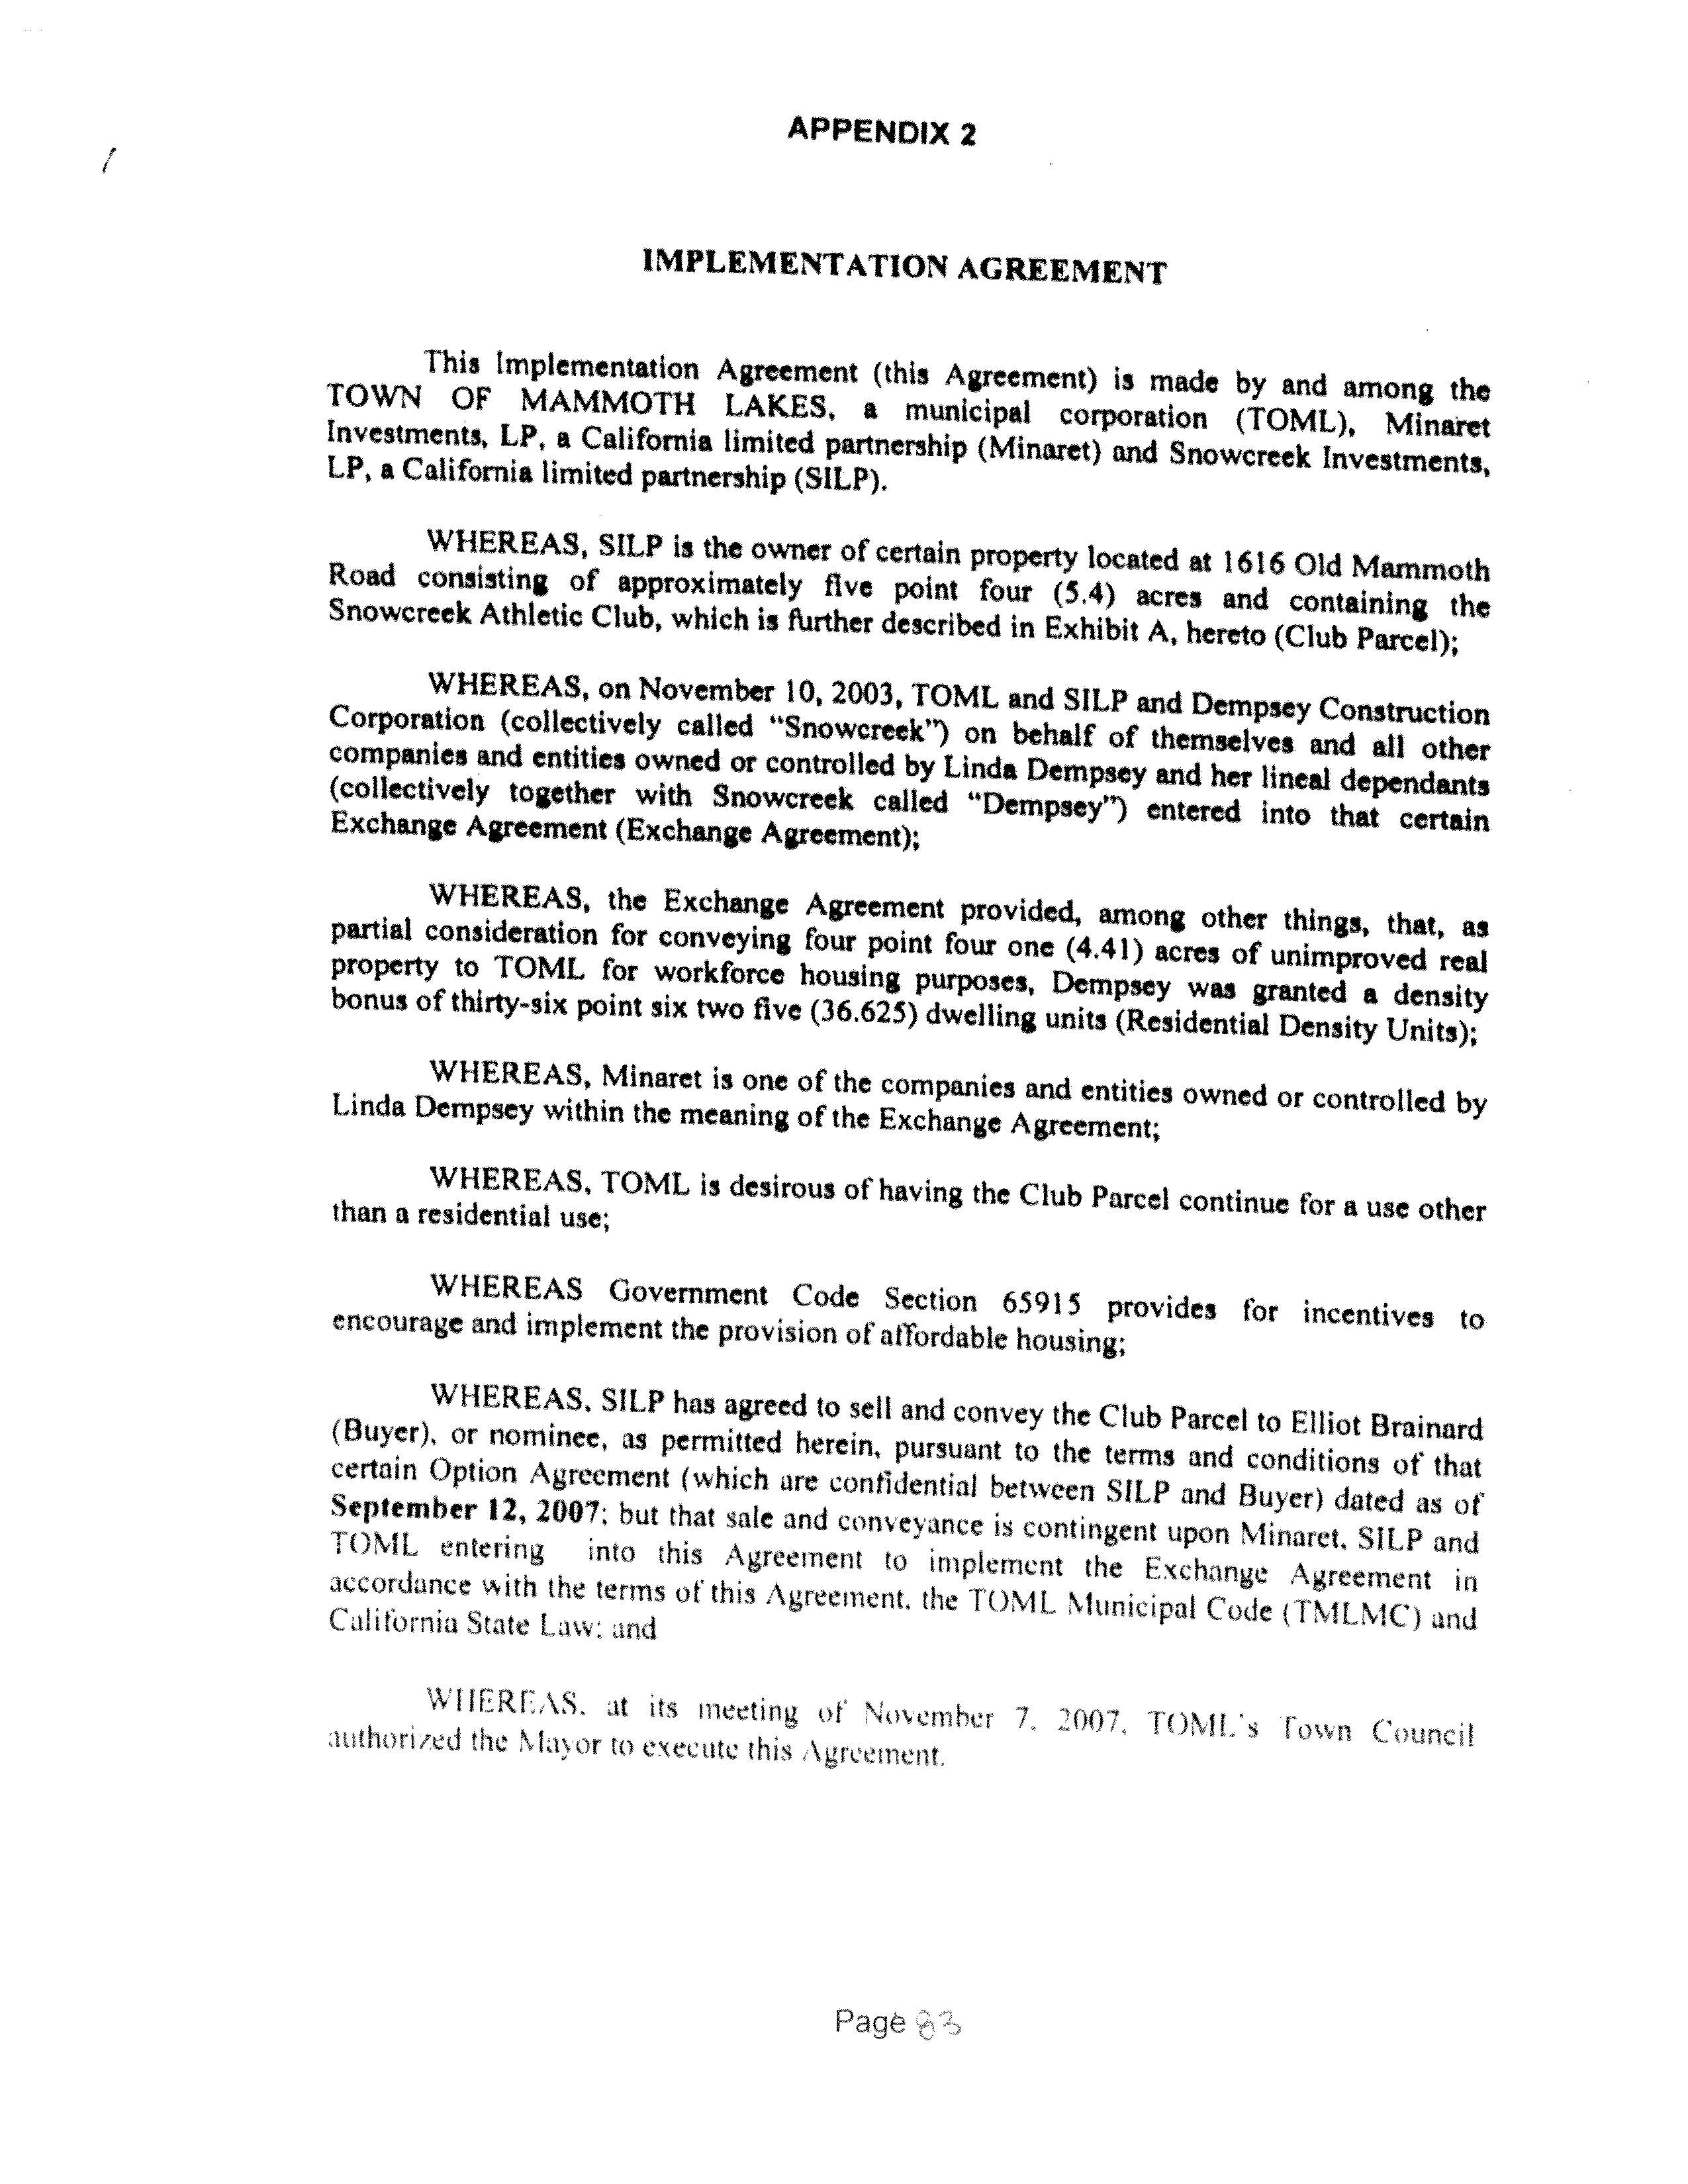
APPENDIX 2

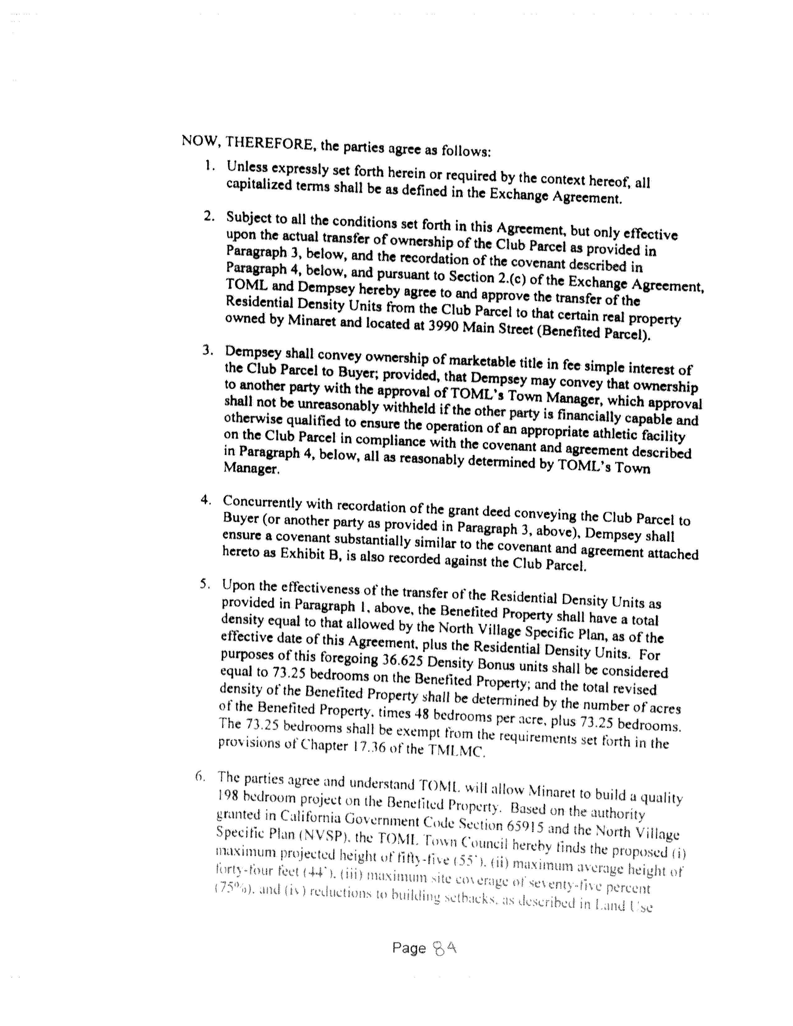
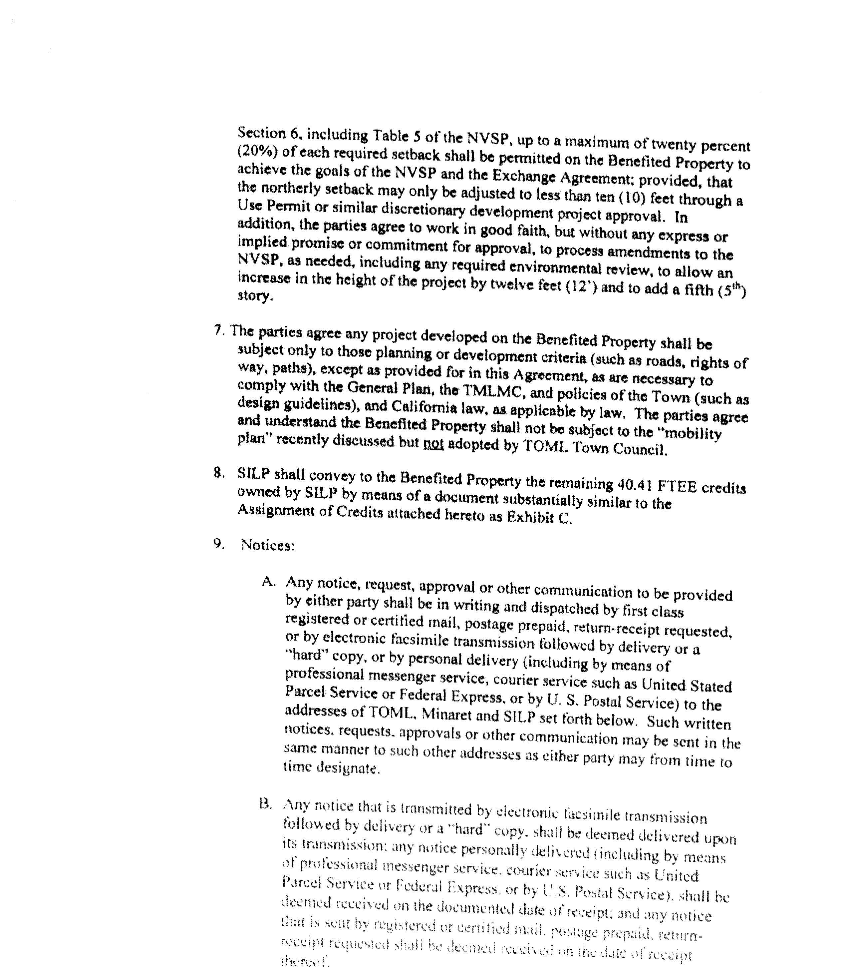
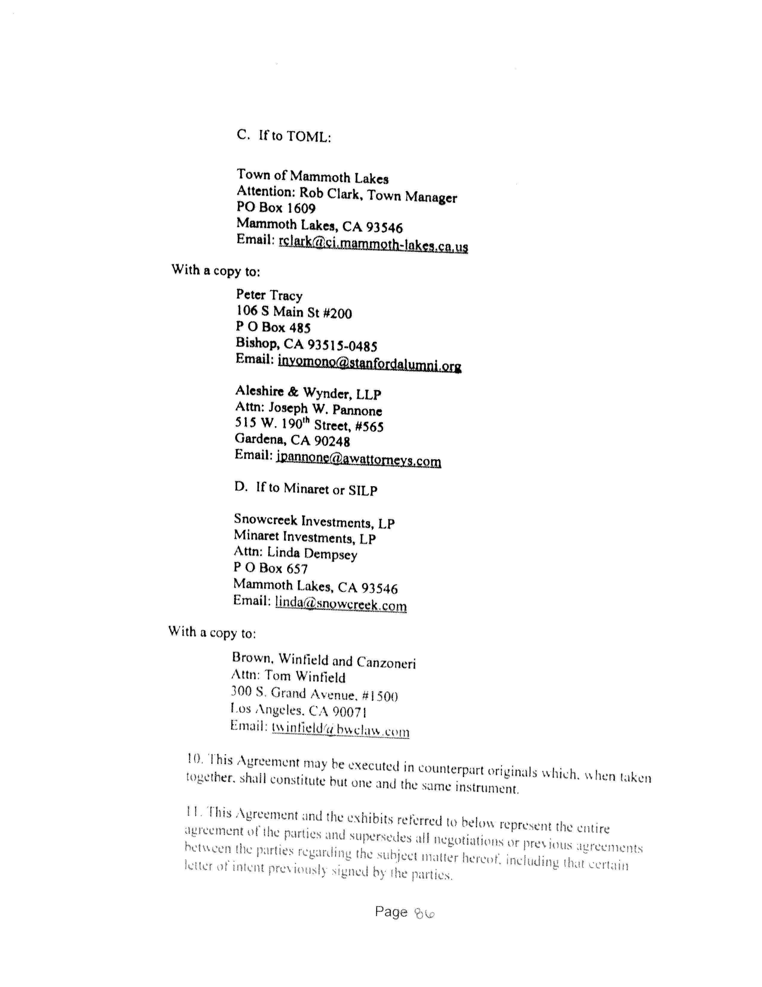
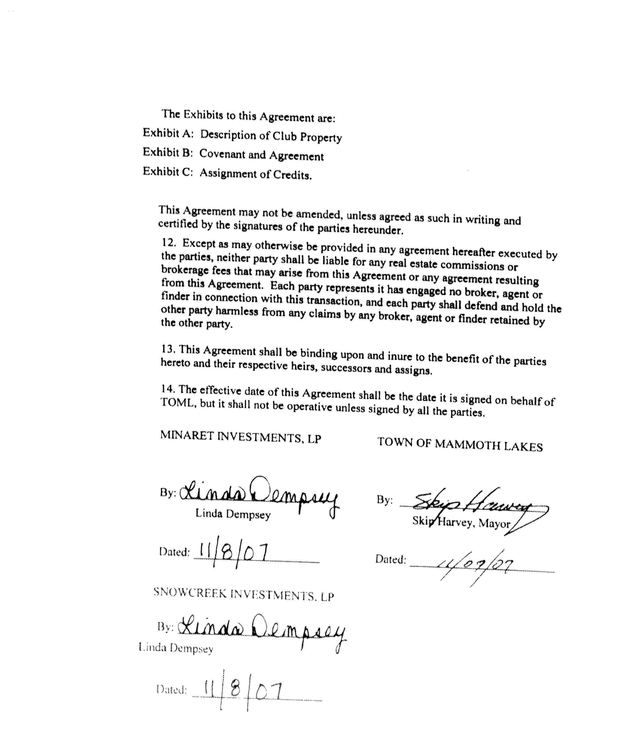
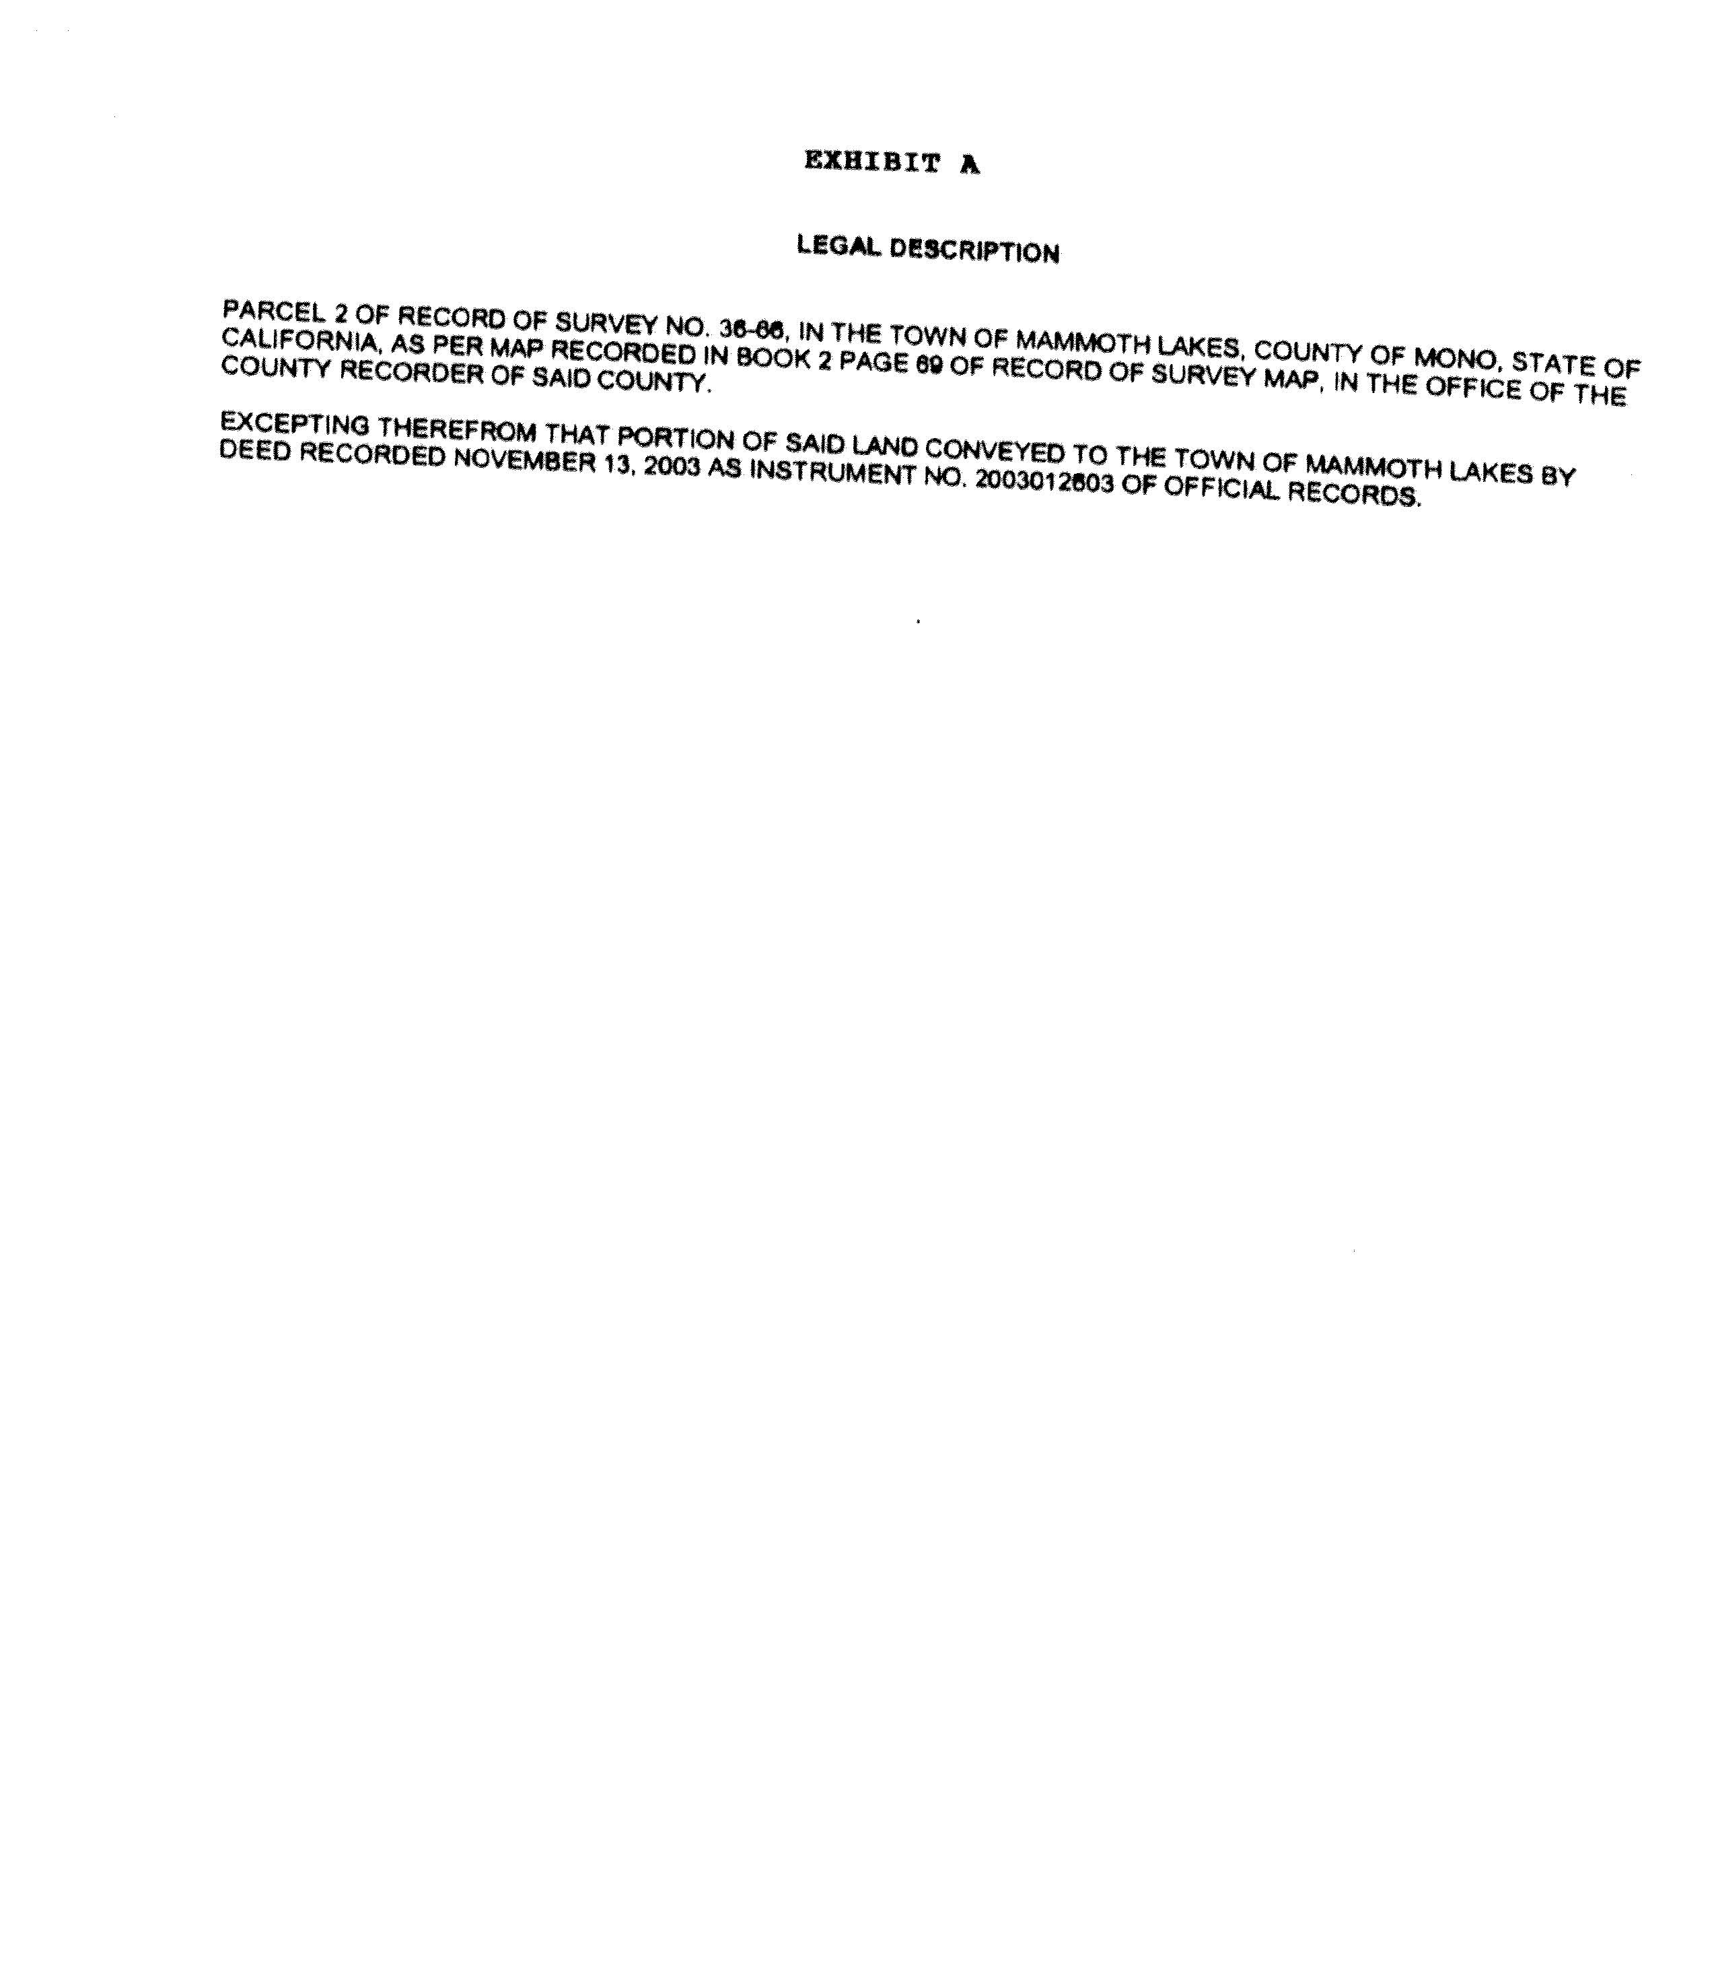
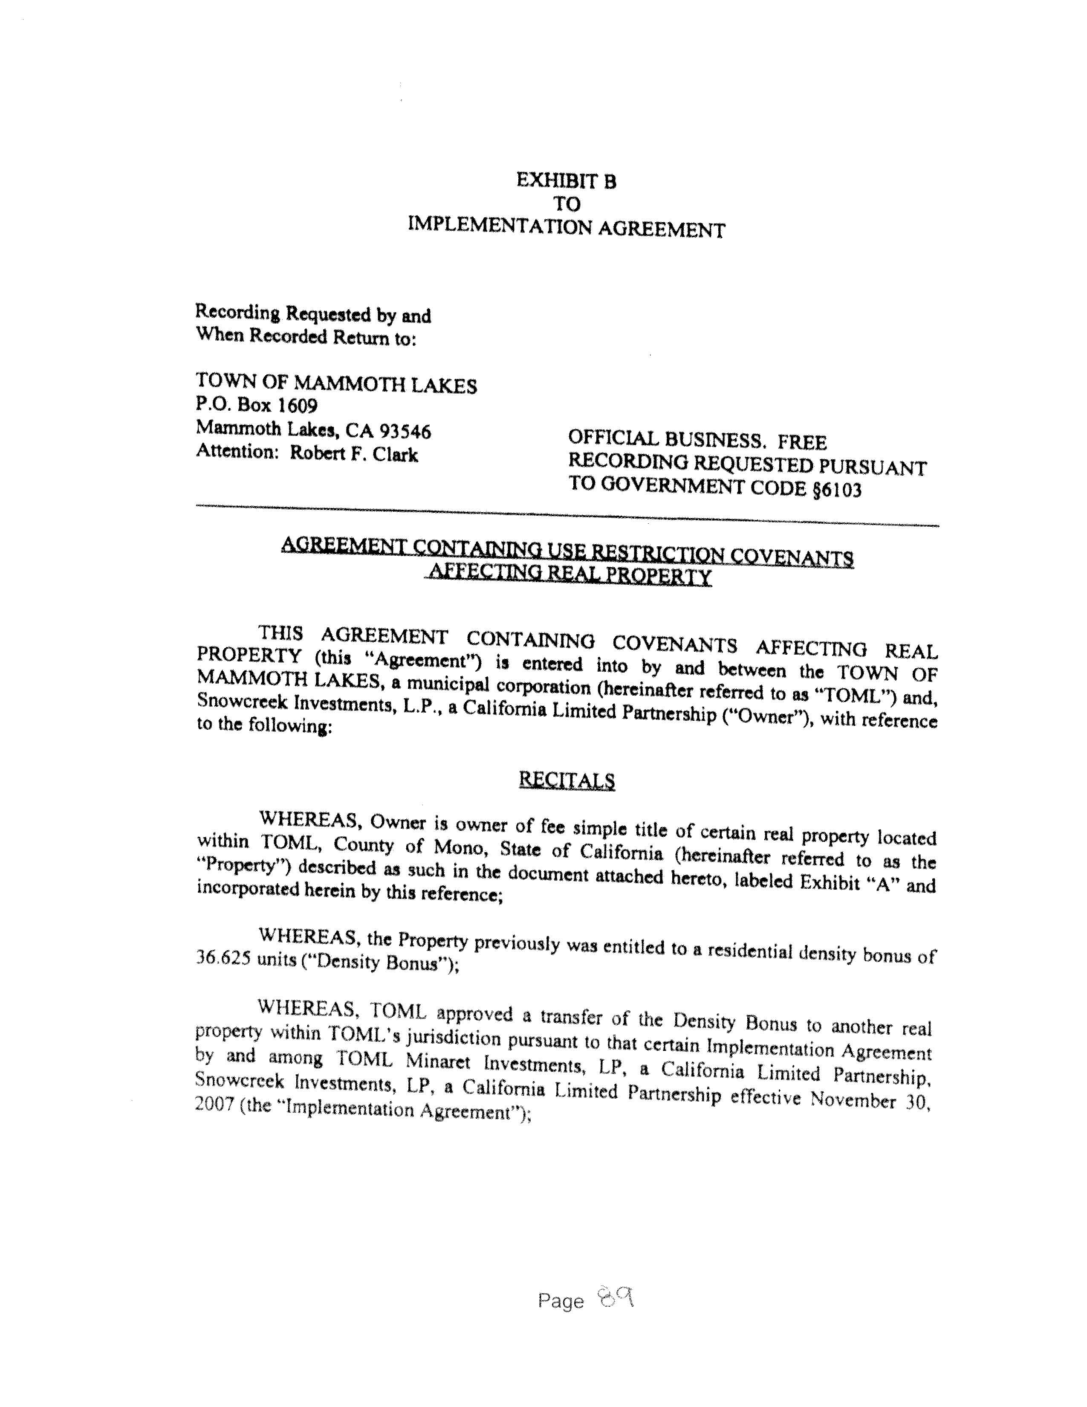
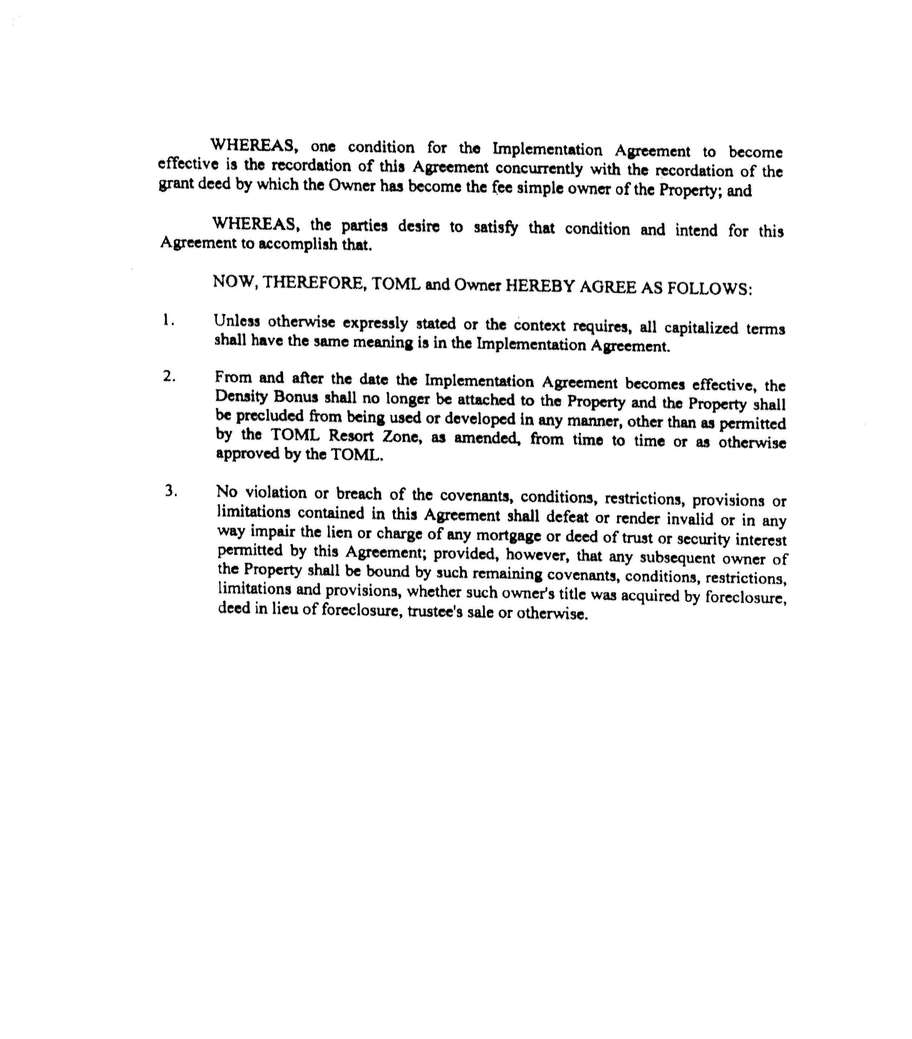
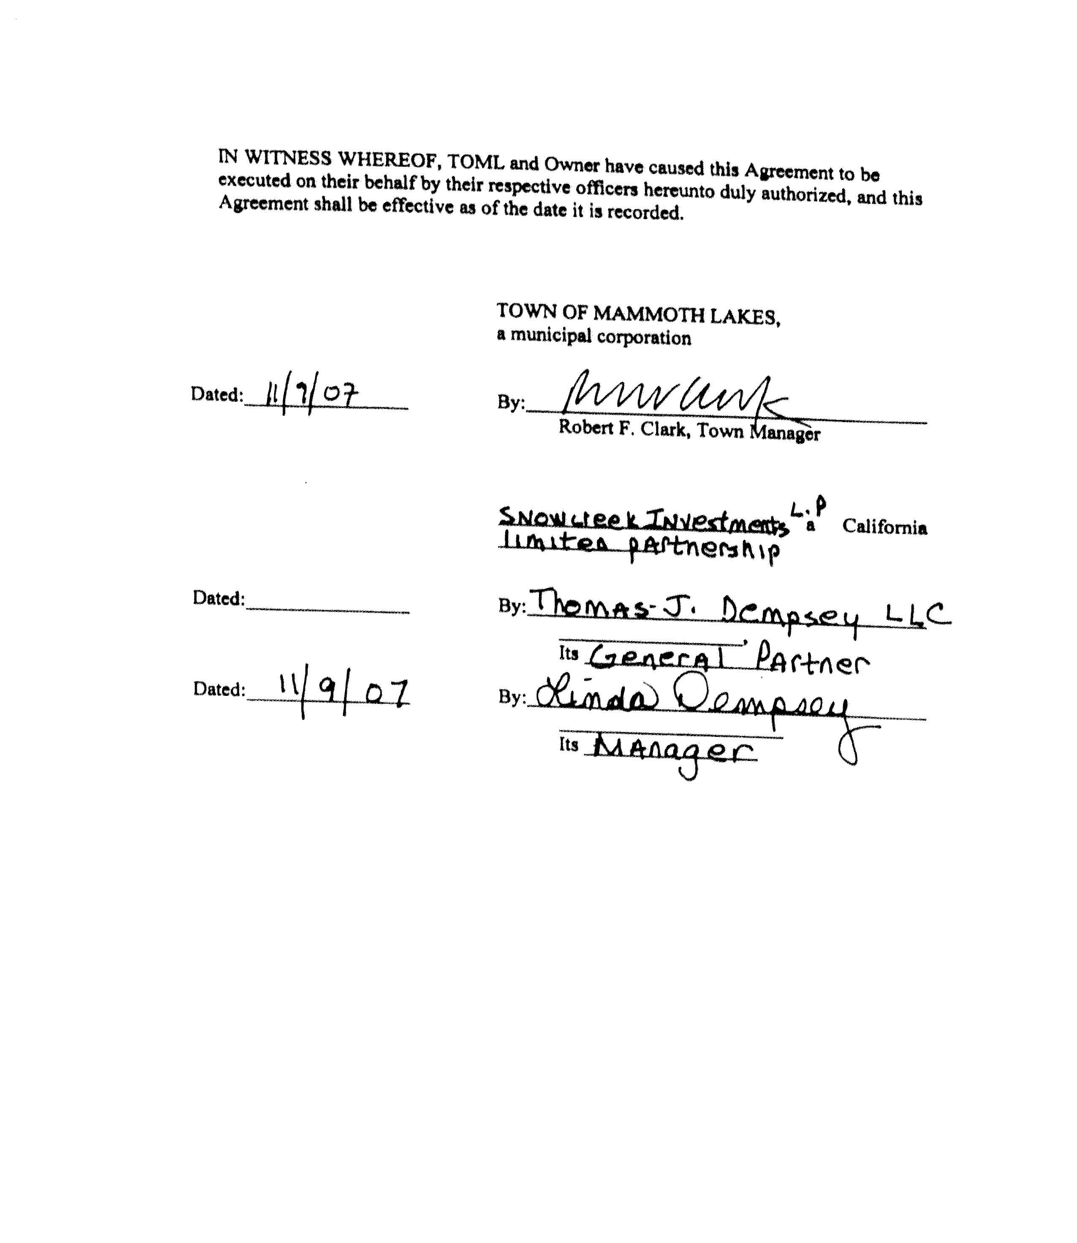
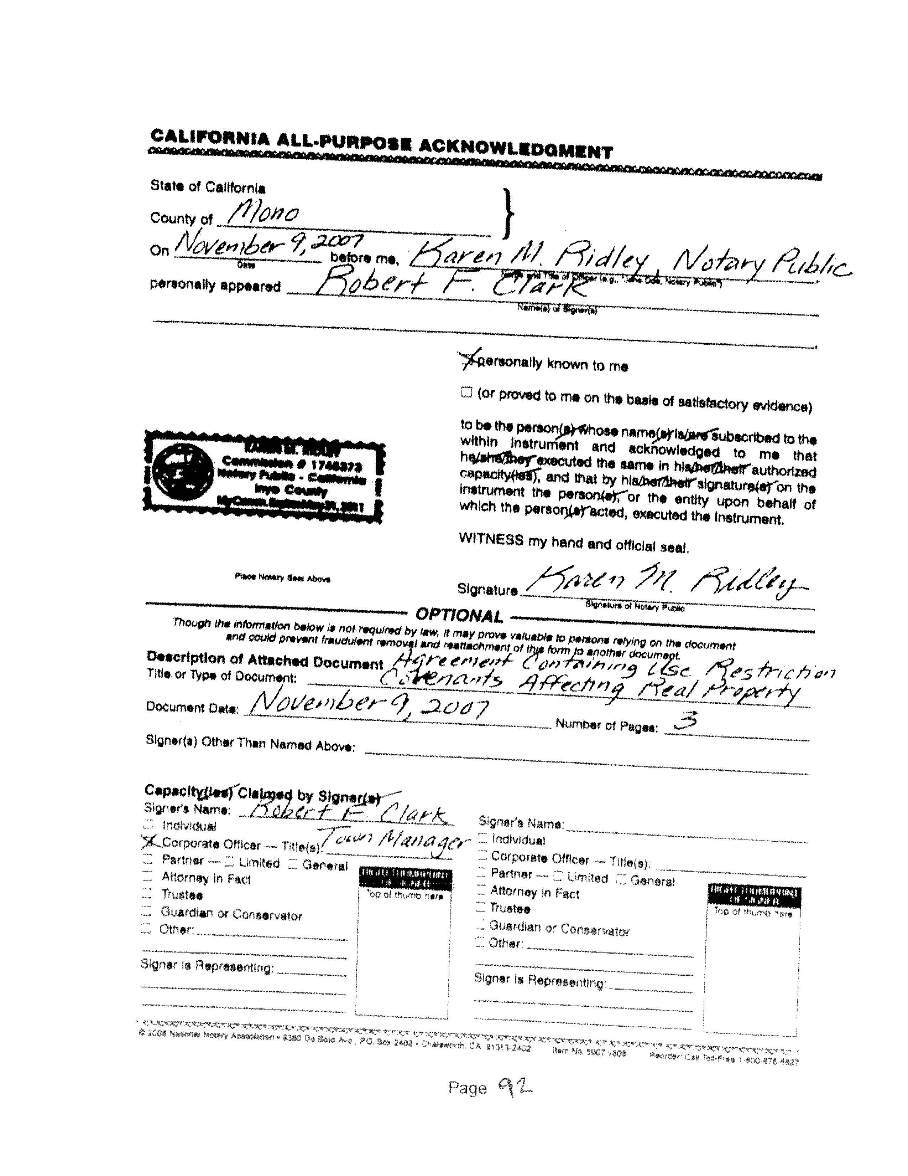
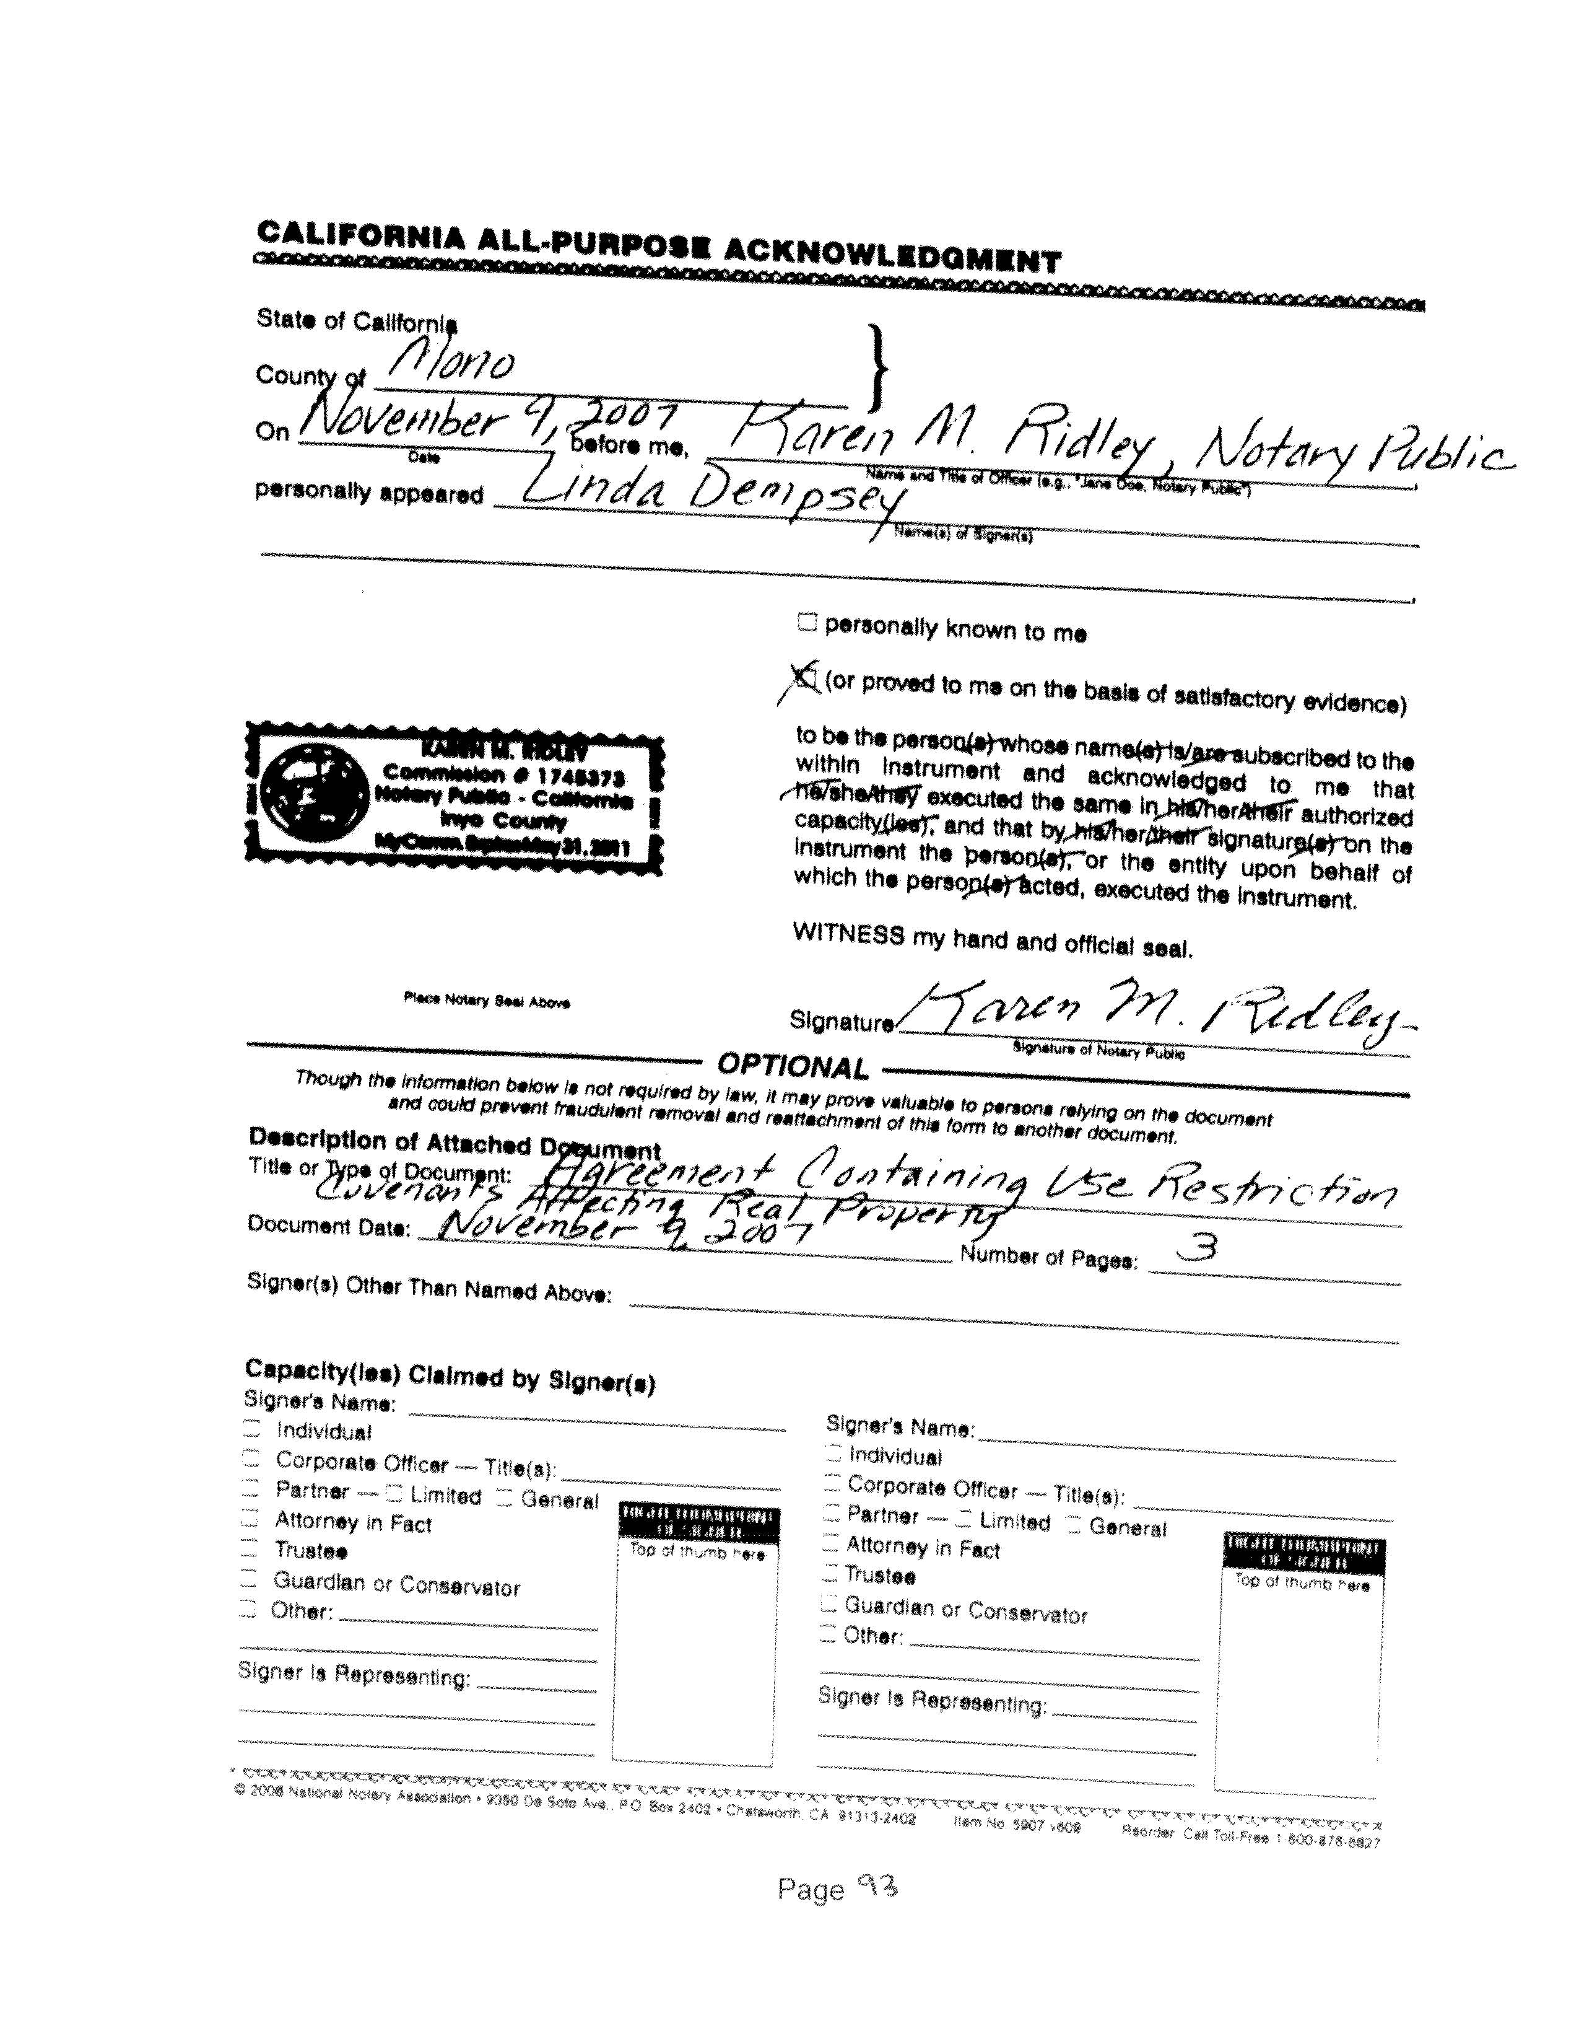
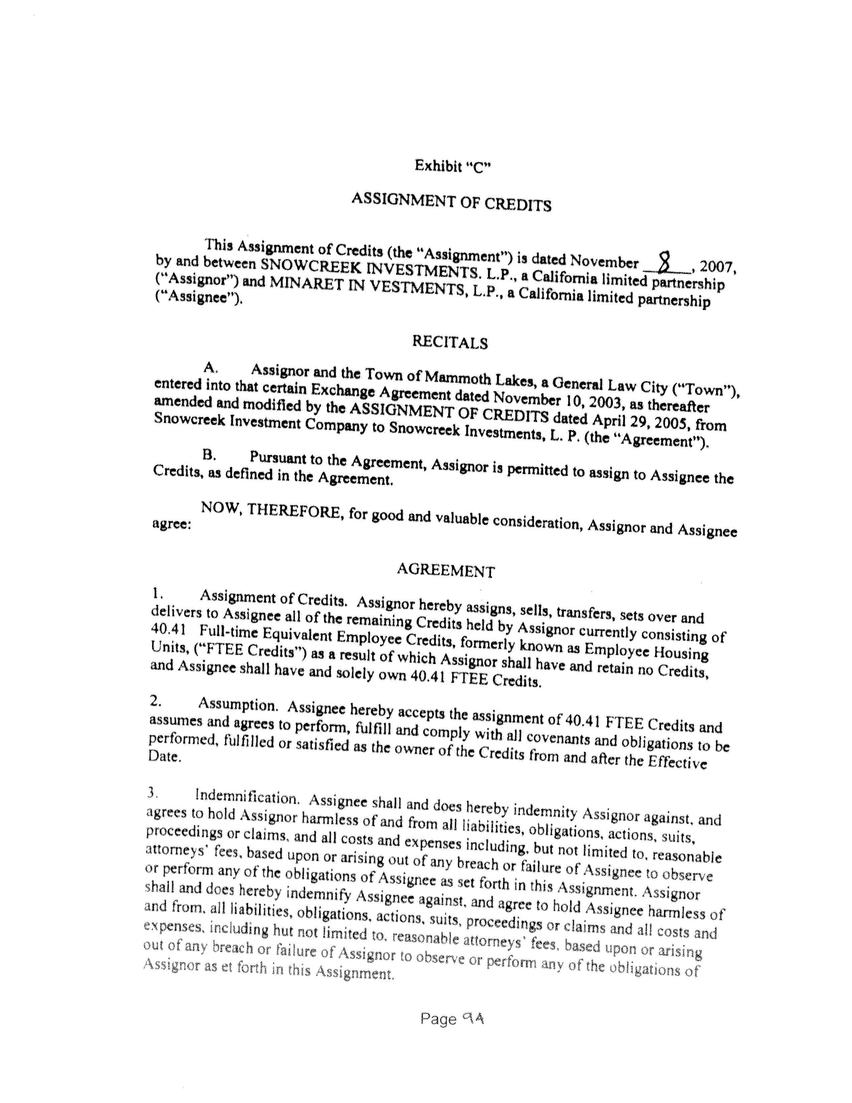
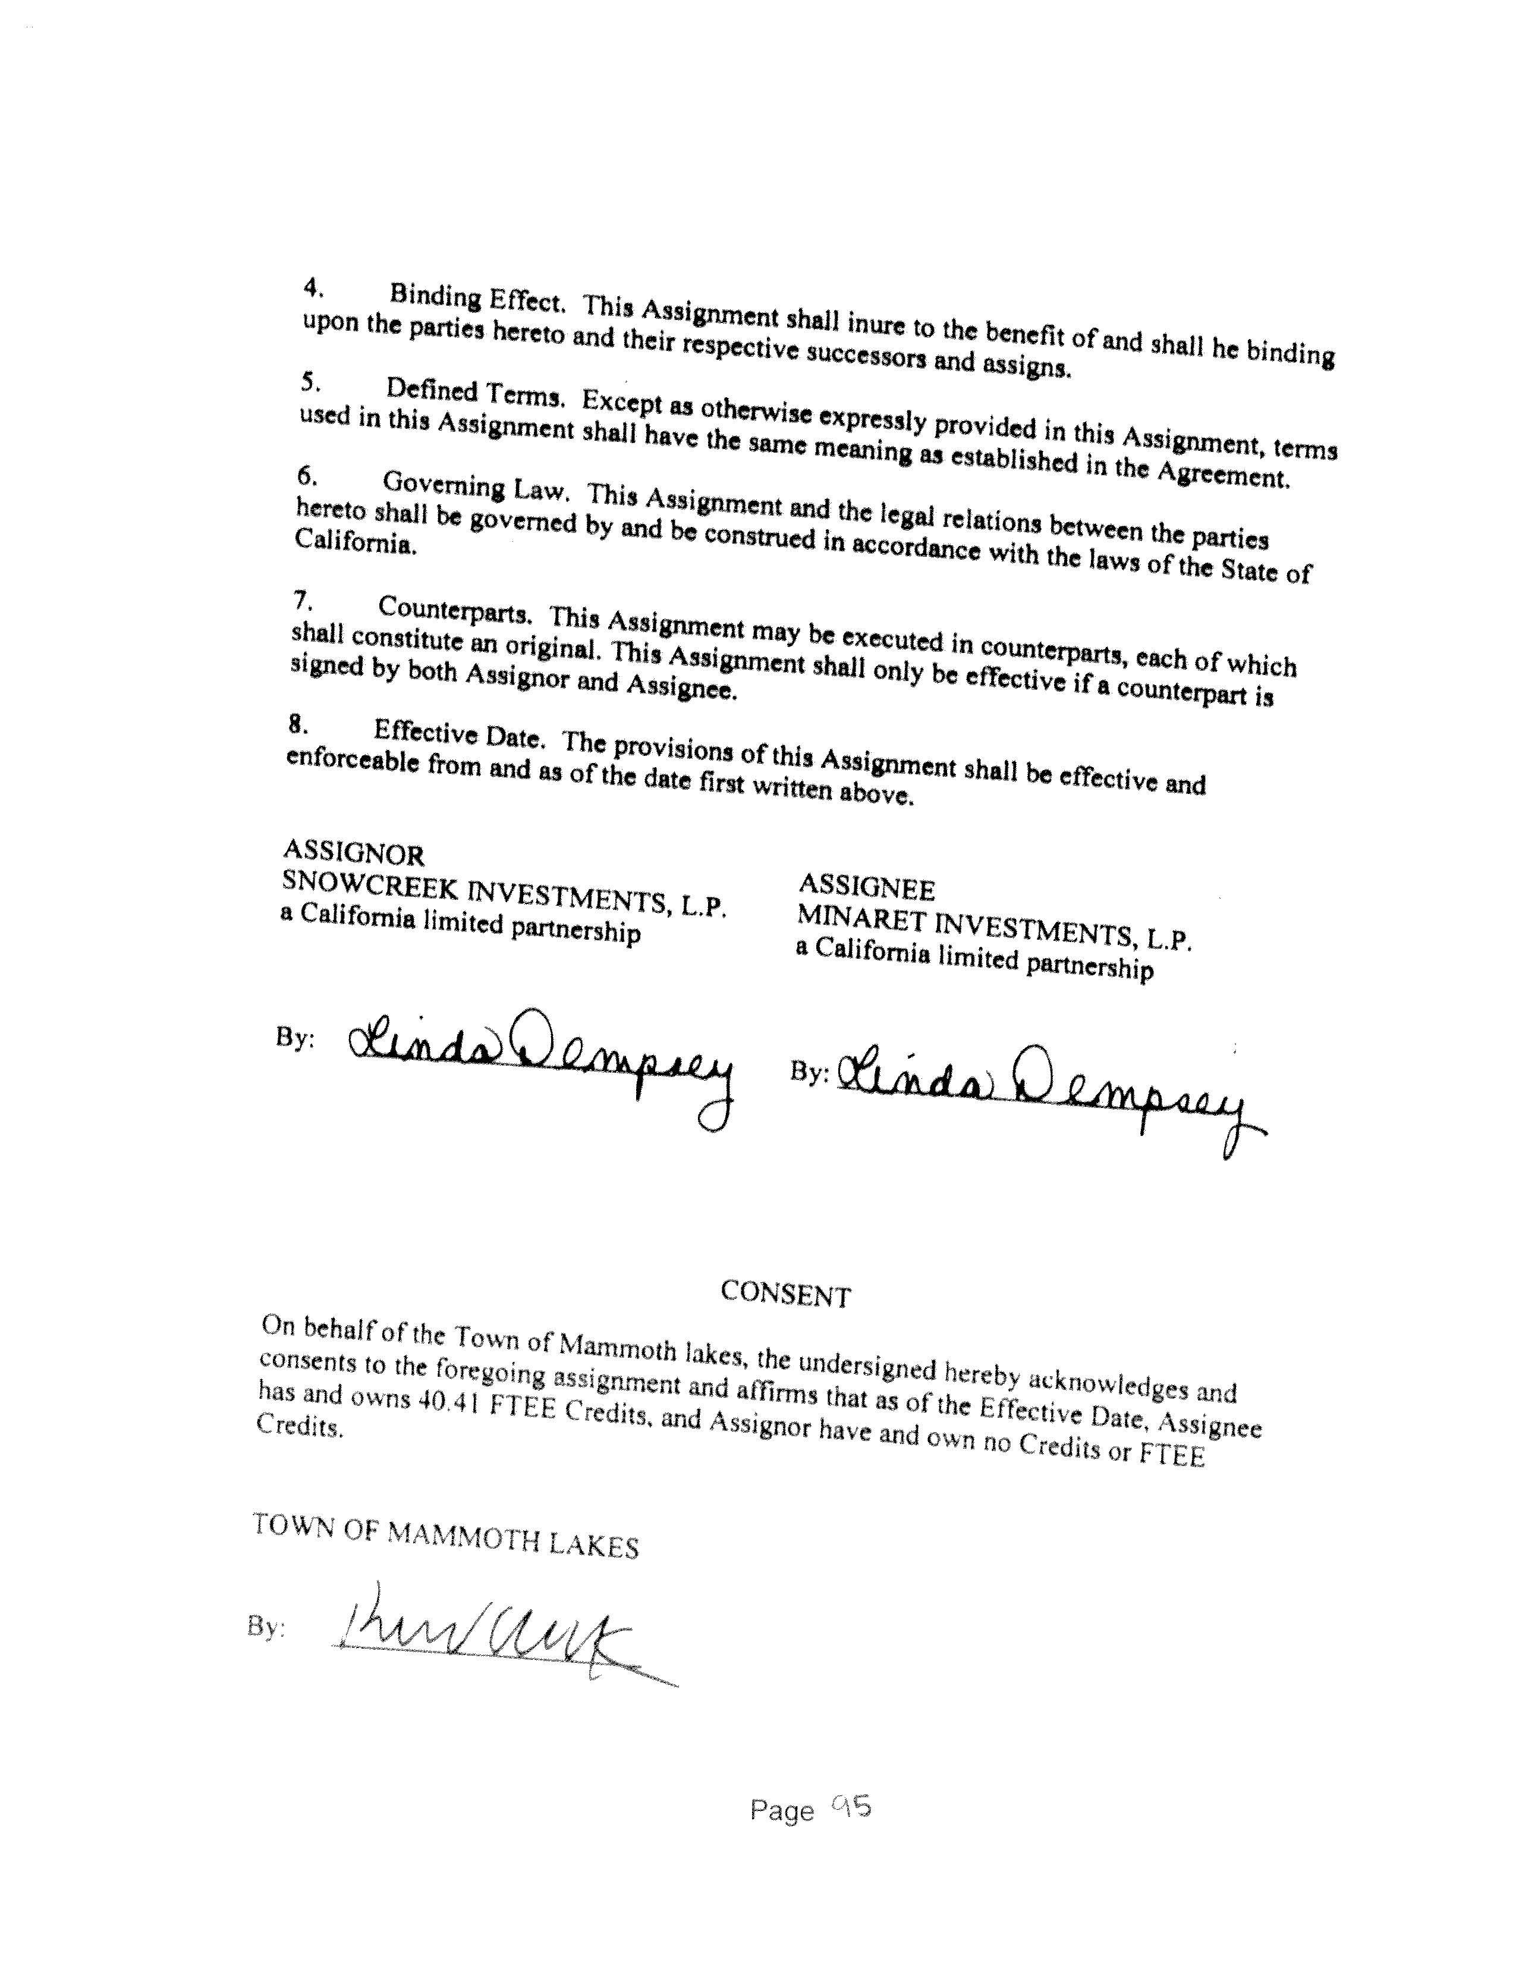
APPENDIX 3
DESIGN OBJECTIVES AND GUIDELINES FOR MAMMOTH CROSSING

The following design guidelines shall be applied to all future development on the three Mammoth Crossing sites. They are to be used to supplement design requirements and guidelines established by the North Village Specific Plan, and in other relevant documents including the “Design Guidelines for the Town of Mammoth Lakes.” The application of these guidelines is intended to be reasonable and practical, and not as regulation, except where regulation contained elsewhere in the NVSP is referenced.

A. Built Form

The ideas presented in this section are suggested treatments of building elements. They are rooted in the vernacular of the High Sierra, as well as in the development objectives of Mammoth Lakes. The descriptions of material use, articulation, and massing are a means of achieving a design that is appropriate to the context and responds to the human scale. Building form is an essential tool in creating a sense of place. Scale, varied volume, and appropriate material can be used to define the character of Mammoth Crossing and to identify the use of places throughout the sites.

Base
- Create a strong sense of substance through materials and massing
- Reinforce the impression of building mass above
- Respond to pedestrian activity with a robust articulation of materials at street level
- Masonry is an appropriate material to give an impression of strong building base

Wall
- Use fenestration to reveal a rhythm and proportion related to activity within
- Articulate the wall as a three dimensional object with projections and recessions, using shadow to add depth
- Balance relationship of open window space to solid wall volume
- Materials reflect a human proportion; for example, wood shingles are a perceptible unit of measure which add texture to the wall surface
- Manage window/wall portioning with respect to orientation, solar load, views, the need for natural light and respect for privacy
Roof
- Create a sense of shelter in the roof form through scaling and articulation
- Design roofs to appear “inhabited” to heighten the sense of intimacy and comfort
- Use the expression of dormers, bays, and structure to enfold and contain spaces within
- Reveal structural elements with an articulation in framing material, adding a layer of lightness to the mass of the roof
- Differentiate and emphasize places through a successional relationship of roof planes
- Draw the roof towards the ground by carrying roof elements down through the wall volume
- Use deep overhangs to protect and enclose activity at the street level
- Roof overhang edges should become thin and light at their extremities like the branches of a tree
Volume
- Incorporate variations in height and volume that reflect the surrounding silhouettes of the forest and mountains
- Create contrasts of robustness and lightness in building mass
- Vertical accents emphasize significant places
- Stepping back, or projection of mass reveals a skyward evolution of building form
Scale
- Provide variation throughout the building to reveal different realms of inhabitation
- Create a human scale pedestrian environment at street level
- Identify the public area with a repetition of storefronts and street elements
Materials
- Extend exterior materials to interior to create continuity
- Use regional and authentic materials and color palette
- Use materials appropriate to their structural function.

B. Landscape

Natural surroundings are a valuable asset at Mammoth Crossing. Guiding Concepts describes the importance of preserving the environment, and also the value of public space that flows from interior to exterior. The suggestions in this section are guides for designing a landscape that integrates the natural environment with the built one, and for using natural features to define urban space. Design of the ground plane is as important to consider as the buildings. It acts as the floor of the urban room. Ground treatment mediates the built mass and the site’s topography, it also creates transitions between public and private, interior and exterior, and natural and constructed environments.

- Use changes of scale, texture and material in paving to furnish the urban room
- Paving provides texture and pattern at the ground level, unit pavers reflect a human scale
- Ground level elements highlight spatial hierarchies and facilitate intuitive way-finding
- Bollards, walls, and planters can create subtle contrast between pedestrian and automobile circulation
- Flexibility should be incorporated into the design of all ground elements, so a variety of social interactions may take place
- Augment existing trees with plantings designed to regulate the summer and winter climate
- Use trees to create a rhythm and scale at the street level and to define the public realm.
- Fine grain planting accentuates spaces and creates an atmosphere of rest or transition.
- Plantings should be conscious of the local ecosystem and make use of regional species that can thrive without additional energy input.

C. Views
Preservation of views and vistas is an important goal of the NVSP and of the General Plan. The following guidelines are intended to ensure that future development of the Mammoth Crossing sites will respect and preserve views, consistent with the community vision.

- Building heights, form and massing should respond to topography and the surrounding forest and mountainsides, so as to maintain the sense of a Village in the Trees.
- Buildings should be oriented and massed so as to frame, not obstruct, significant views to the Sherwin range and Mammoth Knolls.
- The tallest building heights should generally be massed away from neighboring residential development through use of step-backs and setbacks.

