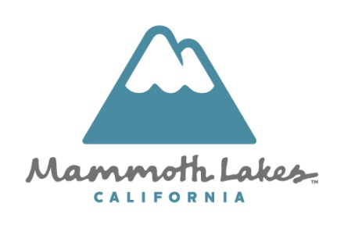
Public Works Department
P.O. Box 1609, Mammoth Lakes, CA, 93546
(760) 934-8989
www.townofmammothlakes.ca.gov

______________________________________________________________________________

CONSTRUCTION AND DEMOLITION WASTE MANAGEMENT WORKSHEET
(FORM TO BE SUBMITTED TO RECEIVE FINAL SIGNOFF AND RELEASE OF DEPOSIT)

Permit # _____________________________________
Project Address: _____________________________________
Project Manager: _____________________________________
Waste Hauling Co: _____________________________________
Construction and Demolition Waste Management (CDWP) Plan
Acceptable Waste Materials | Diversion Method: |  | Projected Diversion Rate
Acceptable Waste Materials | Commingled and Sorted Off-site | Source Separated Onsite | Projected Diversion Rate
Metals
Wood
Plastics
Cardboard
Aggregates
Other:
Other:
Other:

Contractor (Documentation Author’s / Responsible Designer’s Declaration Statement)
- I certify that this Certificate of Compliance documentation is accurate and complete.
- I certify that the features and performance specifications for the design identified on this Certificate of Compliance conform to the requirements of Title 24, Part 11 of the California Code of Regulations.
- The design features identified on this Certificate of Compliance are consistent with the information documented on the other applicable compliance forms, worksheets, calculations, plans and specifications submitted to the enforcement agency for approval with the permit application.
Signature: | Date:
Company: | License:
Address: | Phone:
City/State/Zip:

